HSE0135 - Risk Assessment Matrix (RAM) Assessment and
Risk Management Guidance

Table of Contents

Table of Contents 1
1 Risk Assessment using Risk Assessment Matrix (RAM) 2
1.1 Scope 2
1.2 Applicability and Process 2
1.3 Risk Assessment Matrix 2
1.4 RAM Assessment Steps 3
2 Guidance on Risk Assessment Process 4
2.1 Introduction 4
2.2 Types of Risk Assessment 4
TOOL HSE0135-PR01-TO.01 RAM Pocket guide and material 5
TOOL HSE0135-PR01-TO.02 operational risk assessment template 6
TOOL HSE0135-PR01-TO.03 Hydrocarbon Loss of Primary Containment (LOPC) Potential Consequence Estimation Tool 7
Loss of Containment Consequences 7
Hydrocarbon Gas/Vapor Release (Jet Fire) 7
Hydrocarbon Gas/Vapor Release (Vapor Cloud Explosion) 8
Hydrocarbon Oil Release (Pool Fire) 8
Hole Size Correlation 8
Potential Consequence Severity for Hydrocarbon Gas Release 9
Potential Consequence Severity for Hydrocarbon Liquid Release 9
Basis of Potential RAM on Consequence (Jet Fire/Pool Fire) 9
Potential Consequence Severity for Hydrocarbon Gas (Vapor Cloud Explosion) Release 10
Basis of Potential RAM on Consequence (Vapor Cloud Explosion) 10
References 10
TOOL HSE0135-PR01-TO.04 Failure Modes and Consequence from Overpressure Scenarios 11
Scope 11
Basis 11
Guidance on Assessment 11
Overpressure Consequence Table 12
Example 12
References 12
TOOL HSE0135-PR01-TO.05 Dropped Object Consequence Calculator 13
Dropped Object Prevention Scheme (DROPS) Model 13
Calculator 13
How to Use 14
References 14
TOOL HSE0135-PR01-TO.06 Hydrogen Sulfide (H2S) Release Potential Consequence Estimation Tool 15
Hydrogen Sulfide Health Hazards 15
H2S Actual / Potential Incidents Classification and Potential RAM Ranking for H2S Release 15
References 15

1 Risk Assessment using Risk Assessment Matrix (RAM)

1.1 Scope | This document gives guidance on how to score risks based on the Shell Risk Assessment Matrix (RAM) when performing risk assessment as needed by the following activities:  - HEMP (e.g. HAZOP, HAZID),  - manage of change,  - PTW and LOTO,  - incident reporting,  - EME/CMPT  - Deviation (bypass)  - MTO (threats/opportunity)

1.2 Applicability and Process | This manual section applies to:  - All the activities involved with the hazards/ threats conducted on Gulf of Mexico development / drilling / production locations  - Event that had resulted in consequences or findings that could have resulted in consequences; and  - Review of designs or opportunities that could adversely expose HSE Risk in operations.  Refer to Shell HSSE & SP Control Framework Risk Management – Managing Risk section for information on Risk Assessment Matrix and application.  - Control Framework:  http://sww.shell.com/hse/control_framework/index.html  - Managing Risk:  https://eu001-sp.shell.com/sites/AAAAA8432/CF/Web/Managing_Risk.aspx

1.3 Risk Assessment Matrix | Risk Assessment Matrix (RAM) is to provide insight in how the risk can be managed based on the concept of applying experiences of events or incidents in the pasts.  The starting point for a RAM assessment is identifying the hazards with an understanding of the context (hazard release scenario, activity, location etc.), or a description of the particular incident being considered with an understanding of the actual and potential consequences.  Refer to TOOL HSE0135-PR-01-TO.01 for details on Gulf of Mexico specific consequence descriptions.

1.4 RAM Assessment Steps
  Step | Action
  1 | Identify actual / potential consequences: Identify the “worst case credible” consequences that could develop from the hazard under the prevailing conditions.  - Actual: Determine the impact that the event / incident had on People, Asset, Community and Environment  - Potential: Develop ‘reasonably foreseeable’ potential consequence by asking the question “What could happen if the controls don’t work or are not in place?”  How do you identify ‘Reasonably Foreseeable’ potential consequence?  - Ask the question “What if?”, be credible but not too imaginative with potential consequences scenarios.  - Avoid stringing too many “what ifs” together to produce less likely consequence.  - If two or more “what ifs” are needed for a consequence to be realized, challenge each to establish whether when they are combined, the overall consequence is credible.
  2 | Estimate the Severity of each potential Consequence: For each of the identified Consequences assess the Severity (0 - 5) in the four Consequence categories - People, Asset, Community and Environment (P, A, C, E).
  3 | Estimate the Likelihood: For each of the potential Consequences make an estimate of the Likelihood of the Consequence in terms of the Likelihood levels.  - The Likelihood level is judged from past experience, by asking the question, “How often in the past has a hazard release resulted in a Consequence similar to the one that we are considering?”  - The estimate of Likelihood is based on the Likelihood that the particular Consequence under consideration occurred, not on the Likelihood of the Hazard being released.
  4 | Estimate the RAM risk rating: For each potential Consequence determine the RAM risk rating for each of the applicable P, A, C, E categories in terms of the product of the consequence severity and the likelihood.  - The risk ratings can be plotted on the matrix to provide a visual representation of the risk profile of the hazard release scenario under consideration.

2 Guidance on Risk Assessment Process

2.1 Introduction | Purpose: To provide guidance on how to perform risk assessment for various processes to assess risks of identified hazards for worst-case credible scenarios.  Overview: This section contains:  - Different types of processes that requires risk assessment using Risk Assessment Matrix (RAM),  - Approach on how to properly assess and manage risk

2.2 Types of Risk Assessment | There are two different types of risk assessments to understand underlying risks involved with the identified hazards. Two approaches provide different aspects of risk to effectively communicate and manage relevant risk involved in activities or events.
  Type 1 | Comments
  Purpose | Evaluating risk of design or installation  - Test robustness / strength of new or existing design  - Applied to prioritize actions to address barrier strength
  Approach | Do NOT account any effects from barriers that are in place
  Application | HEMP (HAZOP / HAZID), Hazards & Effect Register, Risk Register  - Assess risk of new or existing design  Management of Change  - Assess risk of final design (refer to HSE0004A standard)  PTW / LOTO  - Assess risk while performing activity
  Type 2 | Comments
  Purpose | Evaluating risk of existing impaired design / opportunity.
  Approach | Takes into account existing VALID barriers.  - Valid Barriers:  - Effective: has to be proven effective all the times  - Independent: must not have any common mode failures  - Auditable: must be able to prove effectiveness of barriers
  Application | Incident Reporting  - Evaluate potential of worst-credible scenario from the incident / event occurred  EME/ CMPT; Deviation (bypass); HBA; MTO (for threat)  - Evaluate potential of impaired system or needs to be managed  MTO (for opportunity)  - Assess new risk of opportunity identified

TOOL HSE0135-PR01-TO.01 RAM Pocket guide and material

Risk Assessment Matrix Pocket Guide

Risk Assessment Matrix Guidance Material

TOOL HSE0135-PR01-TO.02 operational risk assessment template

Operational Risk Assessment | Operational risk assessment template supports risk based decision when assessing risk involved in daily operations.  - Assessment of Risk – Apply Type 1 Risk (does not account any existing valid barriers)  - Assess – List controls and mitigation measures available - must meet following criteria: a) independent; b) auditable; and c) effective. Assess basis for selection/uncertainty and justification for chosen/rejected options.  - Control & Evaluation – Develop recommendations based on the residual HSSE risk and controls/mitigation

Operational Risk Assessment Template and example

TOOL HSE0135-PR01-TO.03 Hydrocarbon Loss of Primary Containment (LOPC) Potential Consequence Estimation Tool

Loss of Containment Consequences | When release of hydrocarbon occurs on an offshore platform, depending on the condition of the release, various consequences can occur.  In case of pressurized release and jet stream ignites, jet fire can occur. If the hydrocarbon gas accumulates in a congested area and has delayed ignition, vapor cloud explosion may occur. If the liquid hydrocarbon releases and pool forms, pool fire can occur within the containment (e.g. skid pan).  Based on the release point, the expected consequence will vary depending on the initial release condition and materials.
  Material / Phase | Primary consequence lookup table
  Hydrocarbon gas / vapor | Jet fire
  Produced hydrocarbon liquid. All class 1 flammable chemicals (FP < 100F) | Vapor Cloud Explosion
  Flammable materials with a Flash point > 100F | Pool fire

Jet Fire | Once hydrocarbon gas release occurs, the jet fire is most likely to occur. This is a burning jet of gas, which stabilizes with its source close to the point of release, until the inventory is exhausted. While the cloud fire, compartment fire or explosion can also occur from gas release, it requires certain conditions to be present prior to occurring.  A jet fire is usually localized but very destructive to anything within or close to the flame. Jet fires represent a significant element of the risk associated with major accidents on offshore installations. The jet fires can escalate to more severe consequences, such as vessel failure, Boiling Liquid Expanding Vapor Explosion (BLEVE), structural loss and impact to lifesaving equipment

Vapor Cloud explosion | All occupied buildings will have blast resistance checked against vapor cloud explosions as part of the asset safeguarding documentation. The impairment of the temporary refuge will only be considered in the HSE case bowties, not at an individual HAZOP threat line level because of the number of right hand barriers that are only documented in the HSE case bowties.  All hydrocarbon based liquids with a flash point <100F (i.e. class 1 flammables) including all produced hydrocarbons (including pipeline RVP spec oil) will be analyzed using the VCE RAM chart. This analysis will align with global practices and risks of high vapor pressure fluids and the asset hazard and effects register.

Pool Fire | In the event of a topsides release of flammable liquid, a pool fire may form on either the deck (skid pan) or the sea surface depending on how much and where liquid is released. A large release may block the drains and collect the liquid in skidpans.  Due to the volatility of most fluids offshore, a pool fire will be considered the primary risk only for fluids with a flash point > 100F. For more volatile fluids, see above and the VCE table. For a continuous release ignited early, the pool fire grows until equilibrium is reached where burning at the surface just balances the release rate. If the release occurs with small hole size, the impact from oil release will be limited. The time it takes for pool to form will be significantly large, and the radiation from the pool fire will be limited as the pool fire will not be sustained. If the release rate of oil is high due to larger release hole size, the release rate may exceed the drain rate through the skid pan, the pool fire of the skid pan can occur. A large oil fire will probably cover the entire area below the point of release throughout the fire duration.

Hole Size Correlation | Representative hole size resulting in release is presented below based on industry data. If release hole size is not available, information below can be referred.
  Hole Size |  | Categories
  [mm] | [in] | Categories
  1 | 0.04 | Weep / Seep
  3 | 0.12 | Pin Hole;  Gasket Leak (Early Stage);  Corrosion Holes (Early Stage)
  7 | 0.28 | As observed in field
  25 | 1.0 | As observed in field
  100 | 4.0 | As observed in field

Potential Consequence Severity for Jet Fire | Potential consequence severity ranking for hydrocarbon jet fire is provided as below based on the potential impact on personnel.
   |  | mm | 1 | 3 | 7 | 25 | 100
  psi | Bar | in | 0.04 | 0.12 | 0.28 | 1.0 | 4.0
  100 | 6.9 |  | 2 | 2 | 3 | 4 | 5
  250 | 17 |  | 2 | 3 | 3 | 4 | 5
  725 | 50 |  | 2 | 3 | 4 | 5 | 5
  1500 | 103 |  | 3 | 3 | 4 | 5 | 5
  2600 | 180 |  | 3 | 3 | 5 | 5 | 5
  8000 | 552 |  | 3 | 4 | 5 | 5 | 5
  10000 | 690 |  | 3 | 4 | 5 | 5 | 5

Potential Consequence Severity for vapor cloud explosion | The table below can be used for a VCE scenario from a volatile liquid release (example- methanol, xylene, export crude).
   |  | mm | 1 | 3 | 7 | 25 | 100
  psi | bar | in | 0.04 | 0.12 | 0.28 | 1.0 | 4.0
  100 | 6.9 |  | 3 | 3 | 3 | 3 | 4
  250 | 17 |  | 3 | 3 | 3 | 3 | 5
  725 | 50 |  | 3 | 3 | 3 | 3 | 5
  1500 | 103 |  | 3 | 3 | 3 | 4 | 5
  2600 | 180 |  | 3 | 3 | 3 | 5 | 5
  8000 | 552 |  | 3 | 3 | 4 | 5 | 5
  10000 | 690 |  | 3 | 3 | 4 | 5 | 5

Potential Consequence Severity for Pool fire | Potential consequence severity ranking for non-volatile (>100F flash point) fluid pool fire is provided as below based on the potential impact on personnel.
   |  | mm | 1 | 3 | 7 | 25 | 100
  psi | bar | in | 0.04 | 0.12 | 0.28 | 1.0 | 4.0
  100 | 6.9 |  | 2 | 2 | 2 | 4 | 4
  250 | 17 |  | 2 | 2 | 2 | 4 | 4
  725 | 50 |  | 2 | 2 | 2 | 4 | 4
  1500 | 103 |  | 2 | 2 | 2 | 4 | 4
  2600 | 180 |  | 2 | 2 | 4 | 4 | 4
  8000 | 552 |  | 2 | 2 | 4 | 4 | 4
  10000 | 690 |  | 2 | 2 | 4 | 4 | 4

Basis of Potential RAM on Consequence (VCE) | Following information had been applied to align with potential RAM on hydrocarbon release (for Vapor Cloud Explosion case).
  RAM | RAM Description | Explosion Rule (bar) | Description
  1 | Slight Injury | 0
  2 | Minor Injury / LWC, RWC up to 5 days | 0 – 0.1 | Result in small jet fire rather than explosion.
  3 | Minor Injury / LWC, RWC more than 5 days | 0.1 – 0.2 | Equates to 0.01 or 1% fatality in probability function for explosion fatality.
  4 | PTD or 3 fatalities | 0.2 – 0.35 | Impact to the module / area, resulting in 1 to 20% fatality fraction.
  5 | >3 fatalities | > 0.35 | Impact on wider asset beyond module, resulting in greater than 20% fatality fraction.

Basis of Potential RAM on Consequence (Jet Fire/Pool Fire) | Following rule had been applied to align with potential RAM on hydrocarbon release (for Jet Fire and Pool Fire cases).
  RAM | Ram Description | Fire Rule | Description
  1 | Slight Injury
  2 | Minor Injury / LWC, RWC up to 5 days | <5 ft | 5ft represents a typical offshore skid area and therefore fire will be limited to that area.
  3 | Minor Injury / LWC, RWC more than 5 days | 5-20 ft | This represents/correlated to a sub-module within a big module e.g. FGC Module one level on the process module, or about 1/4 the area of the lower level process module.
  4 | PTD or 3 fatalities | 20-50ft | This represents about 1/4th to 1/2 of offshore module area. e.g. 50% of process module on the lower deck.
  5 | >3 fatalities | 50+ft | This corresponds to more than 50% of area in an offshore module.

References | - Primary Containment Failure Mode Guidance for Process Safety Design (Pressure / Temperature) – Document No. VTO-300-MX-7180-0000001-000  - QRA Methodology for Shell EXPRO Installation

TOOL HSE0135-PR01-TO.04 Failure Modes and Consequence from Overpressure Scenarios

Scope | The overpressure is where the internal pressure exceeds design pressure of a component at a coincident temperature. This section addresses immediate failure mechanisms when a pressure containment system is subject to overpressure above normal operating conditions.  - Pressure vessels: ASME VIII (Div. 2) including pump and compressor casing  - Piping: ANSI B31.3  - Flanges: ANSI B16.5, up to and including ANSI/ASME 2500 class

Basis | Following assumptions have been applied in this section:  - Containment design principles and inherent characteristics of the materials and codes which typically are based on ‘leak before burst’ criteria  - Safety factors are based on the codes (ASME VIII, ANSI B31.3, API 521, DEP 80.45.10.10) regarding allowable versus ultimate strengths

Guidance on Assessment | Following guidance is provided for defining proper pressure source:
  Type | Source
  Vessel / Piping | Upstream pressure is derived directly or indirectly from well  Prevailing upstream pressure  - Maximum of 95% of the upstream design pressure; or  - 90% of PSV setting where PSV setting is lower than design pressure; or  - Scenario that would lead to higher upstream pressure
  Compression / Pump | Shut-in differential pressure  - 130% of design operation differential; or  - Maximum of 95% of the discharge PSV pressure; or  - 90% of PSV setting where PSV setting is lower than design pressure
cHTP = corrected hydrotest pressure = actual hydrotest pressure corrected for relief scenario or design temperature
Overpressure Consequence Table
  % of Design Pressure | Potential Consequence | Release Hole Size
  < cHTP | None expected – flange (weak point) is designed to ANSI B16.5, allowing short duration overpressure up to 133% design. Minor pinhole leaks should be considered for toxic service. | No leak expected
  < 190% | Severe loss of containment via leaks, probable at joints / flanges which will limit vessel deformation and likelihood of rupture | 7 mm
  < 280% | Severe loss of containment through parted flanges, catastrophic vessel rupture / disintegration considered unlikely (Probability = 0.01). | 25 mm
  < 320 | Severe failure. 10% change of catastrophic vessel rupture | 100 mm
  > 320% | Catastrophic failure considered as a likely consequence based on vessel rupture / disintegration | RAM 4 for non hydrocarbon service  RAM 5 for all hydrocarbon, flammable chemical or toxic chemical services

Example | A blocked-in case where the vessel involved is rated to 1500 psig (cHTP = 1950 psig), and the source pressure is 2100 psig hydrocarbon gas:  - Amount of overpressure is: 2100/1500 = 1.4 or 140%  - Hole Size = 7mm  - The gas would be released at 2100 psig. Using tool PR01.TO2, the expected consequence of releasing a hydrocarbon gas from a 7mm hole at a pressure of 2100 psig is a 5

References | - Primary Containment Failure Mode Guidance for Process Safety Design (Pressure / Temperature) – Document No. VTO-300-MX-7180-0000001-000

TOOL HSE0135-PR01-TO.05 Dropped Object Consequence Calculator

Dropped Object Prevention Scheme (DROPS) Model | Dropped objects pose risk of serious injuries, fatalities, and asset damage. The DROPS calculator provides guidance in classification of the potential consequences of a dropped object. The DROPS calculator provides only cursory indication of potential outcome, not precise prediction. DROPS calculator can be applied for following purposes:  - Designed to be employed during task planning and risk assessment to determine potential severity rating.  - Used in reporting processes to determine potential outcome of an actual dropped object incident.  The following applies to DROPS model:  - Dropped object classification is defined by the mass of an object and the height from which it falls.  - Evaluates probability of fatality based on risk level  - With light objects (i.e. with a weight <0.1 kg), a key influencing factor is the likelihood of an object piercing the skin and damaging tissue and organic functions.  - Calculator assumes a blunt object and does not take into consideration sharp objects (e.g. broken glass, metal shards)  - Assumes standard personal protective equipment (i.e. hard hat, safety boots, and eye protection)  - Do not subtract the height of an individual; measure fall distance to ground level  The DROPS model provides results in the following consequences:
  1. | Slight | A first aid case. No or limited injury. Treatment may be limited to first aid.
  2. | Minor | A recordable incident. A work-related injury that does not involve death, day(s) away from work, restricted work or job transfer, and where the employee receives medical treatment beyond first aid.
  3. | Major | A lost time incident (LTI). Non-fatal traumatic injury that causes any loss of time from work beyond the day or shift it occurred. Also referred to as DAFWC.
  4. | Fatality | Death resulting from an injury or trauma.

Calculator

How to Use | Following provides steps to apply DROPS calculator.
   | Action | Screen
  1 | Enter the height and weight into the cells provided, select the desired units using the drop down menus, and click the Outcome button as shown below.
    Figure 1
  2 | The Outcome Calculator will state the likely outcome as shown above and will plot the event on a colored graph as shown below.
    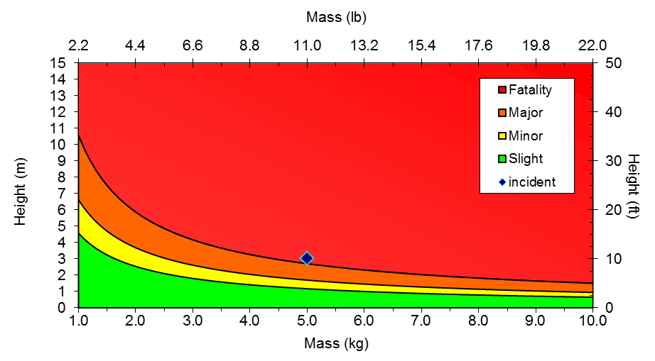
    Figure 2

References | - DROPS Recommended Practice 2017

TOOL HSE0135-PR01-TO.06 Hydrogen Sulfide (H2S) Release Potential Consequence Estimation Tool

Hydrogen Sulfide Health Hazards | Hydrogen sulfide gas causes a wide range of health effects. Workers are primarily exposed to hydrogen sulfide by breathing it. The effects depend on how much hydrogen sulfide you breathe and for how long. Hydrogen sulfide is a highly flammable, explosive gas, and can cause possible life-threatening situations if not properly handled. In addition, hydrogen sulfide gas burns and produces other toxic vapors and gases, such as sulfur dioxide.  Refer to HSE0030-PR01 Hydrogen Sulfide (H2S) Safety for more details on requirement around safe management around H2S.

H2S Actual / Potential Incidents Classification and Potential RAM Ranking for H2S Release | 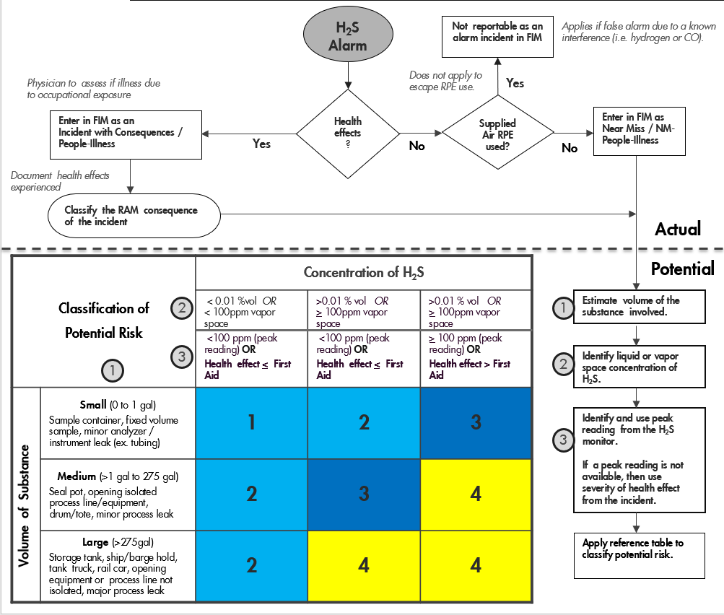

References | DSM Classifying H2S Alarm Events

