Deep Water – Gulf of America (DW-GOA)


PERSONAL PROTECTIVE EQUIPMENT

Project | DW-GOA
Document Title | Personal Protective Equipment
Document Number | HSE0078
DCAF Control ID Number | N/A
Document Revision | 4.0
Document Status | Approved
Document Type | Policy
Owner/Author | Keith Richard/Jared Deguise
Issue Date | May 2026
Expiration Date | May 2031
ECCN | EAR 99
Security Classification | Internal
Disclosure | None
Revision History shown on next page

Revision History
Revision | Date | Summary of Changes | Author
0 | October 2006 | - Published | See Change Matrix
1 | June 2011 | - Update to hand protection | See Change Matrix
2 | January 2018 | - Reimbursement, safety glasses updates and preferred vendor section added | See Change Matrix
3 | January 2019 | - Updated references, minor verbiage | See Change Matrix
4 | January 2026 | - Updates to section 1.3, 2.3, 2.9, 9, email contact in section 10 & instructions in section 10.8 | Jared Deguise
5 | May 2026 | - Section 2.9 Revision  - Section 2.3 removal of all-terrain vehicle  - Combine Tool 6 into Tool 4  - Increased reimbursement amount $250  - Changed Tool 2 into section 11 (tool not required)  - Removed Ergonomics site reference not applicable  - Updated HR contact for safety glasses submittal | Jared Deguise

SUMMARY
This DW-GOA document sets requirements for the identification and management of routine workplace hazards through the use of Hazard Identification, Hazard Controls, and the use of Personal Protective Equipment.

For tasks which involve non-routine hazards, those hazards must be identified and appropriately addressed by supplemental PPE or other means prior to initiation of work.

This document applies to all DW-GOA and DW-GOA managed operating units, including contractors.

Key Words
PPE, JSA, SWPA, SDS, Hierarchy of Controls, PPE-exempt areas, ANSI/ASTM/NFPA standards

Document Contents
1 INTRODUCTION 6
1.1 OVERVIEW AND REFERENCES DOCUMENT 6
1.2 PPE HAZARD ASSESSMENTS 6
1.3 HIERARCHY OF CONTROLLING HAZARDS 6
2 MINIMUM REQUIRED PPE 7
2.1 OVERVIEW 7
2.2 EXCEPTIONS 7
2.3 HEAD PROTECTION 7
2.4 EYE PROTECTION 7
2.5 HEARING PROTECTION 8
2.6 FOOTWEAR 8
2.7 HAND PROTECTION 9
2.8 HAIR, WATCHES AND JEWELRY 9
2.9 PERSONAL FLOTATION DEVICES 10
2.9.1 WORK ACTIVITIES 10
2.9.2 PERSONNEL TRANSFERS 10
2.9.3 PERFORMANCE REQUIREMENTS HIGHLIGHTED 11
2.9.4 KEY STANDARDS 11
2.9.5 RISK ASSESSMENT 11
3 FLAME RETARDANT CLOTHING (FRC) REQUIREMENTS 12
3.1 GENERAL REQUIREMENTS 12
3.2 PROCUREMENT, LAUNDERING, REPAIR AND REPLACEMENT 13
3.3 TRAVEL TO OFFSHORE LOCATIONS 13
3.4 TRAVEL TO OFFSHORE LOCATIONS 13
4 OTHER REQUIREMENTS 14
4.1 INSPECTIONS 14
4.2 STORAGE 14
4.3 TRAINING SUMMARY 14
4.4 SIGN REQUIREMENTS 14
5 TOOL HSE0078-PR01-TO.01: SAFETY SHOE REIMBURSEMENT 15
5.1 QUALIFIED EMPLOYEES 15
5.2 AMOUNT SUBSIDIZED AND VENDOR REQUIREMENTS 15
5.3 REIMBURSEMENT PROCESS 15
6 TOOL HSE0078-PR01-TO.03: CERTIFICATION OF HAZARD ASSESSMENT 16
7 TOOL HSE0078-PR01-TO.04: SAFETY GLASSES PROGRAM 17
7.1 DW GOA EMPLOYEES 17
7.2 PARTICIPATION EYE CARE PROFESSIONALS 17
7.3 VISION CORRECTION FOR VIDEO DISPLAY TERMINAL (VDT USERS 17
7.3.1 BACKGROUND 17
7.3.2 COSTS COVERED 17
7.3.3 QUALIFICATION CRITERIA 18
7.3.4 EYE EXAMINATIONS 18
7.3.5 REIMBURSEMENT REQUEST 18
7.3.6 WHERE TO SUBMIT THE FORM 18
7.3.7 FREQUENCY 18
7.3.8 SAFETY GLASSES WEARERS 19
7.4 VDT EYEWEAR REIMBURSEMENT REQUEST FORM 20
8 TOOL HSE0078-PR01-TO.05: FLAME RETARDANT CLOTHING (FRC) REIMBURSEMENT 23
8.1 QUALIFIED EMPLOYEES 23
8.2 PREFERRED VENDORS 23
8.3 AMOUNT OF SUBSIDY 23
8.4 ALTERNATIVE REIMBURSEMENT PROCESS 23
9 TOOL HSE0078-PR01-TO.07: FRC LAUNDERING INSTRUCTIONS 24
10 GLOSSARY 26
11 REFERENCE AND COMPANION DOCUMENTS 27

INTRODUCTION

OVERVIEW AND REFERENCES DOCUMENT
Except for respiratory protection, this document identifies minimum PPE required at all DW-GOA operating units. Respiratory PPE is addressed in HSE0005. Additional task-specific PPE is addressed in DW-GOA standards listed in HSE0078-PR01-TO.02 Reference and Companion Documents.

PPE HAZARD ASSESSMENTS
OSHA requires that each regulated facility maintain documentation that a PPE Hazard Assessment has been conducted. PPE Hazard Assessments have been conducted at the DW-GOA operating units, and results of those assessments are reflected in the requirements of this PPE Procedure. Specific local PPE Hazard Assessments are conducted and documented routinely (often daily) at each DW GOM operating unit in one or more facets of the Safe Work Planning and Authorization (SWPA) Process or Permit to Work system such as Job Safety Analysis (JSA).
NOTE: See HSE0078-PR01-TO.03 Certification of Hazard Assessment.

HIERARCHY OF CONTROLLING HAZARDS
The Hierarchy of Controls is a systematic approach used to eliminate or reduce workplace hazards to an acceptable level of residual risk. Controls are applied in the following order of effectiveness:
- Elimination – Physically remove the hazard.
- Substitution – Replace the hazard with a safer alternative.
- Engineering Controls – Isolate people from the hazard through design or equipment.
- Administrative Controls – Change work practices, policies, or procedures to reduce exposure.
- Personal Protective Equipment (PPE) – Provide protective gear as the last line of defense.

MINIMUM REQUIRED PPE

OVERVIEW
In addition to PPE identified in local PPE Hazard Assessments, all personnel must wear the following forms of protection when at all DW-GOA and DW-GOA managed operating units. When working with chemicals covered by SDS, PPE requirements noted by the SDS will be considered when determining appropriate PPE for the task.

EXCEPTIONS
Unless otherwise specified by local policy, these requirements do not apply inside of vehicles, “doghouses”, control rooms, living areas, offices, other “exempt” areas identified by local management, or when in safe places in the general vicinity of offices such as parking areas (unless the individual is conducting work activities in these areas).

These requirements do not apply at locations such as office complexes and training/medical facilities.

HEAD PROTECTION
- Except as noted below, ANSI Type I (vertical impact), Class E hardhats are required.
- Rope Access workers must wear appropriate head protection for the type of work being completed. At minimum, Rope Access workers will wear either ANSI Type 2, Class E bump hat or ANSI Type 1 hardhat for the type of work being undertaken. Other types of head protection may be worn if more appropriate for the type of work.
NOTE: For other exceptions see 2.2.

EYE PROTECTION
- Safety glasses with side-shields per ANSI Z87+
- If prescribed, prescription lenses with side-shields per ANSI Z87+
- Goggles:
  - when performing work where safety glasses do not provide adequate protection (e.g. use of high-pressure washers, handling hazardous chemicals) or
  - if deemed appropriate based on information provided in an SDS
- Hard hat, full face shield, and goggles are required for all buffing and grinding.
- Permanently tinted, Photo Gray, or Photo-Chromatic lenses must not be worn during work indoors or during non-daylight hours.
- Transition lenses are acceptable.
- Use of contact lenses is allowed unless they pose a hazard to the wearer, such as in the presence of toxic gases.
- Some individuals experience discomfort when viewing video display terminals (VDTs). Special glasses can often relieve that discomfort. DW-GOA has a program to reimburse employees for the purchase of special VDT glasses if the employee uses a VDT at least 2 hours/workday (avg.).
- See HSE0078-PR01-TO.04 Safety Glasses Program for specifics.
NOTE: For exceptions see 2.2.

HEARING PROTECTION
- Employees must wear hearing protection with a minimum noise reduction rating of 27 dB when in designated areas. Earplugs, earmuffs, or both are acceptable.
- Locations that expose workers to decibel levels exceeding levels identified in HSE0007 Hearing Conservation Program must comply with and participate in requirements of HSE0007.
NOTE: For exceptions see 2.2.

FOOTWEAR
- Footwear must comply with ASTM F2412 and ASTM F2413.
- Footwear shall be appropriate for expected work hazards.
- Whenever the work hazard requires more than the established minimum, as identified in the local PPE Hazard Assessment, the location shall provide adequate protection.
- The above shoe requirements do not necessarily apply to visitors touring the location (i.e. not performing work) if those visitors are escorted by a designated employee.
- See HSE0078-PR01-TO.01 Safety Shoe Reimbursement.
NOTE: For more exceptions see 2.2.

HAND PROTECTION
All Shell employees and contractors at DW-GOA locations shall wear appropriate gloves when outside of offices, buildings, and vehicles.

- Gloves must also be worn when performing work, with the following exceptions:
  - gloves shall be removed in situations in which wearing gloves creates a greater hazard, and
  - gloves may be removed for tasks requiring greater dexterity if the task does not expose hands to potential hazards.
NOTE: For more exceptions see 2.2.

HAIR, WATCHES AND JEWELRY
- Long hair must be tucked inside a shirt collar or otherwise confined.
- Except for watches, exposed jewelry (e.g. rings, neck chains, wrist chains, key chains, and exposed jewelry associated with body piercings) must not be worn when working around operating equipment or when engaged in manual labor.
- Wrist watches are only allowed if pins connect the watch to the band.
NOTES:
- Individual locations may have a stricter jewelry policy.
- For exceptions see 2.2.

PERSONAL FLOTATION DEVICES
In addition to the above minimum required PPE, all personnel exposed to danger of drowning shall wear an appropriate USCG-approved personal flotation device (PFD). For evacuations, Type I Emergency Evacuation Vests are required. For work activities, Type V Industrial Work Vests are required.

All personnel working over or near water where there is a risk of drowning must wear a U.S. Coast Guard (USCG)-approved personal flotation device (PFD). Acceptable PFDs include life preservers, life jackets, or work vests that meet the following criteria:
- USCG Approval for Commercial Use: Devices must comply with 46 CFR Part 160 and be classified as Type I or V, depending the activity.
- Markings: PFDs must be clearly marked for use as a work vest, for commercial use, and must be worn according to the conditions on the label.
- Evacuations: Required Type I Emergency Evacuation Vests are required.

WORK ACTIVITIES
- Work Vests: Required type V, to be clearly marked for use as a work vest, for commercial use, and must be worn according to the conditions on the label.
  - Work vests cannot substitute for required life jackets during drills or emergencies—they are considered safety apparel, not primary lifesaving equipment.
- If you choose to wear a Commercial Inflatable PFD: It must comply with the requirements of 46 CFR 160.176. This ensures the inflatable PFD meets federal safety standards for design, performance, and reliability.

PERSONNEL TRANSFERS
- Personnel Transfer: Required Type I clearly marked Commercial PFD.
  - Work vests (Type V) are not acceptable as the sole PFD during personnel transfer operations—they are for work near water, not for transfer safety.
- Traveling over water in helicopters or seaplanes: FAA-approved devices required; FAA-approved inflatable PFDs are acceptable.
- Other: Under any other conditions determined by the OIM and Compliance Lead.

PERFORMANCE REQUIREMENTS HIGHLIGHTED
A PFD must be capable of doing the following under prevailing environmental conditions:
- Lifting the mouth of an exhausted or unconscious person clear of the water.
- Turning an unconscious person from any position to one where the mouth is clear of the water within 5 seconds.
- Providing sufficient comfort and flexibility for work activities.

KEY STANDARDS
Additionally, Under §160.176-9, each inflatable lifejacket must meet these key standards:
- Two independent inflation chambers for redundancy.
- Clear donning method understandable by an untrained wearer.
- Automatic inflation mechanism on at least one chamber.
- Manual inflation mechanisms on separate chambers (minimum two).
- Oral inflation capability for each chamber.
- Tool-free activation and mechanisms located outside the chambers.
- Universal sizing for wearers over 40 kg (90 lbs.).
- Bright reddish-orange color for visibility.
- No sharp edges or projections, and proper water drainage.
- First-quality workmanship and compliance with Commandant-prescribed requirements.

RISK ASSESSMENT
An asset may conduct a structured risk assessment to evaluate the adequacy of a U.S. Coast Guard-approved PFD with reduced characteristics (e.g., lower buoyancy, simplified design) but still provides adequate protection for specific tasks or conditions. It cannot override regulatory compliance (e.g. If the PFD does not meet the required performance level e.g., Type I for offshore transfers), it cannot be used solely based on risk assessment. It cannot authorize non-compliant equipment. Compliance with USCG approval and performance standards remains mandatory.
The assessment must consider:
- Environmental conditions (sea state, weather, temperature).
- Task-specific hazards (transfer method, exposure duration).
- Rescue response time and resources.
- Additional controls (immersion suits, standby rescue craft, personal locator beacons).
- Documentation of the risk assessment must be maintained in accordance with SEMS requirements (API RP 75) and reviewed by the OIM and Compliance lead for approval.

FLAME RETARDANT CLOTHING (FRC) REQUIREMENTS

GENERAL REQUIREMENTS
Apart from as clarified later in this section, all DW-GOA, employees, contractors, and visitors:
- must wear FRC when outside of PPE exempt areas such as living quarters, the galley and the gym.
- A limited number of “loaner” FRC garments will be kept on location by DW- GOM supervision and made available for visitors.
- FRC means coveralls, or pants and shirt with long sleeves that comply with NFPA 2112.
- FRC clothing shall be worn as designed. It is not acceptable to roll up shirtsleeves or pant legs.
- FRC must be removed and replaced if saturated with flammable, toxic, and/or irritating substances.
- Except as noted below, FRC shall always be worn as the outermost garment.

Exceptions and notes:
- FRC does not provide protection from arc flash hazards. See HSE0038-PR01 (Electrical Safe Work Practices) for information regarding tasks which require special arc flash PPE.
- While welding, welders are allowed to wear PPE over their FRC that minimizes the potential for ignition, burning, or trapping hot sparks.
- Chemical suits or other special protective clothing may be worn over FRC as the outermost garment when doing especially wet/dirty jobs which may impair the protective properties of the FRC within a short time, or when there is potential for chemical exposure based on information from a Safety Data Sheet (SDS) or other source related to work being performed.
- Fire-resistant rainwear certified by the supplier is approved to be worn over FRC as the outermost garment during rainy weather as necessary.

PROCUREMENT, LAUNDERING, REPAIR AND REPLACEMENT
FRC garments (coveralls, pants/shirt combinations) will be provided for DW-GOA employees. The 1st option for purchase of NFPA 2112-compliant FRC should be purchased through the approved Shell vendor using this link https://shell.vfimagewear.com. NFPA 2112-compliant FRC purchase outside of approved Shell vendor must be pre-approved by the employee’s supervisor before purchase and not exceed the yearly allowed dollar amount.

- Where required, alternative and/or specialty fire-related garments can also be purchased for DW-GOA employees with supervisor approval.
- FRC rain suits will be issued to employees by the location when needed and will be returned to the location after use.
- FRC “hood socks” to cover the head and neck during cold weather will be issued to employees by the location when needed.
- Long-term and short-term DW-GOA contractors shall provide their own FRC which meets NFPA 2112.
- Badly torn or frayed garments are unacceptable and must be removed from service.
- Contract personnel will follow their company’s policy for repair/replacement.
- Employees and contractors may use the laundry service for each location to launder soiled garments. FRC shall be laundered in accordance with the manufacturer’s recommendations. If the laundry service is not used, follow the laundering instructions in HSE0078-PR01-TO.07.

TRAVEL TO OFFSHORE LOCATIONS
Personnel who travel to offshore locations are not required to wear FRC on the helicopter or boat. Pre-trip planning should include a discussion of the tasks to be performed and the work areas to be entered. All personnel shall plan to have FRC and other PPE available.

TRAVEL TO OFFSHORE LOCATIONS
The location Compliance Lead shall verify that this FRC policy is communicated to affected individuals, and that the policy is being followed.

OTHER REQUIREMENTS

INSPECTIONS
All PPE must be inspected prior to each use. PPE deemed damaged or unusable must be immediately removed from service.

STORAGE
PPE must be stored according to manufacturers’ recommendations to ensure cleanliness and protection from damage and environmental contamination.

TRAINING SUMMARY
The following is a summary of training and information requirements. Training will:
- occur prior to PPE use in the workplace,
- occur when introducing new PPE,
- address relevant DW-GOA standards, and
- include a “demonstration of understanding” by the trainee.

One GoA Orientation Video

Site-specific orientation must include:
- DW-GOA minimum PPE requirements,
- location-specific PPE requirements, and
- identification of PPE-exempt areas.

Retraining is required based on certain triggering events including:
- changes in the workplace that require new types of PPE,
- changes in standards, policies, or procedures that affect PPE usage, and
- lack of knowledge or understanding of PPE usage, maintenance, sanitation, and/or storage as demonstrated by an employee.

SIGN REQUIREMENTS
Signs must be used to designate high-noise areas, “PPE-exempt” areas, and other areas where it is appropriate to provide supplemental, specific information regarding use of PPE.

TOOL HSE0078-PR01-TO.01: SAFETY SHOE REIMBURSEMENT

QUALIFIED EMPLOYEES
The DW-GOA Safety Shoe Subsidy Program applies to all DW-GOA field personnel who are required to wear safety shoes as part of their job and to other employees who are required to visit field locations regularly for business purposes.

AMOUNT SUBSIDIZED AND VENDOR REQUIREMENTS
DW-GOA will provide a subsidy of up to $150 per pair, per employee, per calendar year for the purchase of approved safety shoes. Safety shoes may be purchased from a vendor of the employee’s choice, provided the safety shoes are American Society for Testing and Materials (ASTM) certified as specified in the DW-GOA PPE Standard.

REIMBURSEMENT PROCESS
Reimbursement may be obtained through the following process:
- Employees who wish to receive the subsidy should include the cost on their monthly Expense Report.
- Employees will be reimbursed for approved shoe purchase in a subsequent payroll check.

TOOL HSE0078-PR01-TO.03: CERTIFICATION OF HAZARD ASSESSMENT
In accordance with OSHA 1910.132(d)(2), I hereby certify that Shell Upstream Deep Water Production (DW-GOA) have conducted PPE Hazard Assessments throughout their operating units over the course of doing business, and results of those assessments are reflected in the requirements of this PPE Standard.

Specific local PPE Hazard Assessments are conducted and documented routinely (often daily) at each DW-GOA operating unit in one or more facets of the Safe Work Planning and Authorization (SWPA) Process or Permit to Work system. Most commonly, those assessments are documented in task Job Safety Analyses (JSAs).

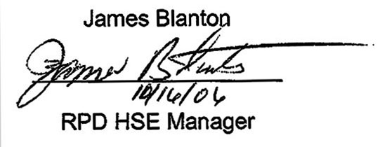
James Blanton

____________________

RPD HSE Manager

Shell Exploration & Production Company

Document Number |  | Title
HSE0078 |  | Personal Protective Equipment (PPE)
HSE0078-PR01 |  | Personal Protective Equipment (PPE) Requirements
HSE0078-PR01-TO.01 |  | Safety Shoe Reimbursement
HSE0078-PR01-TO.02 |  | Reference and Companion Documents
HSE0078-PR01-TO.03 |  | Certification of Hazard Assessment
HSE0078-PR01-TO.04 |  | Safety Glasses Program
HSE0078-PR01-TO.05 |  | FRC Reimbursement
HSE0078-PR01-TO.06 |  | Vision Correction for VDT Users
HSE0078-PR01-TO.07 |  | FRC Laundering Instructions

TOOL HSE0078-PR01-TO.04: SAFETY GLASSES PROGRAM

DW GOA EMPLOYEES
DW-GOA will provide one pair of clear and one pair of tinted prescription safety glasses, or one pair of transition prescription safety glasses per employee, per calendar year.

Order form and instructions for DWGOA employees requiring prescription safety glasses may be found at:

https://us.hoyasafety.com/order/e-form.asp?OBN=5100295&ShowSCCID=0

Note – Effective 9/17/2012, credit card (GCC or personal) is the only form of payment accepted; not providing credit card information will result in order rejection.

PARTICIPATION EYE CARE PROFESSIONALS
Participating eye care professionals may be found through the vendor website located at: https://us.hoyasafety.com/locator/e-form_default.asp

VISION CORRECTION FOR VIDEO DISPLAY TERMINAL (VDT USERS

BACKGROUND
- Some individuals experience eye discomfort when using VDTs. In certain cases, that discomfort can be relieved by using special glasses. An eye care professional can assist in determining if special glasses will relieve an individual’s eye discomfort.
- DW-GOA employees who need vision correction to comfortably operate a VDT are encouraged to purchase and wear appropriate vision correction.

COSTS COVERED
- The company will reimburse up to $250 of the cost for lenses and frames meeting the criteria of these guidelines.
- This price is based on typical cost for a pair of single vision plastic lenses with basic frames and ultraviolet and scratch resistant coatings.
- Employees may choose to supplement the reimbursement (with their own funds) to purchase more expensive options (e.g. bifocals, designer frames, contact lenses).

QUALIFICATION CRITERIA
To qualify for reimbursement, both requirements must be met:
Job Requirement
- The employee must be a user of a VDT that has been provided by the company for use in performing assigned work.
- The employee must be able to show that his/her job requires a minimum of 2 hours of VDT use per day, on average.
Prescription Specification
Prescription glasses will be reimbursed only if, in the opinion of a licensed Optometrist or Ophthalmologist, they are necessary to correct a disorder such as Presbyopia, eye alignment problems, or other conditions that make it difficult to focus on normal VDT viewing distances and angles.

EYE EXAMINATIONS
- Employees who use VDTs are encouraged to get eye examinations every
2 years or whenever they feel visual discomfort.
- The eye examination must be conducted by a licensed Optometrist or Ophthalmologist, selected by the employee and performed at the employee's expense.

Employees are expected to provide their eye specialist with all necessary information regarding their work habits, workstation arrangement, and any problems they may already be experiencing. An example worksheet is attached to assist employees in providing this information.

REIMBURSEMENT REQUEST
Use the two-section VDT Eyewear Reimbursement Request form to provide information to the examining Eye Specialist and to obtain your reimbursement.

WHERE TO SUBMIT THE FORM
Submit the completed VDT Eyewear Reimbursement Request Form to the HR Online – Create a Case

FREQUENCY
- The frequency of company reimbursements for purchases is limited to once every 2 years except when:
  - A new eye examination shows that the employee’s prescription has changed, and new glasses are needed, or
  - The employee’s glasses are damaged in an on-the-job incident.
- Prescriptions used in company funded glasses purchases must be current (not more than 12 months old).

SAFETY GLASSES WEARERS
- If you routinely wear safety glasses, you may want to obtain a prescription that protects your eyes and accommodates your vision needs at the VDT.
- To obtain safety glasses for both needs, you should use DW-GOA’s Hoya Vision Safety Glasses Program.
If you need prescription safety glasses, see below for instructions on how to order prescription safety glasses.
- Shell uses HOYA program for ordering prescription safety glasses.
Click on the following link: https://us.hoyasafety.com/order/e-form.asp?OBN=5100295&ShowSCCID=0 to fill out the required form. Fill out only the required fields and click on 'View E-Form
- Complete the form
- ​You will need signature approval from your line manager or supervisor
- See Special Instructions note in orange
- In order to pay with your GCC, you will need to register your credit card (only first-time users) in the HOYA program to get a Security Credit Card ID that will need to be entered in the Employee SCCD# field.
- ​To obtain this SCCD #, click on the following link and fill out the form: https://us.hoyasafety.com/gettoken​
- Then, click on Register Token. A confirmation message will show up
- Enter Security Credit Card ID # in the HOYA Safety Division Form shown on Step 2.
- You will need to fill out the prescription section on the HOYA Safety Division Form by using your updated prescription (contact your primary eye care doctor to get this information)
- After the HOYA Safety Division Form is finally complete. Contact one of the HOYA Eye Care professionals in your area to schedule an appointment to order your glasses. You will need to bring a physical copy of this form and your Shell ID to the appointment.
- To see nearby HOYA Eyer Care professionals in your area and their contact information, please visit this link: https://us.hoyasafety.com/locator/e-form_default.asp

VDT EYEWEAR REIMBURSEMENT REQUEST FORM
Section 1 - VDT Glasses Reimbursement (To be completed by employee)
Enter the information below then attach your receipt of purchase for a pair of qualifying video display terminal (VDT) glasses purchased on / / (date).
NOTE: The reimbursement amount must be preceded by a negative (-) sign. If the negative sign is omitted, a deduction instead of a reimbursement will result. Please forward this sheet to the HR Service Desk for reimbursement

Submit cases for specialized support: HR Online – Create a Case
For external parties or if you are an employee without access to the Shell network, you may contact HR by submitting a webform through: Contact HR | Shell Global.

I request that the reimbursement be applied to my payroll check, as follows:

PRICE OF LENSES & FRAMES: $ SALES TAX: $
(Attach receipt, retain a copy)

REIMBURSED COST ($250.00 max.) $
(Equal to lesser of total cost of glasses or $250.00)

EMPLOYEE CONFIRMATION:
I confirm that this purchase 1) qualifies for the reimbursement per the “Vision Correction for Video Display Terminal Users” program; and 2) has not been previously reimbursed during the past 2 years.
Employee Signature:
Employee Name (Please Print):
Employee Number:
Date: / /
OPTOMETRIST/OPHTHALMOLOGIST OPINION:

In my opinion, this prescription is necessary to correct a disorder such as Presbyopia, eye alignment problems, or other conditions that make it difficult for the employee to focus on normal VDT viewing distances and angles described to me on the following page.

_________________________________
Optometrist/Ophthalmologist Signature

Section 2 – VDT Glasses Worksheet
This form will help you describe your workstation, work habits, and any problems you may be having with your Optometrist or Ophthalmologist.
Workstation
Measure your workstation according to the diagram below. (It will be easiest to have a co-worker make these measurements while you are seated at your workstation.)
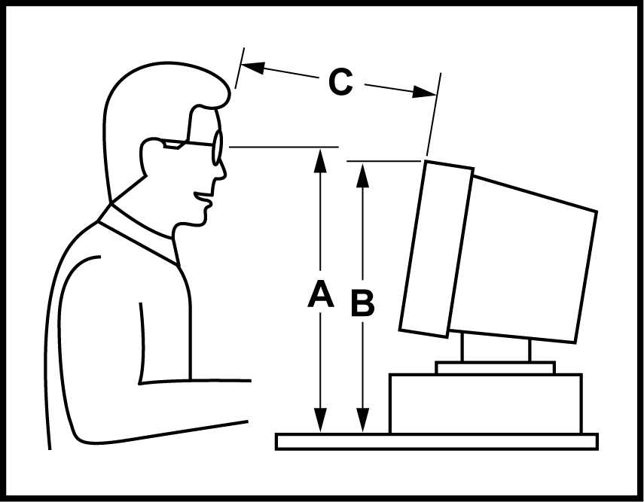

A. Height of eye above desktop: ____ inches
B. Height of top of screen: ____ inches
C. Distance from eyes to screen: _______inches
Work Habits
Describe the type of work you do at your computer workstation (e.g. word processing, drafting, or other graphics intensive work):
How many hours per day? _________
Description of Problems
Describe any problems you have been having (e.g. headaches, neck aches, backaches, blurred vision, double vision, difficulty in focusing, tired eyes, sore eyes):

TOOL HSE0078-PR01-TO.05: FLAME RETARDANT CLOTHING (FRC) REIMBURSEMENT

QUALIFIED EMPLOYEES
The DW-GOA FRC Subsidy Program applies to all DW-GOA field personnel required to wear FRC as part of their job, and to other employees who are required to visit field locations regularly for business purposes.

PREFERRED VENDORS
DW-GOA has designated Bulwark as the preferred vendor for flame-resistant clothing (FRC) purchases by DW-GOA employees.

Utilizing a preferred vendor ensures:

- Access to a Shell-specific catalog of approved items.
- Compliance with DW-GOA FRC standards.
- Simplified administration of the FRC subsidy program.

Employee flexibility to manage their own FRC purchases within the subsidy guidelines.

AMOUNT OF SUBSIDY
DW-GOA will provide a subsidy to cover the cost of a reasonable number of FRC garments that complies with NFPA 2112 for Shell employees and interns. The subsidy amount is based on the individual’s work environment and categorized as follows:
- Full-Time Employees assigned to an offshore location: $500/per calendar year
- Full-Time Employees assigned to an office location who regularly visit field sites for business purposes: $250 per calendar year
- Spring/Summer/Fall interns: $250/internship

ALTERNATIVE REIMBURSEMENT PROCESS
If an individual is unable to purchase FRCs through the preferred provider, supervisor approval is required before placing an order outside the DW GOA FRC program. All purchases must be made using the company credit card and processed through the standard expense reporting procedures.

The maximum allowable subsidy for purchases outside the program remains consistent with the limits established under the DW GOA FRC program. Every effort should be made to utilize the established program whenever possible.

TOOL HSE0078-PR01-TO.07: FRC LAUNDERING INSTRUCTIONS
(Double-click image to open PDF)
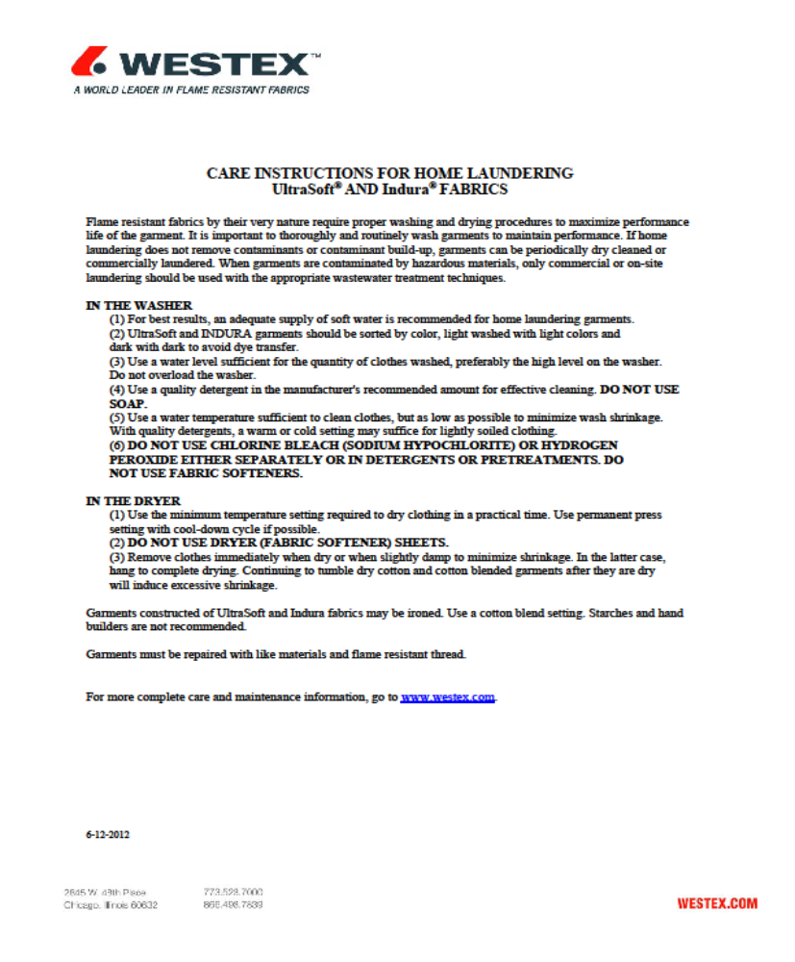

GLOSSARY
Term | Definition
ANSI | American National Standards Institute
ASTM | American Society for Testing and Materials
Hierarchy of Hazard Controls | Preferred order of control measures for hazards whereby hazard elimination equals controlling the hazard at its source.
JHA | Job Hazard Analysis
JSA | Job Safety Analysis
Local PPE Hazard Assessment | An evaluation of task and/or work environment hazards conducted at a DW-GOA location, including assessments such as JSAs and JHAs.
SDS | Safety Data Sheet
OSHA | Occupational Safety and Health Administration
PFD | Personal Flotation Device
PPE | Personal Protective Equipment
RAM | Risk Assessment Matrix
DW-GOA | Deep Water Production
USCG | United States Coast Guard
Operating Unit | Includes locations at which drilling, production, construction, warehousing, and terminal activities take place. Locations such as office complexes and training/medical facilities are not considered “operating units”.

REFERENCE AND COMPANION DOCUMENTS
Documents in this suite are listed in the table below.
Document Number | Title
Shell Documents
OPS0011 | Marine Transportation
OPS0081 | Safe Practices of Aviation Operations
HSE0051 | Federal OCS Waters (Western GOM) Environmental Compliance Manual (ECM)
HSE0097 | Federal OCS Waters (Eastern GOM) Environmental Compliance Manual (ECM)
HSE0131 | Waste Management for Federal OCS Western GOM
HSE0005 | Respiratory Protection
HSE0007 | Hearing Conservation
HSE0011-PR01 | Hazardous Communication (HAZCOM) Program
HSE0038-PR01 | Electrical Safe Work Practices
HSE0044-PR01 | Fall Protection
HSE0030 | Hydrogen Sulfide (H2S) Safety
OPS0096A-PR01 | Welding/Burning on Offshore Production Platforms and Drilling/Workover Rigs
OPS0103A-PR01 | Radiation Safety
OPS0191-PR01 | Blasting and Coating Best Management Practices Plan
Government Regulations
OSHA 29 CFR 1910.132 | (Personal Protective Equipment) General requirements.
Industry Standards
ANSI Z87+ | American National Standard for Occupational & Educational Personal Eye & Face Protection Devices
ANSI Z89.1 | American National Standard for Industrial Head Protection
ASTM F2412 | Standard Test Methods for Foot Protection
ASTM F2413 | Standard Specification for Performance Requirements for Foot Protection
NFPA 2112 | Standard on Flame-Resistant Garments for Protection of Industrial Personnel Against Flash Fire, 2007 Edition
Except for respiratory PPE, HSE0078-PR01 identifies minimum PPE required at all DW-GOA operating units. Additional task-specific PPE is addressed in the documents listed below. The list is not all-inclusive.

