Procedure

Fall Prevention and Protection
- Introduction
- Target Audience
- Roles and Responsibilities
- Methods and Requirements for Fall Prevention
- Methods of Fall Prevention
- Fall Prevention Requirements by Situation
- Planning Fall Prevention and Fall Mitigation
- Fall Protection Plan
- Pre-Job Safety Planning
- Physical Structures/Site Conditions Fall Prevention Requirements
- Handrails and Guardrails
- Barricading
- Temporary Deck Penetrations
- Leading Edges Controlled Access Zones
- Temporary Signs, Tapes, and Warnings
- Scaffolding and Temporary Platforms
- Personnel Work Baskets
- Rope Access
- Contractor Requirements
- Ladders
- Fixed Ladders
- Ascending and Descending Ladders
- Emergency Escape Ladders
- Portable Ladders
- Ladder Inspection
- Fall Arrest Systems
- Overview and General Requirements
- Anchor Systems
- Full Body Harnesses
- Lifelines
- Lanyards, Connectors and SRDs
- Fall Distance and Clearance Calculation
- Special Considerations for Fall Prevention and Protection
- Special Considerations
- Drilling and Completions Operations
- Equipment Inspection, Maintenance, Marking, and Removal from Service
- Inspection and Maintenance
- Marking
- Removal from Service
- Equipment Documentation
- Documentation
- Training Requirements
- Introduction
- Training Requirements for Specific Individuals
- Auditing Requirements
Tools and Guidelines
- General Inspection Guidelines (GL.01)
- Glossary (TO.01)
- Fall Protection Planning Guide and Hazard Analysis (TO.02)
- Start-Work Check (TO.03)
- Equipment Inspection Form – Annual (TO.04)
- Equipment Inspection Form – Monthly SRL (TO.05)
- Air-Hydraulic Hoist Operations (TO.06)
- Rope Access Criteria (IRATA-SPRAT) (TO.07)
- Anchorages Matrix (TO.08)
- Fall Distance and Clearance Calculation (TO.09)
- Suspension Trauma (Orthostatic Intolerance) (TO.10)
- Single Point Suspension Scaffold Start Work Checklist (TO.11)
- Equipment Annual Inspection Log (TO.12)
- Horizontal Lifeline Inspection Form (TO.13)
- Personnel Work Basket Inspection Form Annual (TO.14)
- Ladder System Annual Inspection Checklist (TO.15)
- Aerial Lift Rules (TO.16)
- Single Point Suspension Transfer (TO.17)
Document Suite Map

1 Introduction

1.1 General

1.1.1 Purpose | This procedure describes the following:  - Policies, guidelines, and regulatory requirements that shall be followed to mitigate the risks associated with personnel working at heights, including confined spaces and welding habitats.  - Specifications for:  - Fall protection and  - Equipment construction, inspection, and use.

1.1.2 Scope | The following requirements/practices are detailed in this procedure:  - Job Planning  - Rescue  - Securing Openings in Elevated Decks  - Repair of Temporary Deck Penetrations  - Barriers and Barricading  Fall prevention techniques using the following are detailed in this procedure:  - Fall Protection Systems  - Ladders  - Scaffolds  - Decking  NOTES:  - Requirements stated in this Procedure are Deep Water - Gulf of Mexico (DW-GOM) policy, regulatory requirements, and industry practices.  - National regulatory stipulations for fall protection that are more restrictive may be applicable for specific situations.

1.1.3 Target Audience | This HSE Standard applies to the following:  - DW-GOM employees  - Drilling, Workover, and Completions personnel on DW-GOM properties  - Contract personnel on DW-GOM and contractor-operated DW-GOM facilities and locations, Offshore OCS, and Onshore locations

1.1.4 Contractor Requirements | Contractors on DW-GOM locations shall:  - Comply with this procedure. Where there is a conflict with the DW-GOM procedure and that company’s requirements, workers will comply with the stricter of the two.  - Provide fall protection equipment to all employees who are exposed to a fall while performing a task.  - Ensure equipment will meet or exceed all applicable regulations, standards, and guidelines.  Ensure that employees are adequately trained (provided certification from a professional organization) in the use, inspection, and maintenance of all fall protection equipment (see section  - 11 Training Requirements).  - Have a written rescue plan in place and have available all equipment necessary to facilitate a rescue.  Be adequately trained in the use of rescue equipment and proper rescue techniques required to complete a retrieval of personnel in a timely manner (see section  - 11 Training Requirements).

1.1.5  On-the-Job Monitoring of Contractors | - DW-GOM personnel are responsible for ensuring that contractors have been provided with adequate training.  - If contractors fail to observe minimum fall protection safety requirements, the DW-GOM foreman or supervisor must:  - Review DW-GOM fall protection polices with all contractor employees,  - Review Contractor Company fall protection policies with contractor supervisors and workers (if there are any conflicts, use the most stringent policies), and  - Shut down the job until the corrections are made and advise that services may be terminated for significant violations.

1.1.6 Referenced Documents | This table lists the references and regulations that apply to fall prevention and protection.

Regulation/Reference |  | Title
ANSI | A10.11 | Personnel and Debris Nets
ANSI | A10.22 | Safety Requirements for Rope-Guided and Nonguided Workers' Hoists for Construction and Demolition Operations
ANSI | A14.3 | Fixed Ladders
ANSI | Z359 | ANSI/ASSP Fall Arrest Systems Suite of Documents
ANSI | A14.1, A14.2, and A14.5 | Safety Requirements for Portable Wood, Metal, and Reinforced Plastic Portable Ladders
ANSI/ SIA | A92.2 | Vehicle-Mounted Elevating and Rotating Aerial Devices
ANSI/ SIA | A92.3 | American National Standard for Manually Propelled Elevating Aerial Platforms
ANSI/ SIA | A92.5 | American National Standard Boom-Supported Elevating Work Platforms
ANSI/ SIA | A92.6 | Self-Propelled Elevating Work Platforms
ASME | B30.23 | Personnel Lifting Systems
ASME | B30.9 | Slings
API RP 2D (5.2.4b) |  | Offshore Cranes
USCG | 33 CFR  Subchapter N | Part 142,  (OCS Facilities) | Subpart B – Personal Protective Equipment, 142.42 Safety Belts and Life Lines
USCG | 33 CFR  Subchapter N | Part 142,  (OCS Facilities) | Subpart C – General Workplace Conditions, 142.87 Guarding of Deck Openings
USCG | 33 CFR  Subchapter N | Part 143,  (OCS Facilities) | Equipment and Design, Subpart B, OCS Facilities 143.110 Guards and Rails
OSHA | 3146 | Fall Protection in Construction
OSHA | 29 CFR | 1910.146 Permit Required Confined Spaces
OSHA | 29 CFR | 1910.21–23 General Industry
OSHA | 29 CFR | 1910.28 Safety Requirements for Scaffolding
OSHA | 29 CFR | 1915 Maritime Industry
OSHA | 29 CFR | 1917.119 Portable Ladders
OSHA | 29 CFR | 1926(i)(4)
OSHA | 29 CFR | 1926.106 Working over or near Water
OSHA | 29 CFR | 1926.450 Subpart L Scaffolds
OSHA | 29 CFR | 1926.451 General Requirements
OSHA | 29 CFR | 1926.500 Subpart M Construction Industry, Fall Protection
OSHA | 29 CFR | 1926.1431 Hoisting Personnel
OSHA | 29 CFR | 1926.1501 (g) Crane or derrick suspended personnel platforms
OSHA | 29 CFR | 1926.650-652 Subpart P Excavations
BSEE | 30 CFR 250 | Oil and Gas and Sulfur Operations in the Outer Continental Shelf
DW-GOM |  | - HSE0004A Management of Change (MOC)  - HSE0084 Control of Work  - HSE0078 Personal Protective Equipment (PPE)  - HSE0136A-PR01 Manual of Permitted Operations (MOPO)  - OPS0055 Lifting and Hoisting  - OPS0033 DW-GoM Facility Requirements Below Main Deck  - OPS0230 Prevention of Dropped Objects  - UAD-101-068  - Human Factors Engineering DEPs

1.2 Roles and Responsibilities

1.2.1 Roles and Responsibilities | The table below contains requirements for roles related to this procedure.

Role | Responsibility
DW-GOM HSE with the assistance of the Author and Curator of this Procedure | Maintain and monitor the performance of the requirements.
Document Custodian | Review the procedure periodically, at least every 5 years, to ensure regulatory and industry standards are met.
DW-GOM Operations Personnel | - Ensure that all requirements for fall protection are managed in accordance with this procedure.  - Monitor activities.  - Conduct periodic audits.  - Identify deficiencies in compliance.
Line Management (includes OM, OIM, Field Supervisor, Plant Supervisor, Wells/ Completions Supervisor, Wells/Completions Foreman, Construction Supervisor) | - Ensure proper implementation of this procedure.  - Assist in the development of local Fall Protection Plans and Rescue Plans and grant variances when circumstances warrant.  - Provide for the identification of fall hazards in the workplace, equipment selection, and availability.  - Ensure all DW-GOM personnel are adequately trained and retrained as necessary.  - Audit the performance of DW-GOM and contract personnel.
DW-GOM HSE and Operations/Field/Wells HSE | - Assist in implementation of this procedure and development of Fall Protection Plans and Rescue Plans.  - Audit for compliance and make recommendations for correcting deficiencies.  - Assist with employee training and retraining as necessary.  - Act as Competent Persons, conduct annual equipment inspections, and maintain documentation of the inspections.
Qualified Person (QP) | An individual who:  - possesses a recognized degree, certificate, or professional standing, or  - has demonstrated, by extensive knowledge, training, and experience, the ability to resolve problems relating to the specific task or project.
Competent Person | An individual who:  - is knowledgeable of applicable standards through training and/or experience,  - is capable of identifying workplace hazards relating to the specific operation,  - is designated by the employer, and  - has the authority to take appropriate actions.

NOTE:
- The Management of Change (MOC) process is to be used when seeking a variance

2 Methods and Requirements for Fall Prevention

2.1 Methods of Fall Prevention

2.1.1 Recognizing Fall Hazards | All personnel must be able to recognize where fall hazards exist, which may include the following:  - Uneven surfaces  - Obstacles or clutter  - Elevated work areas  - Inadequate handrails  - Inadequate barricades around a deck opening or edge  - Improper climbing equipment  - Fall protection equipment failures

2.1.2 Fall Prevention Method Order | Mitigate fall hazards by using fall prevention methods in the order listed in this table.
  Order | Method
  1 | Eliminate fall hazards (e.g., reposition equipment and valves through engineering to avoid work at heights).
  2 | Use traditional fall protection design (e.g., handrails and guardrails) on permanent platforms.
  3 | Work from temporary or moveable platforms that are properly secured.
  4 | Use fall restraint systems (e.g., barricades or restraint lines that prevent personnel from reaching the fall hazard).
  5 | Use fall arrest systems, ladder climbing systems, or other systems designed to “catch” personnel when the possibility of a fall cannot be prevented.

2.1.3 ALARP | When planning work, consider the highest level of control in the hierarchy and demonstrate that the chosen method for fall prevention offers risk as low as reasonably practicable (ALARP).

2.2 Fall Prevention Requirements by Situation

2.2.1 Fall Arrest System Mandatory Requirements | A fall arrest system is a system that will stop a worker’s fall before the worker contacts the surface below. The following are situations where 100% continuous attachment fall arrest systems are required (see methods for using fall arrest systems in section 6 Ladders of this procedure):  - Working ≥ 6' (1.8 m) above a working surface not protected by handrails or guardrails (measured from the deck to where the individual is standing or sitting while performing work).  - Working near or above handrails or guardrails where the potential to fall over or outside the protected area exists, regardless of the height.  - Ascending or descending uncaged ladders to a height > 6' (1.8 m) and not accessing a properly guarded landing.  - Ascending or descending fixed ladders, caged or uncaged, to a height > 20'.  - Ascending or descending ladders with or without cages regardless of height, where a risk assessment has determined a fall arrest system is required.  - Working from portable ladders ≥ 6' (1.8 m) in height.  - Accessing flare and communications towers, flare booms, scaffolds, and temporary platforms.  - Performing stationary maintenance on a ladder ≥ 6' while working ≤ 6' from a handrail.  - Exposed to an open hole or within 6 feet or 1.8 meters of a Flat Roof or platform edge without a guardrail; or on any Pitched Roof regardless of proximity to the edge.  - Working over water, on column tops that do not have handrails, at the +12 level of offshore platforms, river crossings, or other over-water situation. Use fall arrest system in addition to a USCG-approved life jacket/work vest for over-water situations  - Working from or riding in lifted personnel platforms attached to the crane boom:  - When working in a lifted basket over a deck, tie-off to the basket is required.  - When working in a lifted basket over water, tie-off is not recommended (29 CFR 1926.106).  - When working from Single Point Powered Scaffold or similar devices, use a vertical lifeline that is attached to a separate anchor from the Single Point Powered Scaffold.  - Walking or working on roofs < 6' from an unprotected edge.  - Working near excavations ≥ 4' deep.  - Working on top of vessels, transporters, and road and rail tankers that do not have platforms and/or guardrails.  - Exposure to any other fall hazard exists.  - Accessing and/or performing work on scaffolds.  - During work activities below the 6' (1.8 m) level where a fall hazard exists, by means of a full body harness attached to a Self-Retracting Device (SRD) or lifeline.  - Tool lanyards, tool pouches, netting materials and other small object control measures shall be employed to manage dropped objects as is required in OPS0230 Prevention of Dropped Objects in production Operations.

2.2.2 Work Near Handrails | When working at height in close proximity to a handrail (≤ 6') and at a height that will allow the individual to fall over the handrail to the lower deck, fall protection is required.  The closer an individual is to the handrail when at height the more likely the center of mass for a person’s body is high enough to carry a person over the railing should a fall occur. One scenario is an individual 2' from a handrail on a ladder or stand 2' in height, the individual’s upper body mass is at such a height that, should the individual fall back or on to the railing, the individual could fall over the hand rail to the lower level. An assessment of the situation can determine if an SRD or lanyard attached to the full body harness will provide protection or if a positioning strap or attachment device can be used. Regardless of the equipment used, fall protection is required.

2.2.3 Confined Space Entry | When working in a confined space all requirements of this procedure shall be followed.

2.2.4 Towers and Flare Booms Fall Protection Requirements | - Work on towers and flare booms is defined as climbing on structural parts of the derrick, masts, communication towers, and flare towers/booms.  - Flare booms shall require fall protection due to the steep angle of the stairway structure and the risk of falls into the water.  - Follow these requirements:  - Use fall protection.  - Install retractable lanyards or cable devices.  - Follow HSE0078 Personal Protective Equipment for personal flotation devices requirements.

2.2.5 Excavations Fall Protection Requirements | - Fall protection methods such as the following shall be provided when work will be performed near to excavations that are ≥ 4' deep:  - Barricades  - Guardrails  - Fences  - Strict adherence to OSHA 29 CFR 1926 Subpart P (1926.650 – 1926.652) and applicable appendices is required.

2.2.6 Open Pit Mining Fall Protection Requirements | - Locations where open pit mining is in progress have a constantly moving leading edge, which cannot be effectively barricaded. Therefore, open pit mining requires an appropriate level of security and exclusion zones to prevent personnel from approaching and falling into an open pit.  - Methods to prevent unauthorized access shall include:  - exclusion zones (such as fencing the entire work location),  - site security (such as locks), and  - appropriate warning lines.

3 Planning Fall Prevention and Fall Mitigation

3.1 Fall Protection Plan

3.1.1 Fall Protection Plan | This procedure is designed to serve as the overall DW-GoM Fall Protection Plan that details fall hazards and fall prevention methods and protection specific to work at height activities at the facilities. The procedure defines routine tasks, fall protection requirements, and rescue procedures for personnel performing tasks while at height.

3.1.2 Fall Protection Plan Requirements | A complete Fall Protection Plan for your location should address the following:  - Fall hazards expected in the workplace  - Fall prevention/protection system(s) to be used in each area  - Procedures to assemble, maintain, inspect, use, and disassemble the system(s)  - Procedures for rescue of workers who have fallen and are suspended by a personal fall arrest system or net and are unable to effect self-rescue  - Location of rescue equipment to be used if a rescue operation is required  NOTE: The plan shall be updated with site condition changes and work activity changes.

3.2 Pre-job Safety Planning

3.2.1 Overview | - During the planning phase of a new project, major construction project, or facility upgrade, the planning group should assess the work at height requirements necessary to facilitate the project and include fall protection and prevention measures in the project Safe Work Plan  - This planning should include measures to eliminate the fall hazard through engineering design (e.g., identifying and including fixed anchor points or horizontal lifelines in the design).

3.2.2 General Requirements | - Work at heights must include a risk assessment part of the pre-job safety planning (see 3.2.3).  - A Rescue Plan shall be attached to the work permit/JSA for all work at heights.  - Non-routine tasks require a work permit; working at heights above 6 ft (excluding flare booms/ tower, below column tops or other hazardous location deemed by asset leadership) may require a JSA only.

3.2.3 Risk Assessment | Complete a Risk Assessment for the job as follows:  - Refer to HSE0084 and Tool HSE0044-PR01-TO.02 Fall Protection Planning Guide and Hazard Analysis to aid in assessing what risks are associated with the task, hazard exposure analysis, and equipment selection for complex or infrequent tasks and work.  - Tool HSE0044-PR01-TO.02 can also be useful in determining the value of modifications to equipment, processes, or procedures to reduce or eliminate fall hazards.  - Developed procedures shall demonstrate that the chosen controls mitigate the risks to ALARP.

3.2.4 Rescue Plan | As part of the pre-job planning, prepare a Rescue Plan. Use the following table to ensure a complete Rescue Plan.

Type | Requirements
General | - Procedures for prompt emergency response, which minimizes:  - duration of worker suspension as a result of a fall, and  - medical response time.  - Procedures written in simple, easy-to-understand format.  - Safety precautions.  - Details of an easy-to-execute rescue.
Fall Arrest System | - The primary system of a full body harness and attachments used by the rescuer.  - A back-up fall arrest system for worker in need of rescue.  - Use of an SRD or similar device recommended.
Rescue Equipment | - All rescue equipment needed for rescue shall be available at the work site before any work at heights begins.  - Pre-rigged mechanical retrieval systems are preferred.  - Equipment should be designed and rated for a minimum of two persons.
Not Easily Accessible Areas | Special consideration is required in situations where workers may be suspended in areas not easily accessed by rescue personnel (e.g., under +45 level of platforms, flare towers).
NOTE: Refer to HSE0084 in preparing the entire Safe Work Plan. This table details the Rescue Plan section ONLY.

3.2.5 Pre-Job Consultation with Team Leader | If the pre-job planning identifies areas where total compliance with the safety requirements cannot be achieved, the OIM/PIC must be consulted prior to starting the job.

3.2.6 Plan Execution | The equipment and personnel identified in the approved Rescue Plan shall be at the work site and available upon execution of the work at heights.

4 Physical Structures/Site Conditions Fall Prevention Requirements

4.1 Handrails and Guardrails

4.1.1 Overview | All stairways and elevated walking/working areas shall be equipped with handrails or guardrails that meet or exceed requirements of the following:  - OSHA  - USCG  - Bureau of Safety and Environmental Enforcement (BSEE)  - UAD-101-068 and underlying DEPs  - Applicable Human Factors Engineering DEPs  - Consult the HSE0044 Custodian or DW-GoM Civil Group for guidance  Elevated work platforms shall be equipped with handrails, mid-rails, toe boards and a self-closing, double-bar swinging gate closure (or equivalent) installed at each landing.  NOTE: Elevated walking/working areas are defined as locations that are 6' above normal working surfaces or where a fall hazard exists.

4.1.2 Requirements | Refer to UAD-101-068 for handrail design and construction requirements.  NOTE: Connecting any fall protection system to handrails or guardrails is prohibited as per section 7.2 of this Procedure.  Review the table below for handrail/guardrail inspection requirements and further references.

Inspection | Details
Frequency | Annually (per BSEE and USCG)
Checks | Shall be free of:  - corrosion,  - sharp edges,  - gaps or holes, and  - deformities
Corrective Action | - Repair immediately or replace.  - Securely barricade until repairs are completed.  NOTE: Refer to the DW-GOM Asset Integrity Standard for details.
References:
- USCG Subchapter N, Subpart B (OCS) Facilities) 143.110
- OSHA 1910. 21 – 23, General Industry and OSHA 1926.501-502, Construction Industry
- BSEE 30 CFR 250
- UAD-101-068
- Human Factors Engineering DEPs

4.2 Barricading

4.2.1 Guidelines | Barricades must:  - be constructed in such a way that personnel cannot inadvertently get through;  - meet the handrail standards for top rail, mid-rail, and toe boards (see handrail requirements);  - use a minimum 3/8" cable, adequately tightened to provide proper support, or other suitable material such as pole barricade or scaffolding;  - be surrounded by securely attached fluorescent orange fencing;  NOTE: Plastic or wire mesh fencing of adequate strength may be used in place of a mid-rail if adequately secured in place at each corner, but posts and top rails must comply with all handrail requirements.  - be set up on all unprotected sides or edges of the work area;  - be strong enough to prevent personnel from falling through into the opening (if in close proximity to the opening);  - have only one entry/exit point;  - preferably have some form of closure or removable section for access;  - be identified with signs or flagging at no more than 6' intervals;  - take up as little workspace as possible around the deck opening;  - be erected 5' from the closest edge of the opening when personnel are working inside the guardrail; and  - be erected to prevent access to the hole when personnel are not working inside the guardrail (however, the 5' perimeter is not required).

4.3 Temporary Deck Penetrations

4.3.1 Deck Penetration Plan | Activities that create holes in the deck creating fall hazards require a Deck Penetration Plan. Examples of these activities include:  - Drilling  - Workover  - Coiled tubing  - Construction  The Deck Penetration Plan should be included in or attached to the overall work plan or work permit for the project as required by HSE0084.

4.3.2 Deck Penetration Plan Requirements | The plan should include:  - equipment layout;  - penetration location, size, and identification;  - fall prevention provisions; and  - repair plan.

4.3.3 Deck Penetration Barricade Requirements | Barricades for deck openings shall meet the following requirements:  - The USCG and OSHA regulations require that all deck openings shall be:  - covered,  - guarded, or  - made inaccessible.  - Install the barricade or guardrail before making the opening.  NOTE: Personnel shall wear fall arrest equipment before and during making an opening in the decking of a platform.

4.3.4 Hole Covers | All hole covers shall be:  - of adequate size and strength,  - secured to prevent displacement, and  - color-coded or marked “HOLE” or “COVER.”  Hole covers fashioned from wood or wood products shall be dated upon installation and replaced with a permanent hole cover constructed per 4.3.5 or with new decking equal to original installation within 180 days.  A deck survey shall be conducted by the location periodically, at least every 180 days, to ensure that wood or wood product hole covers are removed, all hole covers are secured and properly labeled, and repairs are completed per 4.3.5.  NOTES:  - Hole covers shall be able to support at least twice the weight of personnel, equipment, or materials that may be on the cover at any time.  - Hole covers shall not be removed without approval.

4.3.5 Penetration Repairs | - Repairs to any penetrations shall ensure that all decking is returned to an equivalent of the original and presents no additional tripping or slip hazard.  - Repair material must be:  - equal to size and dimension of original decking material,  - cut to fit,  - framed in adequately sized angle iron, and  - painted to be visible and recognizable as a repair.  NOTE: At any time there are two or three repairs (approximately 12" x 12") to a single piece of decking, the entire sheet of material shall be replaced with a compatible material with comparable quality.

4.4 Leading Edges and Controlled Access Zones

4.4.1 Leading Edges | Leading edges must not be exposed. These include the following:  - Edges of decks, platforms, hatches, pits, excavations, and similar flat surfaces  - Edges ≥ 2' above a solid surface or the water surface  A leading edge is an unprotected edge of a platform, deck, roof, floor, or other work surface that may be above or adjacent to dangerous equipment. Examples include:  - lifeboat davit area when the lifeboat is not secured in the davit,  - an area where the handrail or guard rail has been removed for lifting/hoisting operations, and  - a walkway around a vessel, engine, tank or other item without proper handrail.  These are typically open-sided decks, platforms, landings, stairway floor openings, and walking or working surfaces that are more than 4' above the ground. However, fall protection may be required at a height less than the 4' after a risk assessment by local supervision and the Fall Protection Competent Person.

4.4.2 Controlled Access Zones | Controlled access zones shall be established to restrict personnel who are authorized to enter an area from inadvertently accessing the work site. These include the following:  - Areas where overhead work may take place  - Leading edges; areas where the leading edge is unguarded (e.g., capsule davit areas)  - Areas where hazardous work activities are performed  - Areas with existing hazards or exposures where restricted access is necessary

4.4.3 Methods: Barricades and Controlled Access Lines | - Adequate barricades must be erected to restrict access to potential fall hazards such as a leading edge or open hole. See section 4.2.1 for details.  - All barricades and controlled access lines shall be erected in accordance with guidelines as prescribed by:  - OSHA and  - USCG in 29 CFR 1910.21-23, 29 CFR 1926.502, and 33 CFR 143.110  NOTE: Perimeter guards shall not be removed without approval.

4.5 Temporary Signs, Tapes, and Warnings

4.5.1 Requirements | Areas where there is a slip/trip/fall hazard or activities that present a danger to employees must have temporary:  - flagging,  - signs, and  - control lines.

4.5.2 Temporary Warnings Table | The following table outlines requirements for temporary warnings.

Type | Purpose | Requirements
Folding Yellow Floor Signs | Restrict personnel from hazards. | Cones or collapsible fencing shall be placed to warn or restrict personnel from areas where there are wet floors, spills, and other hazards to signify that caution is required if access is necessary.
Yellow Caution Tape or Yellow Plastic Chain | Indicate jobs are in progress. | - With or without warning labels, yellow caution tape shall designate to workers that jobs are in progress and a hazard exists.  - Individuals must have the attention of workers in a taped/chained area before entering. If no one is inside the area, individuals must carefully evaluate the conditions and, if safe, enter with caution.
Red Danger Tape or Red Plastic Chain | Do not enter; indicates hazardous activities or identified hazards in the area. | - Restrict personnel from entry due to hazards in area.  - Do not barricade more area than is needed to safely accomplish the task.  - Only employees involved in the activity are permitted within the area (for activities such as pressure testing, load testing, overhead work).  - Stop work for entry by others.
Radioactive Tape (magenta and yellow) | Do not enter. | Radioactive tape shall be used to indicate activities involving radioactive materials are in progress (X-ray, NORM, logging). Radioactive tape can be used in conjunction with red danger tape or red plastic chain.

4.6 Scaffolding and Temporary Work Platforms

4.6.1 Temporary Work Platforms Definition | Where a permanent platform or structure protected by guardrails is not available, a temporary work platform with guards shall be used where practical and may include one of the following designs erected by a trained/certified individual:  - Scaffolding  - Rolling scaffolds  - Suspended scaffolds (includes spider baskets)  - Wire and cable systems (e.g., Suspended Systems)  - Aerial lifts

4.6.2 Scaffolds by Competent Person | All scaffolds shall be:  - constructed using an engineered certified design that complies with the requirements found in 29 CFR 1926 Subpart L - Scaffolds;  - erected, moved, dismantled, or altered under the supervision of a Competent Person. See 29 CFR 1926.451(a)(3);  - Modular/component scaffolds are scaffolds erected as a unit from manufacturer designed structural members, poles, legs, posts, brackets, frames, and uprights by trained personnel. Scaffold components shall not be altered without written consent of the manufacturer engineer qualified and competent in this field.  - Custom/Specific Use designed scaffolds shall be custom designed by a qualified engineer to fulfill a specific need and erected in accordance with the design requirements. Custom/Specific Use designed scaffolds shall not be altered without written consent of the design engineer qualified and competent in this field.  - erected with attachment to structural members of a platforms, buildings, or other structures that meet the OSHA 29 CFR 1926 Subpart L – Scaffolds specification 1926.451(a)(1) which states:  - “Except as provided in paragraphs (a)(2), (a)(3), (a)(4), (a)(5) and (g) of this section, each scaffold and scaffold component shall be capable of supporting, without failure, its own weight and at least 4 times the maximum intended load applied or transmitted to it.”  NOTE: Handrails shall not be used as a primary support; however, they may be used as a bracing attachment for stability under limited circumstances and after analysis by a qualified person or civil engineer.  - inspected by a Competent Person before daily use and/or at shift changes and tagged in accordance with a three-color tagging system (red, yellow, green, see 4.6.3 below) that displays:  - date of construction,  - inspector and erector signatures,  - workload rating in lb./ft²,  - special conditions or cautions, and  - dates of re-inspection.  - equipped with:  - handrail (height shall be 42" to 45"),  - mid-rail, and  - toe board; and  - equipped with proper access.  NOTE: When ladders > 6' in height are attached to scaffolds as a means of access, additional protection, such as an SRD, vertical lifeline, or other means of attachment is required.  All scaffolds shall have:  - access ladders that:  - extend 3' above the deck and  - provide breaks and a deck every 20' when the ladder is > 20' in length.  - material used according to manufacturer specifications; and  - one safe means of egress/access (a secondary means of egress/access is not required).  NOTE: Scaffold ladders are narrow and not always ideal; alternate means for reaching the upper levels should be looked into when designing and building the scaffold (e.g., building a walkway with handrails from a nearby upper deck is preferred over use of a ladder).

4.6.3 Scaffold Tag Tri-Color Systems | Scaffold tag tri-color systems shall be similar but not restricted to the following:  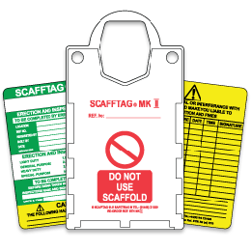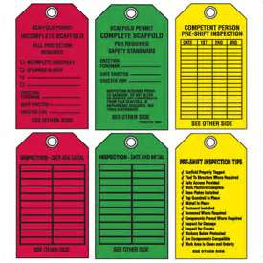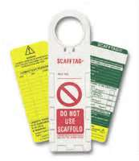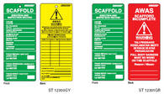  - Scaffolds that are erected and not in use shall be identified with a red tag indicating that the scaffold has not been inspected and is restricted from use.  - Scaffolds that will not be used for extended periods, 90 days or longer, shall be dismantled and components placed in storage unless justification for leaving in place is agreed upon with Shell Leadership and the Technical Authority.  - Scaffolds used for storage of materials and supplies shall be tagged with maximum load bearing capacity and signed by the competent person. These scaffolds shall be re-evaluated periodically, not to exceed quarterly, for compliance with weight capacity.  - A load bearing analysis shall be conducted on the area or space where materials are stored and weights on the structure documented with the location by the individuals erecting the scaffold or storage rack.  - Third-party contractors erecting and using scaffolding shall communicate to their work crews that load analysis and tagging is required for each unit erected on a location.

4.6.4 Scaffold Use | - Fall arrest equipment is required for access and egress of scaffolds.  - Fall arrest equipment is not required for scaffolds < 6' in height unless there are other hazards present, such as close proximity to handrails.  NOTE: Fall arrest equipment is not required while working within the handrails of a scaffold that is leveled and stabilized to prevent movement, is properly secured and supported, includes top rails and mid-rails with a toe board, is constructed under the supervision of a Competent Person in accordance with 29 CFR 1926 Subpart L - Scaffolds requirements, and has an approved local variance from fall arrest requirements.  - Fall arrest equipment is required while performing activities on scaffolds.  - Each worker must be protected by a safety harness and lifeline or SRD attached to a substantial structural member or rigged lifelines. In the absence of a substantial structural member, workers may utilize an SRD attached to a davit or approved strap that is secured to a main vertical member of a completed and inspected scaffold. (See Figure 1.) Workers shall not attach to other components of the scaffold, however, scaffold erectors may attach to upright (vertical) structural components with an ANSI-rated scaffold strap with D-ring connector and compatible snap hooks/carabineers or to anchors designed into the vertical utilizing a compatible hook of proper size and design that allows the anchor to rest in the top rear of the hook and not on the nose or gate, during the building and disassembly of scaffolds in accordance with OSHA 29 CFR 1926.451.  - No Pelican Hooks/Rebar hooks are permitted.  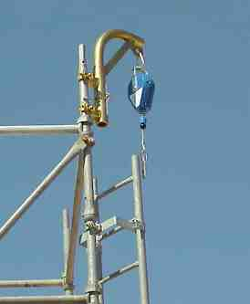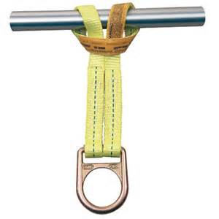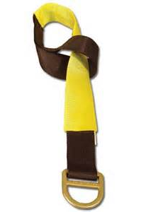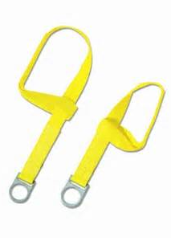  Figure 1 Safety Device Attachment Configurations  - Where overhead tie-off points (anchors) are not readily available, seek other options to properly protect personnel conducting activities on the scaffold, such as the following:  - Rig a horizontal lifeline  - Drop a vertical lifeline from upper deck  - Crane boom/line in limited applications  NOTE: Only after close examination of the available systems and methods of protecting workers performing tasks at height should a variance be sought. Once it is determined that conventional fall protection cannot be used supervisors must seek a variance to perform work without the prescribed fall protection. The variance shall state in writing why a conventional fall arrest system is not feasible and why a variance is requested. The variance shall also document the measures taken to reduce or eliminate the fall hazards to which the workers are exposed.  - Work shall not be performed on scaffolds during:  - Storms  - High winds  - Other weather related hazards, as deemed by the Competent Person or local supervision.  Refer to HSE0136A-PR01 MOPO for external influences determination.  NOTE: Under specific circumstances, as determined by location supervision after a risk assessment with management and engineering review, the use of scaffolds may continue with increased environmental forces once additional bracing on the scaffold structure, additional anchorage to platform structure, and the installation of netting around the scaffolding is affected.

4.6.5 Scaffold Maintenance | Any part of a scaffold that shows sign of deterioration or damage shall be immediately removed from service or replaced.

4.6.6 Single Point Suspension Scaffolds | Single point suspension scaffolds are personnel lift devices and shall not be used to lift equipment and materials other than personnel hand tools, and similar items necessary to perform work, including blast and paint hoses, etc.  Single point suspension scaffolds (spiders) used in Shell Operations must conform to 29 CFR 1926.451 and 1910.28.  A National-Recognized Testing Laboratory (NRTL) letter of conformance and a certificate of conformance shall be readily available.  Anchor points for single point suspension scaffolds used in Shell Operations must be designed in accordance with 29 CFR 1926.451. For pipe laid between 2 beams on the grating and used as anchor points, P.E. stamped calculations validating the span and load rating shall be available from the vendor upon request.  Single point suspension scaffolds shall be sent for inspection and recertification, at least semiannually (every 6 months), to the manufacturer or a manufacturer-approved and certified repair vendor.  Any removable single point suspension scaffold anchor points shall be sent for inspection and recertification at least annually to an appropriately-qualified manufacturer or inspector.  Single point suspension scaffolds shall not be left on offshore locations when jobs are suspended for 30 days or longer unless sheltered from the weather in a building or container.  Single point suspension scaffolds must meet the following design requirements:  - Tested and listed by a nationally recognized testing laboratory (e.g., UL/CUL Listed)  - Air Powered  - Provided with an emergency stop to isolate air supply in an emergency  - Minimum gross load capacity of 1000 lb. (453.6 kg)  - Over speed safety device in braking system per 29 CFR 1926(i)(4)  - Operator manual attached to unit  - Certification certificate attached to unit  - Equipped with a top limit switch with trip plate  The following requirements must be met for operations using single point suspension scaffolds:  - HSE0044-PR01-TO.11 Single Point Suspension Scaffold Start Work Checklist has been completed.  - Anchors, connections, and support equipment have been inspected and verified prior to use. Wire rope inspection has been documented. Suspension points are certified or approved by a Civil Engineer.  - Operator is trained in use of unit and fall protection.  - Work crew has at least two personnel (one person in the Single Point Powered Scaffold and one person on the ground watching hoses, lines, etc.).  - Independent lifeline is attached to separate anchor from basket.  - Lifelines and fall protection equipment have been inspected prior to use.  - Safety Zone below work area has been identified and properly barricaded.  - Operating air supply has been verified for adequate pressure prior to use.  - Supply hoses have been inspected for deficiencies prior to use.  - Hoists and controls are in proper working condition prior to use.  - Braking system and over-speed device operation has been verified prior to use.  - Single point suspension scaffold is anchored at desired height to prevent swaying.  - Basket is in good condition with no structural damage, cracks, frayed wires, etc.  - Fall Rescue Plan has been developed and approved.  - Rescue equipment is on location and rigged if conditions allow.  - HSE0084 requirements are complete and a signed permit is available at work location.  - Single Point Powered Scaffolds may be transferred from anchor to anchor at height (“walked”) with the following stipulations.  - The Single Point Powered Scaffold Transfer Procedure, TOOL HSE0044-PR01-TO.17, shall be followed.  - All personnel operating a Single Point Powered Scaffold shall be trained in the operation and use of the device per Manufacturer’s policy.  - Shell HSE0044 Fall Prevention and Protection procedures for 100% tie-off, anchor selection and PFAS selection shall be followed.  - The SWA and JSA for the activity shall include a review of the procedure, risks and mitigations for the basket transfer.  - Each component, beam clamp, transfer cable, connecting shackles, basket fairlead legs and guards shall be inspected prior to use. The inspection results shall be documented on the pre-use inspection log.

4.6.7 Wire and Cable Systems (Suspended Systems) | Suspended systems are independent cable rigging systems used to access the underside of the cellar decks (typically +45-foot elevation on fixed leg assets) and are a safe alternative to scaffolding in these specific applications.  The following requirements must be met for operations using suspended systems:  - Contractor must have a manual for the system which identifies the details of each component.  - Procedures for installing the suspended system must be developed specific to the location and will reference the contractor’s manual.  - Cables utilized in the suspended system will be of material not previously used and must be certified.  - All hardware, such as cable clamps, snatch blocks, shackles, and com-a-longs must be certified, and in good working order.  - System must be designed by a qualified engineer and erected in accordance with the design requirements. This design shall not be altered without written consent of an engineer qualified and competent in this system.  - Installation shall be completed under the supervision of a competent person.  - A mechanical dynamometer must be identified and utilized to gauge the tension for initial setup of cables to meet the requirements of the pre-load tension provided by the qualified person.  - A method for pre-shift tension checks of the cables will be identified with clear parameters.  - Horizontal lifelines utilized must meet the criteria found in section 7.4 of this standard.  - Pre-shift inspections of the system will be carried out and the documentation will be maintained by the contractor for the entire time the system is deployed.  - If required, safety nets shall be installed and tested as per 29CFR1926 Subpart M and section 8.1.2 of this standard.  - A pre use inspection will be completed by the competent person upon installation and prior to use.  - Workers are tied off 100% of the time.  - The maximum duration a Suspended System can remain in place is 60 days. An extension beyond 60 days will require a deviation with proper authorization as per section 1.2

4.7 Personnel Work Baskets

4.7.1 Design Requirements | Personnel work baskets must be built to the following industry standards:  - ANSI/SIA A92.2, A92.3, A92.5, and A92.6  - ASME B30.23  - OSHA 1926.1501 (g)  - ANSI A10.22  - OSHA 1926.1431  The following information must be marked on the interior of personnel work baskets and be legible from the outside:  - Manufacturer’s name and address  - Basket rating in terms of maximum weight and number of personnel allowed  - Identification number  - Weight of the empty basket  - Date of manufacture  - List of any unique operational environments for which it was designed.  A test certificate should be readily available.

4.7.2 General Requirements | The following is required for all lifting equipment:  - A preventive maintenance (PM) program based on manufacturers’ recommendations, which will document completed work and correction of deficiencies, must be implemented.  - A functional test must be conducted and documented after repairs or replacement.  - All critical components must be repaired or replaced promptly by or under supervision of a Qualified Person (QP).  - The maintenance program must be contained in SAP PM for DW-GOM-owned equipment. Contractors shall have a system in place for their equipment and maintain records on rental equipment as prescribed by applicable regulations.

4.7.3 Operations Requirements | Refer to ASME B30.23 for detailed operational requirements for operators and occupants. DW-GOM requirements are as follows:  - Occupant remains in continuous communication with the operator/designated signal person.  - Ensure personnel being lifted adhere to fall protection requirements.  - Do not stand, sit on, or work from the top rail or mid-rail or use any other device to enhance the vertical working height while in the basket.

4.7.4 Inspections | Personnel work baskets shall be inspected:  - Before each use/shift change,  - Once a month,  - Annually using the inspection form in Tool HSE0044-PR01-TO.14, and  - Before returning equipment to service after it has been idle, been placed on standby, or received repairs or modifications.  The QP shall perform and document inspections as follows:  - Check for defects (e.g., damage, distortion, cracks, corrosion, wear).  - Check suspension system, attachment points, and any motion controls.  - Identify conditions that have been specifically indicated by the manufacturer.  All work baskets deemed unfit for use by inspection must be:  - Tagged Do Not Use.  - Taken out of service and repaired/re-tested or destroyed.

4.7.5 Operational and Load Test | Operational and load testing shall be performed and documented before initial use and before each subsequent use. Documentation of these tests shall be kept on location by the owner for at least two test cycles and shall be made readily available.  The QP shall perform and document load tests as follows:  - At each new job site the platform and rigging must be proof-tested to 125% of the rated capacity before hoisting personnel.  - With the load evenly distributed in the basket, the platform must be hoisted and held in a suspended position for at least 5 minutes.  - After the test, a QP shall inspect the basket.  After any structural repair, the basket must be proof-tested to 150% of the rated capacity.  NOTE: Repairs or alterations to non-lifting or non-holding components do not require a load test, although a functional check should be performed to determine if the repairs or alterations are acceptable.

4.7.6 Wire Rope Slings | All wire rope slings must be manufactured in accordance with API RP 2D (5.2.4b) and ASME B30.9.  Field fabricated slings are not allowed.

4.7.7 Replacement Parts | An original equipment manufacturer (OEM) or other approved vendor shall supply parts or components.

4.7.8 Repairs | Structural repairs must be performed by qualified personnel in accordance with manufacturers’ recommendations and the applicable ASME B30 document.

5 Rope Access

5.1 Contractor Requirements

5.1.1 Overview | Rope access work at DW-GOM locations shall be performed by certified contractors.

5.1.2 Requirements | Contractors engaged in rope access shall:  - Be certified per the conditions set forth by the:  - Industrial Rope Access Trade Association (IRATA), or  - Society of Professional Rope Access Technicians (SPRAT), and  - Use equipment as stipulated in the above criteria. (Refer to Tool HSE0044-PR01-TO.07 Rope Access Criteria (IRATA/SPRAT).  NOTE: DW-GOM fall protection policies apply where activities that do not require rope access are performed.

6 Ladders

6.1 Fixed Ladders

6.1.1 Requirements | Fixed ladders (except emergency escape ladders) ≥ 20' shall be equipped with:  - Cages (to start at 7' to 8' to ensure adequate head clearance);  - Self-closing swing-gate closures with a top rail and a mid-rail, or equivalent, installed at each landing;  - A ladder climbing system;  - An alternate means of access (e.g., walkways, permanent or temporary stairs) should be installed in lieu of a ladder where possible to eliminate the fall hazard;  - A ladder climb/safety system; and  - A lanyard/attachment of 9" maximum is to be used on ladder climb systems.

6.1.2 Scaffold Ladders | - Fixed ladders built as part of a scaffold require additional safeguarding as defined in Section 4.6.  - Ladders attached on the outside of a scaffold for should be reviewed and alternate location or designs considered (i.e., inside scaffold frame, temporary stairs, or walkways from platform deck).

6.1.3 Ladder Climbing Systems | - Ladder climbing systems (ladder safety systems, safety-climbing devices) shall be provided for fall protection while ascending and descending ladders.  - Before using chain or rope ladders, verify that all other means of accessing the work area have been discounted as not Reasonably Practicable.  - Chain and rope ladders shall only be used with an inertia fall arrestor.  NOTE: These systems are not intended for use as a positioning device. When activities require an individual to perform work from a fixed ladder, a positioning device shall be attached to an appropriate anchor point.

6.1.4 Positioning Device Systems | A positioning device system (in addition to a fall arrest system) designed to support or position a person at the work level for hands-free work shall be used when working from a fixed ladder or work location where there is a potential for free fall.  The work positioning system shall be:  - designed such that a worker can fall no more than 2' and  - attached to an anchorage that can withstand 3,000 lb. of arresting force or twice the potential impact load of a worker’s fall.

6.2 Ascending or Descending Ladders

6.2.1 General Requirements | When ascending or descending ladders < 20' to access a landing that is properly guarded with handrails and a double bar gate, 100% tie-off is not required; however:  - Both hands and feet shall be free to allow three-point contact  - Worker shall face the ladder front, remaining inside the rails at all times.  - When ascending or descending ladders > 20',100% tie-off is required.  - Where landings are not fully protected, the individual must be secured by a fall protection system at all times.  - 100% fall protection is required when performing work from a ladder.  - A positioning device shall be used to allow hands-free work from a ladder.  - Where a ladder is within 6' of a platform edge and exposed to a lower deck or surface, 100% tie-off is required.  - Fixed ladders that are a part of scaffolding also require special consideration. Ladders that are outside the scaffolding structure in multilevel scaffolds or ladders built outside of scaffolds on facilities that are already at an elevated height can result in situations that create the potential for falls from the ladder that are much greater distance above the lower surface. These situations should be reviewed and alternate designs considered, such as locating the ladders within the confines of the scaffold, installation of safety-climbing devices, or providing an alternate means of access.

6.3 Emergency Escape Ladders

6.3.1 Requirements | Emergency escape ladders from upper decks, building tops, and equipment skids to decks and areas above the splash zone do not require the inclusion of a ladder climbing system, but they must have the following:  - Cage protection  - Identification by means of a sign with these characteristics:  - Red background color with white lettering  - Placed on or next to the top and bottom of the ladder  - Sign should state “Emergency Escape Ladder”  NOTE: This section does not apply to rungs or ladders attached to floating facility columns (e.g., TLPs, SPARs), or ladders in the splash zone from boat landings or similar landings to the water line.

6.4 Portable Ladders

6.4.1 Guidelines | Portable work platforms are recommended for use in lieu of ladders. Where portable ladders are used, they shall:  - Be structurally sound.  - Be inspected prior to use. Identify as unusable (with a tag and red flagging) and remove from service any portable ladders found to be unsafe.  - Have labels that designate capacity rating and instructions for use attached and legible. (Labels may be replaced by contacting the Manufacturer or distributor and providing purchase records to determine the ladder model.)  - Meet OSHA Standards and ANSI guidelines (29 CFR 1926 Subpart X Ladders, ANSI A14.1, A14.2, and A14.5).  - Allow only one person on a ladder at a time.  - Be of adequate length and design for the intended use.  - While ascending or descending ladders ≥ 6', use 100% tie-off.  - When performing work from a portable ladder ≥ 6', 100% tie-off is required.  - Be constructed from nonconductive material when used where the possibility of exposure to electrical components exists.  - Be used maintaining 3-point contact. Do not carry tools in hands while ascending or descending a ladder. Transport tools and equipment by:  - tool belt secured to body,  - raising and/or lowering by a rope, or  - handing by a coworker.  NOTE: For work inside buildings, the use of portable work platforms, narrow span scaffolding, and ladders designed with a work platform and handrails is recommended and preferred.

6.4.2 Safe Practice Requirements | Follow these safe practices when using an extension ladder:  - Face the ladder when climbing or descending.  - Be adequately secured at each end by straps, rope, or other suitable material to prevent movement.  - Be used at an angle such that the horizontal distance from the top support to the foot of the ladder is approximately 1/4 of the working length of the ladder. For access to an elevated work surface, extend the top of the ladder three feet above that surface.  - Keep shoulders and hips between the ladder side rails.  - When reach is greater than an arm’s length away, reposition the ladder. Do not lean out beyond the side rail.  - If not secured, ladders used indoors shall be held steady by a coworker.  Follow these safe practices when using a step ladder (applies to A-Frame Stepladders 6 feet and greater to a maximum of 20 feet)  - Ladder shall be held steady by a coworker. A-Frame stepladders are not designed to be tied down.  - Set the A-Frame stepladder on a level and stable surface.  - Never use the top step or the cap as a step.  - Never use the bracing on the rear of a stepladder for climbing.  - Never leave tools/materials on the ladder.

6.5 Ladder Inspection (For fixed ladder climbing systems)

6.5.1 Checklist | See Tool HSE0044-PR01-TO.15 Ladder System Annual Inspection Checklist for ladder inspection requirements.

7 Fall Arrest Systems

7.1 Overview and General Requirements

7.1.1 General | Fall arrest systems must:  - Meet ANSI Z359 requirements.  - Be constructed and used in such a way that the person’s fall is arrested with maximum free fall of 6' (ideally 1').  - Provide a maximum limit arresting force of 1,800 lb. with full body harness.  - Utilize self-locking, double-action snap hooks or triple-action, captive eye (pinned or permanent) carabineers.  - Be rigged to prevent contact with any lower surface or adjacent structures,  - Be fitted with suspension trauma prevention kit.  - Be removed from service 5 years after manufacture date if constructed of a synthetic web material (this Includes harnesses, lanyards, beam straps, SRD lines, etc.).  Fall rescue systems and equipment must:  - Be designed and rigged to accommodate the intended load during a rescue.  - Be fit for purpose, used as designed, and have personnel onsite trained in its use.  - Be one component of a complete Fall Rescue Plan.  - Be removed from service 5 years after manufacture date due to potential degradation of synthetic web material and rope.

7.1.2 Specifications | Elements and components used in personal fall arrest systems, subsystems and rescue systems (e.g., harnesses, lifelines, lanyards, SRD, drop lines, connectors) must meet the specifications found in the most recent publication of the ANSI Z359 standards (i.e., “Safety Requirements for Personal Fall Arrest System, Subsystems and Components”) and 29 CFR 1926 and 29 CFR 1910.

7.1.3 General Requirements | - All personnel shall protect themselves from a fall by using a personal fall protection system with continuous attachment.  - The fall arrest system must match the particular work situation.  - Proper use of fall arrest systems should ensure that the worker will not contact the deck or any obstructions in the event of a fall. To reduce fall arresting forces, the following should be ensured:  - Lanyards and attachments should be kept as short as possible.  - SRDs shall be used for activities <6' (1.8 m), where a fall potential exists. This includes, but is not restricted to, work outside the normal walking/ working surfaces, on equipment skids and bases, lower level pipe systems, etc.  - For activities <6' (1.8 m), where a fall potential exists, a hazard analysis shall be performed. The Fall Protection Planning Guide and Hazard Analysis (Tool HSE0044-PR01-TO.02) can be used to aid in the analysis.  - Work at height activities ≤17' (5.2 m) shall require the use of an SRD (dual or single), a single vertical lifeline or a horizontal lifeline system installed high enough to prevent a worker from contacting a lower surface in case of a fall.  - Shock absorbing lanyards, SRDs (SRL-Ps), or lifelines shall be used for at height activities ≥17' (5.2 m) where proper clearance calculations and anchor point selection has been performed.  - The use of SRDs, ladder climbing systems, and positioning devices is recommended in lieu of lanyards when performing work at height > 17' (5.2 m).  - For work activities where “green tagged” scaffolding is established and has an approved local variance from fall arrest requirements, fall protection equipment is not required until a person leaves the protected area such as the handrails.  - Free fall distance should be minimized by proper anchorage positioning and minimizing lanyard length (see 7.6.1 and Tool HSE0044-PR01-TO.09 Fall Distance and Clearance Calculation to ensure a Lanyard Safe Fall Zone).  - Review sections 7.2 through 7.6 for specifications of the components of fall arrest systems.  - Connections to components shall be in a 1:1 configuration (e.g., 1 snaphook to a D-Ring). Basket connections where 1 connector is attached to 2 D-rings are not permitted. The exception to this requirement will be where this type of connection is part of an engineer designed, tested, and certified fall protection system.  - General lifting/hoisting components are not to be used as fall protection unless part of an engineered fall protection system. While components may meet the strength requirements for a fall arrest system, assurance that the devices have not been used in a lifting activity may be difficult to confirm. Specifically designed, tested, and manufactured ANSI fall protection equipment shall be used for worker protection.  - Tool lanyards, tool pouches, netting materials and other small object control measures shall be employed to manage dropped objects.  - The use of SRDs, ladder climbing systems, and positioning devices is recommended in lieu of lanyards.  NOTE: SRD use is limited to a maximum 30° movement from the overhead anchor point to reduce swing fall hazards.  Review the following table for general requirements of fall arrest systems.

Components
Minimum Requirements | - Compatible with each other and part of a complete system to include the following:  - Appropriate anchor point (anchor system or tie-off point)  - Full body harness  - Fall arrest device (i.e., shock absorbing lanyard or SRD)  - Inward latching, double-locking snap hooks, or self-locking, triple action carabineers  - Full body harness and appropriate attachment when part of a ladder climbing system  - Only ANSI Z359 certified equipment shall be used.  - Equipment shall be marked and labeled to include the following:  - Manufacturer information  - Model number  - Serial number  - Load limits  - ANSI Standard  - Instructions for use of each piece of equipment shall be affixed to the equipment at the time of and maintained throughout shipment.  NOTE: SRDs should be connected directly to the D-ring. Never attach a lanyard to an SRD. Never anchor the SRD at foot level.
Interchangeable Parts
Interchanged Frequently After Inspection | - Lanyards  - Lifelines  - Body harnesses  - Beam straps
NOTE: Any change or substitution should be fully evaluated or tested by a Competent Person prior to use.

7.2 Anchor Systems

7.2.1 Overview | A complete fall arrest system requires an anchor system (tie-off point) that provides adequate protection for the worker.

7.2.2 System Types | Review the following table for information on anchor system types.

Engineered Systems:
Description | Preferred over an improvised system as it is a tested system and has no associated guesswork regarding strengths.
Requirements | Must be rated at 3,600 lb. or have a safety factor of 2.
Improvised Systems:
Description | - Improvised anchors are generally existing piping, structural beams, etc.  - The use and selection of improvised anchors require a degree of skill and training.
Requirements | - Must be able to support a minimum of 5,000 lb.  - Select structural members.  - In setting up, consider how the worker is to access the point of attachment, how the fall protection is to be connected, and the compatibility of other fall protection equipment.

7.2.3 Specifications | The following table details specifications for anchor systems.

General Requirements
- Anchorages used to attach personal fall arrest systems shall be independent of anchorages used to support platforms.
- Anchorages shall comply with all regulatory requirements 29 CFR 1910, 29 CFR 1926, and ANSI Z359.
Handrails as Anchor Point
Use | Exceptions
The use of any guardrail or handrail as a part of a fall arrest system is prohibited. Reference: 29 CFR 1926.502 d (23). | - Handrails on flare booms  - Towers designed for use as anchor points
Fixed Anchor Points
Use | Definition
When horizontal mobility is not required. | Structural members (e.g. beams, girders, piping, columns), which are the simplest anchor points to use because they have been engineered as part of the structure or inter-connective piping.
NOTE: Frequently used attachments can be color-coded by painting to be acceptable points for which to tie off.
Attachment Point
Requirements
When securing to an anchorage point, care must be taken to ensure the location is capable of supporting the dynamic weight involved in a fall as according to these OSHA requirements:
- The anchor point must be capable of supporting:
  - 5,000 lb. (2,268 kg) for non-engineered anchor points
  - 3,000 lb. (1,361 kg) for non-engineered anchorage points used only for self-retracting lifelines/lanyards
- Engineered anchorage points must be rated for 3,600 lb. (1,640 kg) or have a safety factor of at least 2 for the intended load.
NOTES:
- A professional engineer shall calculate the suitability of piping and structural members for use as anchorage points.
- Before use as an anchorage point, a specific piping system or structural member shall be evaluated by a Competent Person.
- See Tool HSE0044-PR01-TO.08 Anchorages Matrix for additional guidance on anchorage selection.

7.3 Full Body Harnesses

7.3.1 Overview | Any harness used for fall arrest shall be a full body harness with a dorsal D-ring at a minimum. Harnesses used for ladder climb systems and work positioning shall have full sized chest D-rings that are a minimum 2.25" ID for attachment to the climb system and side D-rings for attachment of positioning devices.  Full body harnesses used for positioning and / or attached to ladder climb systems require side and front D-rings in addition to the dorsal D-ring.  For work activities over water, full body harnesses with integral lifejackets (PFDs) are acceptable, provided the harness is ANSI compliant and the lifejacket/PFD is USCG approved. There are multiple vendor-provided full body harnesses of this type available.  Each full body harness shall be fitted with suspension trauma prevention safety steps or straps to aid in minimizing suspension trauma.

7.3.2 Harness Selection | Two decisions should be made regarding the use of full body harnesses (with a dorsal D-ring) for fall arrest systems:  - Configuration – D-rings should be added to configure the harness for particular tasks and fall hazards. (Supervisors and workers must select the configuration that best suits the task performed.)  - Use Type – Use either dedicated or multiple-user harnesses. Use the selection criteria and recommendations listed in the following table to determine that choice.  NOTE: Harnesses selected for use must meet ANSI Z359 standards and shall be discarded 5 years after date of manufacture.

Type | Description
Dedicated (or Individual Issue) | - Safer and more likely to be maintained properly since they become part of an individual worker’s work kit.
Multiple User | - More economical and may be used by multiple workers.  - Less likely to be properly stored and maintained.  - Worker must exercise greater care during pre-use inspection to ensure the equipment has not been damaged or impacted.
Recommendations
- Dedicated harnesses with dorsal, front, and side D-rings are recommended for DW-GOM personnel who frequently use fall protection.
- A minimal number of multiple user harnesses should be available for use in special instances.

7.4 Lifelines

7.4.1 Overview | Horizontal lifelines or vertical lifelines are required so that personnel are never disconnected from fall protection devices while 6' or more above a working space or while exposed to a fall hazard.

7.4.2 Equipment General Requirements | - Only ANSI Z359 certified equipment shall be used.  - Equipment shall be marked and labeled to include the following:  - Manufacturer information  - Model number  - Serial number  - Load limits  - ANSI Standard  - Instructions for use of each piece of equipment shall be affixed to the equipment at the time of and maintained throughout shipment.  - Equipment shall be:  - Inspected prior to use  - Inspected by a trained Competent Person annually at a minimum  - Snap hooks, carabineers and other devices used as connectors shall be auto locking.

7.4.3 Horizontal Lifelines | Horizontal lifelines shall:  - Whether permanent or temporary, be designed by and installed and used under the supervision of a Qualified Person.  - Be engineered systems, because forces on the anchorage points at each end of the horizontal line can be much greater than those on a vertical plane.  - Have a calculated load for the maximum number of workers attached to a single horizontal line at any one time.  - Be rated for one or more persons, depending on the certification by the Qualified Person.  - Maintain a safety factor of at least 2.  - Be capable of withstanding the calculated loads for both the anchor and means of attachment.  - Have a sign posted in the access area indicating the maximum number of persons allowed on the system at one time.

7.4.4 Vertical Lifelines | - Vertical lifelines shall have:  - no more than one worker attached to a single lifeline,  - line stretch calculated into the free fall distance for clearance calculations (the longer the line, the more it will stretch), and  - a minimum breaking strength of 5,000 lb. (29 CFR 1926, ANSI Z359)  - When using a rope grab sleeve, the maximum length of a shock-absorbing lanyard shall be no greater than 3' (0.9 m).  NOTE: Consult manufacturers’ information for specifics on materials and rope used for lifelines.

7.5 Lanyards, Connectors, and SRDs

7.5.1 Lanyards | Lanyards are most commonly used as a connecting means between the harness supporting the workers body and the anchorage. See the following table for lanyard requirements.

Component | Requirements
Configuration and Use | - Dual Y lanyards with an integral deceleration device and self-locking, double-action snap hooks or triple-action, captive eye carabineers at each end.  - Equipped with adjustable D-rings with 2.25" minimum ID.  - Not longer than 6'.  - Meets ANSI Z359 requirements.  - Synthetic webbed lanyards shall be discarded 5 years after date of manufacture.  - Unused legs of double-leg lanyards shall not be hooked into the dorsal D-ring used for attachment of the primary anchor as a means of preventing them from hanging free. A Velcro attachment device or an unused side D-ring shall be used to secure the free lanyard leg. At no time, other than the momentary transfer from one primary anchor to another, should two snap hooks or carabineers be attached to one D-ring (e.g., swapping from a fixed lanyard to an SRD during a traverse). Straps are available from multiple fall protection manufacturers (e.g., DBI SALA Harness Attachment Strap Part No. 9504374; WEBB-Rite Lanyard Keeper Part No. 95007).
D-rings | Must be:  - adjustable,  - not free-sliding, for the purposes of:  - connecting back into the lanyard, and  - preventing side-loading or gate pressure to the snap-hook, which could result in failure,  - compatible with the snap-hook, and  - used in a 1:1 connection, meaning either:  - 1 snap-hook to one 1 D-ring, or  - a snap-hook specifically designed by the manufacturer for tie-back.
Anchoring at the Feet | - Where there is no overhead anchorage and the only option is for the worker to tie off at foot level, standard deceleration devices are not sufficient, so specifically designed lanyards and absorbers for the increased free fall must be used (e.g., DBI-Sala Force2 lanyards).  - For additional information, see section 8.1.6 of this Procedure.

7.5.2 Connectors | - The most common connectors for fall protection are:  - Double action, auto-locking snap hooks  - Triple action, auto-locking carabineers  - Forged steel O-rings  - Beam straps  - Beam clamps  NOTE: Auto-lock carabineers have a spring-loaded locking mechanism on the gate that must be manually twisted and held open to open the gate on the carabineer. Triple-action, auto-lock carabineers add a manual motion (a pull or push) to an auto-lock carabineer so that three manual motions are required to open the gate. Triple-action, auto-lock carabineers are required when used on lanyards or when part of a fall arrest device (e.g., SRD) that attaches to the D-ring of a full body harness. The use of screw-lock carabineers is prohibited.  - Connectors must be checked to ensure they:  - are compatible,  - function properly, and  - are not damaged.  - Connectors must be made unusable and discarded if found to be damaged or defective.  - The use of locking rebar hooks (pelican hooks) is not permitted. Large captive eye, twist-lock carabineers and swivel shackles are to be used as alternatives.  - Double-action carabineers that are part of the LAD-SAF Vertical Lifeline System from 3M DBI-SALA are permitted for use.  - Snap hooks designed by the manufacturer for tie back that meet the ANSI Z359 standard are acceptable for use.

7.5.3 Self-Retracting Devices  7.5.3.1 Self-Retracting Device  Types  7.5.3.2 Self-Retracting Device  Classes  7.5.3.3 Self-Retracting Device  Locking  Mechanisms | Lanyards for SRDs used in personal fall arrest systems may be constructed of either a steel cable or a webbing.  If moving quickly while using an SRD, it is possible this movement will be interpreted by the device as a fall, resulting in lock up, which may cause a user to lose their balance and suffer a fall. Users of SRDs need to be situationally aware and perform their work and movements with deliberation.  Different manufacturers provide models with various features, but the basic operation will be similar. Each worker using a retractable device must be trained on the specific model being used and its pre-use inspection requirements.  SRD lanyard connectors that attach to a full body harness D-ring shall be either double-locking, self-latching snaphooks, or auto-locking, triple action carabineers.  Carabineers used to attach an SRD to an anchor or anchor connector may be double action.  Note: The use of SRDs in conjunction with additional deceleration devices such as energy absorbing lanyards, non-integral personal energy absorbers, rope grabs, carrier sleeves and D-ring extenders may have negative or competing effects. Before utilizing any of these components with an SRD, be sure to consult manufacturer’s instructions for restrictions or limitations. The use of SRDs on any anchor point that is not fixed, such as on a horizontal lifeline, is prohibited.  Self-Retracting Device Types (As defined in ANSI/ASSP Z359.14)  - Self-Retracting Lanyard (SRL) is an overhead fall arrest device which is best applied to fixed overhead anchorages, overhead horizontal lifelines, rigid rail systems and fixed ladder davits. These are typically available in working lengths of 12 to as much as 200 feet (3.6m to 61m). Devices of this type are exceptionally effective because they have short arrest distances and minimal clearance requirements. Careful attention must be paid to selecting a device of the correct class to ensure that it addresses the specific fall hazard that it is being used to address.  - Self-Retracting Lanyard, Personal (SRL-P) is a miniature SRL that is commonly affixed directly to the full body harness and utilized as a substitute for an energy-absorbing lanyard. These are available in both single and dual configurations to facilitate 100% tie off. When used appropriately, they offer some critical advantages, particularly with respect to shorter arrest distances. It is important to note that these devices do not necessarily provide equal protection in terms of ultimate strength and factors of safety. Careful attention must be paid to selecting a device of the correct class to ensure it is capable of dealing with the specific fall hazard it is being used to address.  - Self-Retracting Lanyard with Integral Rescue Capability (SRL-R) is a device that most often features an integral personal winch for the retrieval of a fallen or incapacitated worker. These are commonly utilized with a tripod or davit system in confined space applications. There are also SRL-Rs available that feature controlled descent mechanisms that allow the device to lower the worker to the ground or next level in the event of a fall. SRL-Rs may be beneficial in applications where a technical rescue may be difficult to facilitate. Careful attention must be paid to selecting a device of the correct class to ensure it is capable of dealing with the specific fall hazard being addressed.  Self-Retracting Device Classes  - Class 1 - are self-retracting devices which shall be used on overhead anchorages only and shall be subjected to a maximum free fall of 2 feet (.6m) or less.  - Class 1 SRDs should be used only in applications where the anchorage is located at a sufficient height above the walking/working surface such that the free fall distance should be 2 feet (.6m) or less, and free fall and swing fall should not result in contact with a lower level or an object in the fall or swing path.  - Class 2 – are self-retracting devices which are intended for applications wherein overhead anchorages may not be available or feasible and which may be subjected to a free fall of no more than 6 feet over an edge.  - Class 2 SRDs may be used in Class 1 applications. Class 2 SRDs may be used in applications where free fall may exceed 6 feet (1.8m) and contact with a structural edge is possible.  - Subjecting a Class 2 SRD to a leading-edge condition should be mitigated where possible due to the vulnerability of the line material to possible cutting and abrasive conditions.  - Class 2 SRDs are sometimes referred to as self-retracting devices with leading edge capability (SRL-LE)  NOTE: All self-retracting devices that meet the ANSI/ASSP Z359 requirement are constructed to Class 1 and may be used in that application. Self-retracting devices clearly labeled as Class 2 may be used in Class 1 and Class 2 applications.  Self-Retracting Device Locking Mechanisms  A critical feature of every SRD is the locking mechanism. It is this feature which creates the locking engagement which initiates the fall arrest. There are three basic type of locking mechanisms, and it is important to understand the potential advantages and disadvantages of each type.  - Locking Mechanism, Centrifugal – A method of creating a locking engagement in an SRD wherein the rotating motion of the drum imparts a centrifugal force upon the locking pawl, causing them to engage with a speed, ratchet ring or wheel or other mechanical feature intended to inhibit further rotation of the drum, thereby initiating the fall arrest. Pre use inspections are critical with all SRDs, particularly the inspection of locking functions, as such mechanisms are vulnerable to invasive contaminants which may inhibit locking function, as will corrosion.  - Locking Mechanism, Inertial - A method of creating a locking engagement in an SRD wherein the acceleration of the rotating drum drives an actuator, which secondarily forces the locking pawl to engage with a sperrad, ratchet ring or wheel or other mechanical feature intended to inhibit further rotation of the drum, thereby initiating the fall arrest. Devices featuring inertial mechanisms may not be suitable for sliding falls. Consult manufacturers instructions for limitations. Pre use inspections are critical with all SRDs, particularly the inspection of locking functions, as such mechanisms are vulnerable to invasive contaminants which may inhibit locking function, as will corrosion.  - Locking Mechanism, Mechanically Activated – A method of creating a locking engagement in an SRD wherein the rotating motion of the drum secondarily causes the rotation of a cam or other mechanical feature, forcing the locking pawl to articulate to engage a sperrad, ratchet ring or wheel or other mechanical feature intended to inhibit further rotation of the drum, thereby initiating the fall arrest. These mechanisms are less vulnerable to invasive contaminants, but pre-use inspections are critical, particularly the inspection of locking functions.

7.6 Fall Distance and Clearance Calculation

7.6.1 Calculating Fall Distance and Clearance | A major factor in selecting and using a fall arrest system is the total fall distance and clearance calculation, which includes the following:  - user’s body extension,  - deceleration distance of the equipment,  - maximum 6' free fall distance,  - deflection or stretch of the anchorage (if any), and  - any swing or pendulum that may occur.  Refer to Tool HSE0044-PR01-TO.09 Fall Distance and Clearance Calculation for the calculation formula and calculation examples.  For work at height activities 17' or less from a surface or obstruction, where the clearance distance may pose a safety concern, an SRD is preferred and recommended.

8 Special Considerations for Fall Prevention and Protection

8.1 Special Considerations

8.1.1 First Person Up | - The first person up and the last person down a ladder or other elevated work surface assumes the greatest risk of falling and shall take measures to address the fall hazard.  - Prior to commencing activities where a fall hazard exists, the first person up shall establish an anchor point utilizing an acceptable connector for use during at height activities.  - Where possible, drop lines from overhead decks and landings or retractable lanyards shall be used.  - Systems that allow workers to anchor fall protection overhead and beyond normal reach must be made available.  - The hazards and controls must be documented on the JSA.

8.1.2 Safety Nets | Suspended ANSI approved netting can be used as a secondary fall arrest system and must meet all applicable USCG and OSHA 29 CFR 1910 and 29 CFR 1926 requirements, which include but are not restricted to the following:  - Safety nets must be installed as close as practical under the surface where work is performed and never more than 30' below such levels.  - Once installed, nets shall be inspected at least once a week for wear, damage, and deterioration.  - Safety net mesh openings shall not exceed 36 in.² nor be longer than 6" on any side.  - Each safety net shall have a border rope with a minimum breaking strength of 5,000 lb.  - Connections shall be as strong as integral net components and spaced no more than 6' apart.  - Nets shall be installed with sufficient clearance to prevent contact with obstructions below.  - Items that have fallen into the net must be removed as soon as possible or before the next work shift.

8.1.3 Heavy Workers | - Fall protection equipment designed for larger individuals shall be used to prevent workers from experiencing arrest forces greater than the 1,800-lb limit.  - Special attention must be given in cases where worker weight or worker weight plus tools and equipment carried exceeds 310 lb.:  - Standard fall protection equipment is designed using a 220-lb solid weight (equivalent to a 310-lb person) to determine arrest forces.  - Many workers are larger than 310 lb. or the 310 lb. weight is exceeded when considering tools and equipment carried.  - The arresting force increases as the weight increases and will exceed the allowed 1,800 lb. maximum force for a 6' fall if 310 lb. is exceeded.

8.1.4 Suspension Trauma | Suspension trauma is a condition that may occur when there is no movement of the legs and calves, especially when in a suspended position, where venous pooling occurs and venous return to the heart suffers. To aid in minimizing suspension trauma, each full body harness shall be fitted with a suspension trauma prevention kit. Follow Tool HSE0044-PR01-TO.10 Suspension Trauma (Orthostatic Intolerance) for precautions and treatment.

8.1.5 Single Person Operations | For locations where there are Single Person Operations or where individuals are isolated from others, work where there is a risk of the worker being suspended in a harness is prohibited.

8.1.6 Anchoring at the Feet | - Specifically designed lanyards and absorbers for the arresting force shall be used where there is no overhead anchorage and the only option is for the worker to tie off at foot level.  - These lanyards shall be designed with shock absorbers to limit fall force (6' free fall vs. 12').  NOTES:  - Use ONLY lanyards that can withstand a 12' free fall and keep forces below OSHA’s impact force limits when tying off at your feet (e.g., DBI Force2 lanyard).  - If an SRD is used, only Class 2 SRDs are to be used and only when the SRD is rated to withstand the max allowable forces from a fall.  - Anchoring at foot level should be a last resort and only used when there is no suitable alternative.  - Because of a much greater free fall distance, standard shock absorbers will bottom out, putting dangerous forces exceeding OSHA limits on your body.  - These specialty lanyards can also be used where a greater capacity lanyard is required for the heavier worker that exceeds the capacity of standard fall protection equipment.

8.1.7 Cranes and Lifts | The use of crane block and lifting equipment blocks as anchors is discouraged. However, should the need arise, the following special precautions must be taken to prevent operation of the crane or lift:  - The crane or lift shall be locked out/tagged out of service and signs or other means, such as a safety monitor, shall be used to prevent operation of the device. See HSE0086.  - An announcement shall be made over the location address system to inform personnel of the Lock Out Tag Out.

8.1.8 Welding and Cutting | Where fall protection equipment is exposed to extreme heat, fire danger, or welding and cutting, equipment constructed of fire retardant materials or equipped with fire retardant covers is required.

8.1.9 Aerial Lifts | Aerial lifts include vehicle-mounted devices used to elevate personnel to job sites above the ground. Aerial lifts may be powered or manually operated and include scissor lifts, articulating boom platforms, extension boom platforms, and vertical towers. Aerial lift use and application must comply with the following standards:  OSHA Standards:  American National Standards Institutes Standards:  The following shall be adhered to when using aerial lifts:  - Only trained and authorized persons shall operate an aerial lift.  - Aerial ladders and extensible or articulating platforms shall be secured in the lowered position for traveling.  - Lift controls shall be tested each day prior to use.  - A body harness with a lanyard shall be attached to the boom or basket when working from an aerial lift.  - Articulating booms and extensible boom platforms designed as personnel carriers shall have upper and lower controls  - Upper controls shall be in or beside for use by the operator.  - Lower controls shall have override provisions for use in an emergency  - Controls shall be clearly marked as to their function.  NOTES:  - Refer to Tool HSE0044-PR01-TO.06 Air/Hydraulic Hoist Operations for additional aerial lift operating requirements.  - Reference OPS0055 Lifting and Hoisting for additional details on aerial lift equipment.
  - 29 CFR 1910.67 | - 29 CFR 1926.453
  - 29 CFR 1910.269(p) | - 29 CFR 1926.502
  - 29 CFR1926.21
  - ANSI/SIA A92.2-1969 | - ANSI/SIA A92.5
  - ANSI/SIA A92.3 | - ANSI/SIA A92.6

8.1.10 Aerial Lift Training Requirements | Only trained and authorized persons are allowed to operate an aerial lift.  Training should include:  - Explanations of electrical, fall, and falling object hazards.  - Procedures for dealing with hazards.  - Recognizing and avoiding unsafe conditions in the work setting.  - Instructions for correct operation of the lift (including maximum intended load and load capacity).  - Demonstrations of the skills and knowledge needed to operate an aerial lift before operating it on the job.  - When and how to perform inspections; and Manufacturer’s requirements.

8.1.11 Lifted Personnel Platforms | The following shall be adhered to when using personnel platforms (work baskets):  - The use of a crane or derrick to hoist employees on a personnel platform is prohibited, except when the erection and use of conventional means of reaching the worksite (e.g., stairs, ladders, scaffolds) is not possible because of structural design or worksite conditions.  - The use, inspection, and maintenance of suspended personnel platforms shall meet the requirements specified in 29 CFR 1926.1501.  - Minimum requirements for cranes include, but are not restricted to:  - an anti-two-blocking device,  - a pre-use trial lift and balance check, and  - a pre-use safety meeting.  - All personnel shall use 100% fall protection.  People credited with this responsibility shall be able to:  - Assess the crane-lifted work platform for compliance with the Approved Code of Practice for Cranes, OSHA 1926.1501, and company procedures in OPS0055.  - Assess the crane-lifted work platform for suitability for use.  - Assess suitability of the crane for use with the crane-lifted platform.  - Prepare the crane for use with a crane-lifted work platform in accordance with the Approved Code of Practice for Cranes.  - Assess the hook-up point, slings, etc.  - Assess the level of training of personnel who will be working in the crane-lifted work platform.  - Personal protective equipment requirements when working above water.  - Hook-up the crane to the crane-lifted work platform.  - Determine the safe working limit (SWL) for the operation.  - Develop an emergency plan for operating a crane-lifted work platform.  NOTE: Refer to 29 CFR 1926.1501 for details.

8.1.12 Safe Work Practices for Lifted Work Platforms | - Employees shall keep all parts of the body inside the platform during raising, lowering, and positioning. (Exception: This does not apply to the signalman in the basket).  - Employees shall not enter or exit a hoisted personnel platform that is not landed.  - No lift shall be made on other crane load lines during this procedure.  - The personnel platform shall be secured to the structure unless securing the platform creates an additional safety risk.  - Tag lines shall be used unless their use creates an unsafe condition.  - The crane operator shall remain at the controls at all times when the crane engine is running and the platform is occupied.  - Hoisting of employees shall be immediately discontinued upon indication of any dangerous weather condition, site emergency, or any other known or suspected hazard.  - Employees being hoisted hall remain in continuous sight and direct communication with the crane operator or signal person.  - If work over water is required, the employees being hoisted shall wear personal floatation devices and ring buoys with a minimum of 200 feet of attached line shall be available in the immediate vicinity.  - Cranes shall not travel while employees occupy the personnel platform.

8.2 Drilling and Completions Operations

8.2.1 Overview | Drilling operations on DW-GOM properties must follow and comply with this fall protection standard. Additionally, personnel must assess the hazards associated with each drilling or workover operation and establish appropriate procedures and processes to prevent injury to personnel due to falls.

8.2.2 Hazards | Drilling and workover operations include the following hazards:  - Operations during rigging up and disassembly of rigs and rig equipment  - Assembly of temporary cranes  - Setting:  - Blow-out preventers (BOPs)  - Man-riding  - Derrick operations

8.2.3 Stabbing Boards | SRDs shall be used (not fixed lanyards) at all times when fall protection is required on moveable stabbing boards.

8.2.4 Counterweight Adjustment | When using climbing assist devices in conjunction with a full body harness, the counterweight must be adjusted for each individual using the system.

8.2.5 Man-ride Operations | During man-ride operations, a secondary fall arrest system shall be used that shall include:  - a full body harness,  - lanyard,  - vertical lifeline or SRD, and  - appropriate anchorage (other than the man-ride winch line).

8.2.6 Air Hoist/ Hydraulic Hoist Operations | When personnel are lifted with an air or hydraulic hoist, specific procedures shall be applied to prevent falls and injuries. See Tool HSE0044-PR01-TO.06 Air/Hydraulic Hoist Operations.

9 Equipment Inspection, Maintenance, Marking, and Removal from Service

9.1 Inspection and Maintenance

9.1.1 Requirements | The following must be applied to inspections:  - Fall arrest equipment must be inspected prior to each use by the individual worker (authorized person) and removed from service if the component is found to be defective as described in the table below.  - Additionally, all fall arrest equipment must be inspected annually by a Competent Person.  - SRDs must also be inspected monthly by the authorized person and every 6 months by a Competent Person. Each SRD shall be sent for inspection and recertification to the manufacturer or an authorized service center according to the manufacturer’s recommended frequency. SRDs exposed to severe service conditions (e.g., weather, chemicals, heat) shall be recertified annually by a manufacturer or recognized service center.

If… | Then…
Inspection reveals defects or damage exceeding acceptable limits, | the equipment shall:  - be permanently removed from service and rendered unusable, or  - undergo corrective maintenance by certified vendor before return to service.
Systems and components have been impacted, deformed, or have arrested a fall, | the equipment shall be removed from service (OSHA 29 CFR 1910 and 29 CFR 1926 and ANSI Z359).

9.1.2 Prior to Use Inspection Criteria | When fall protection is required, worker(s) shall complete a Working at Height Start Work Check (Tool HSE0044-PR01-TO.03) at the work site prior to starting work.  If inspection reveals equipment to be in questionable condition, the equipment shall be removed from service. Documentation of deficient equipment removed from service by make, model and serial number is to be recorded on the pre-use form comments section. A competent person will inspect the equipment and determine final status.

9.1.3 Records | A record of monthly SRD and annual fall protection equipment inspections shall be signed and dated by a competent person and filed (current year + 2 years). The inspection form should include the following:  - Type  - Make  - Model  - Serial number  - Date of purchase for each component inspected  - Notes on component status  Reference document file numbers in Section 10.1  NOTE: Review inspection guidelines in Guideline HSE0044-PR01-GL.01 General Inspection Guidelines. Use inspection forms found in Tool HSE0044-PR01-TO.03 Start-Work Check, Tool HSE0044-PR01-TO.04 Equipment Inspection Form – Annual, and Tool HSE0044-PR01-TO.05 Equipment Inspection Form – Monthly SRD.

9.2 Marking

9.2.1 Marking | Only manufacturer-approved markers shall be used to mark and identify fall protection equipment (e.g., Sanford Sharpie or similar).

9.2.2 Marking Web Materials | Marking and identifying fall protection made of webbing is appropriate as long as acceptable markers are used as follows:  - Marking directly on the web can be performed per manufacturer’s approval with the use of waterproof, fast-drying markers.  - Paint and or paint pens should not be used because:  - paint can penetrate the web fibers, dry, and cause the fibers to break when bent, and  - solvents used in inks and other marking products can cause loss of strength in webbing.  - Contact the manufacturer for approved materials before applying to any web material.

9.3 Removal from Service

9.3.1 After Arresting a Fall | After arresting a fall, the complete fall arrest system must be removed from service, including the following:  - Harnesses  - Lanyards  - Anchorage connectors  - Retractable lanyard/cable  - Turn buckles  - Lifelines  NOTE: All equipment must be rendered unusable by removal of hooks, snaps, D-rings, etc. prior to disposal. See OSHA 29 CFR 1926.502 (d)(21) and ANSI Z359 (6.1.3).

9.3.2 Fall with Injury | In instances where an injury is associated with a fall, store and tag any fall protection equipment with a copy of the report for a period of 2 years (File 336.3 offshore; 344.8 onshore) in a location designated by location management to prevent disposal, damage, or tampering prior to any investigation/litigation.

10 Equipment Documentation

10.1 Documentation

10.1.1 Document File System | NOTE: Shell owned/provided equipment inspections are to be filed in UFS. Third party vendors are to establish a system to document and maintain inspections and logs for fall protection equipment utilized by their employees. Third party vendor pre-use inspection logs may be filed with the associated PTW and JSA if approved by Location Leadership.  The following is an example list of Documents files:  - Offshore – Standard File System includes:  - 336.0 – Fall Protection Equipment PPE  - 336.1 – Purchased Equipment Manufacturer Documents  - 336.2 – Equipment Inspection Form - Annual  - 336.3 – Equipment Removed from Service or Destroyed  - 337.0 – Start Work Check (Do not require to be retained)  - 338.0 – Self Retracting Life Lines (SRL) Paperwork  - 338.1 – Self Retracting Lifeline (SRL) Biannual Recertification/Inspection (Annually for harsh environments as identified by Offshore location)  - 338.2 – Monthly SRL Inspection Forms  - 338.3 – Annual Inspection Forms Performed by Competent Person  - 338.4 – Annual Ladder Climbing System Inspection  - 338.5 – Lifted Work Basket Documentation & Certifications  - 338.6 – Monthly Lifted Work Basket Inspection  - Onshore – C.A.R. System Index includes:  - 344.0 – Fall Protection PPE  - 344.1 – Harness and Equipment Inspections  - 344.2 – Start Work Check (Do not require to be retained)  - 344.3 – Self Retracting Life Lines (SRL) Monthly Inspection Sheet  - 344.4 – Self Retracting Life Lines (SRL) Annual Inspection Sheet  - 344.5 – Equipment Inspection Forms – Annual  - 344.6 – Self Retracting Life Lines – Biannual Recertification/Inspection (Annually for harsh environments as identified by Onshore location)  - 344.7 – Purchased Equipment Paperwork (in service)  - 344.8 – Equipment Removed from service or destroyed  - 344.8 – Ladder Climb System Annual Inspections  - 344.9 – Lifted Work Basket Documentation and Certifications  - 344.10 – Monthly Lifted Work Basket Inspection

10.1.2 Records | Records retention for monthly SRD and annual fall protection equipment shall be current year + 2.

11 Training Requirements

11.1 Introduction

11.1.1 General | - The OM and OIM/Field Supervisors shall ensure that all employees and contractors receive the level of training commensurate with that individual’s responsibilities via third-party fall protection professionals.  - Employees must be provided training in all aspects of fall prevention and fall protection.  - Training programs must teach employees who might be exposed to fall hazards how to recognize such hazards and how to minimize them.

11.1.2 Individuals Requiring Training | Individuals responsible for the following shall attend training:  - Supervising  - Planning  - Initiating work  - Preparing work plans  - Engineers designing equipment, structures, and/or facilities where:  - tasks are performed at height, or  - individuals are exposed to falls

11.1.3 Training Requirements | Employees must be trained in the following areas:  - Standards and guidelines for fall protection  - Hazard identification  - Use, inspection, and maintenance of equipment  - Limitations of mechanical equipment  - Anchorage  - Rescue techniques  - Roles and responsibilities

11.1.4 Rescue Training Requirements | Workers shall be professionally trained in:  - Rescue and retrieval  - Proper use of fall protection equipment  at:  - Training Facility-Robert Training and Conference Center or approved alternate training facility.  Rescue personnel shall:  - Be trained on the equipment available and practice as per the table 11.2.1 below.  - Receive instruction on the dangers associated with prolonged suspension in harnesses including suspension trauma, orthostatic shock and rescue and retrieval procedures.

11.1.5 Effectiveness of Training | Personnel shall demonstrate their knowledge of personal fall arrest equipment and procedures through written or practical demonstration or both.

11.1.6 Documenting Training | - Training shall be documented, in writing through Robert Training Center/Workday Learning.  - The documentation must identify each employee trained, record the date of training, and be signed by the trainer.  - Retraining must be provided when necessary (e.g. equipment changes). A refresher course covering the components of fall prevention/protection and equipment use is required once a year for employees who work at heights.  - For DW-GOM personnel, a record of attending the required training will be recorded in the SOU database maintained by Robert Training Center.  - Contractors shall provide documentation of training, as necessary, to respective DW-GOM locations, auditors, and regulatory agencies.

11.2 Training Requirements for Specific Individuals

11.2.1 Specifications | The following table identifies Fall Prevention/Protection System training requirements.

Mandatory and Recommended Courses
Who |  |  | Courses
 |  |  | 8-hr Worker |  | 16-hr Competent Person |  | 16-hr Industrial Rescue
Asset/OPS/Drilling/Wells Managers and Superintendents |  |  | R
OIM, Team Lead, Field Supervisors, Production Engineers |  |  | R
Drilling/Wells Foreman |  |  | R
Staff Associates,  Designated PICs |  |  | R |  | R
Engineers (e.g. Civil, Reliability, Facility) |  |  | R |  | R
Production HSE Lead |  |  |  |  | M |  | R
Drilling/Wells HSE Tech |  |  |  |  | M |  | M
Construction Supervisor |  |  |  |  | M |  | R
Drilling/Well Services Supervisor |  |  |  |  | R
Rescue Team Members |  |  | M |  | M |  | M
Contractor Rescue Lead |  |  | M |  | M |  | M
Contractor Rescue Support |  |  | M |  | R |  | R
Workers, Job Sponsors (Shell and Contractor) |  |  | M |  | R |  | R
Any Individual Donning a Fall Arrest Harness for the purpose of WaH |  |  | M
R = Recommended; M = Mandatory
Course Descriptions and Refresher Training Frequency
8-hr Worker | Regulatory requirements for fall protection  Risk assessment  Definitive parts of Personal Fall Arrest Systems  Anchorage points  Component compatibility  Forces during fall arrest (limits, methods of reduction, calculation, etc.)  Fall distances – limits, deceleration, clearance calculations, etc.  Ladder systems  Vertical and horizontal lifelines  Rescue and retrieval  Rope grab systems  Self-Retracting Devices (SRD)  Care, maintenance, and inspection of equipment  - fall protection equipment,  - anchorage, and  - rescue techniques.
16-hr Competent Person | - Duration: minimum 2 days  - Comprehensive training on regulations and requirements for scenarios encountered at work locations  - Definitive parts of fall arrest systems  - Anchorage points – determination and suitability  - Component compatibility  - Arresting forces, fall distances, and calculations  - Ladder systems, rope grab systems, and man ride systems,  - Horizontal and vertical lifelines – design, selection, force calculations  - Rescue and retrieval systems  - Inspection and maintenance  - Hands-on exercises in application and use of fall protection equipment  NOTE: Locations should consider designating additional personnel to attend the Competent Person course based on need, personnel onboard and frequency of work at height.
Industrial Rescue | - Duration: 2 days  - drills performed on location or RTCC. Rescue Plan must be documented with Rescue Team members name in attendance and kept on file.  - Comprehensive training on retrieval techniques, equipment, and the hazards associated with rescue and retrieval procedures  - Suspension trauma and Orthostatic shock hazards  - Rescue equipment design and use  - Equipment rigging and application
Refresher Training Frequency |  | 8-hr Worker |  | Competent Person |  | Industrial Rescue
Refresher Training Frequency | Duration | 8 hours |  | 2 days |  | 2 days
Refresher Training Frequency | Frequency | Every 5 years |  | Every 3 years |  | Every 3 years

12 Auditing Requirements

12.1 Auditing Requirements

12.1.1 General | Each location shall audit implementation of this procedure:  - In conjunction with other DW-GOM HSE audits at the operating unit.

Guideline HSE0044-PR01-GL.01

General Inspection Guidelines

General

Wear and Deterioration | Before each use, carefully inspect your harness for signs or wear, deterioration, or evidence of impact loading. Visually inspect for loose threads, pulled rivets, burns, cuts, distortions, abrasions, or any other evidence of chemical or physical deterioration that may have weakened the material or assembly.

Malfunctions and Cracks | Inspect hardware for malfunctions, and cracks. Check all snap hooks, buckles, keepers, and D-rings.

Failing Equipment | If any part does not pass inspection, the harness or component should be destroyed.  Warning: Using damaged or worn equipment can cause serious injury or death.

Harnesses and Lanyards

Stitching and Webbing | Check stitching for broken, burned, cut, or pulled stitches. Broken strands appear as tufts on the surface. To inspect, hold the webbing with your hands 6" to 8" apart. Bend the webbing in an inverted U to cause surface tension, exposing problem areas. Inspect all web areas. Damage from cuts, abrasion, corrosives, heat, or chemicals should appear. In load-bearing areas of the harness, a hole or burn > 1/16" in diameter shall be grounds for rejection. Holes on non-load bearing components can be up to 1/4". Cuts in critical components 1/8" or longer shall be grounds for rejection.

Buckles and Belt Ends | Inspect the ends of all straps, which are subject to wear as a result of repeated opening and closing. Enlargement or distortion of holes may indicate excessive wear or possible impact loading. Deformed, egg-shaped, bent buckles could be caused by impact from a fall.

Labels | All labels should be present and fully legible. Having illegible or missing labels is grounds for rejection.

D-Rings | All D-rings should be checked for distortion and deformities. D-ring attachment points should be checked for unusual wear or damaged fibers. Badly pitted D-rings indicate chemical corrosion, and the equipment should be removed from service. Check for cracks, burrs, sharp edges, and discoloration from heat.

Hardware Attachment Points | For stitched attachment points, check that stitching is not broken, burned, cut, or pulled.  Check all riveted attachment points for tightness and deformities. Badly pitted rivets indicate chemical corrosion.

Friction Slide Adjusters | Friction slide adjusters should be checked for distortion, sharp edges, and cracks. The tongue should move freely and overlap the frame. Rollers should not be distorted and should roll freely.

Easy-connect Buckle | Easy-connect buckles (square rings) should be checked for distortion, sharp edges, and cracks. Stitched attachment points should not have any broken, pulled, burned, or cut stitches.

Friction Style Buckles | Friction style buckles should be checked for sharp edges, cracks, and distortion. Make sure outer bars and center bar are straight and parallel. Also, check for wear at the corners and attachment points.

Leather | Leather should be soft and supple. Visually check leather for cracks tears, burns, brittleness, stretching, or other signs of damage, age, or abuse. Whereas leather components are not load bearing, damage to the leather is a sign that the entire harness may not be in acceptable condition. Re-inspect the entire system.

Connecting Devices and Equipment

Stitching and Webbing | Check stitching for broken, burned, cut, or pulled stitches. Visually check for damage caused by corrosives, heat, chemicals, paint, and other conditions. Inspect the entire length of the lanyard, tie-off, etc. For deceleration units, check the stitching for broken, cut, or pulled stitches, and the breakaway jacket for cuts, tears, broken stitches, stretch marks, or other evidence of impact load. For aircraft-cable lanyards, check the full length for breaks burns or cuts in the vinyl covering and cable strands.

Broken Strands | Inspect rope lanyards for broken strands by twisting the rope slightly to untwist the braiding. Inspect the entire lanyard in this lanyard for internal damage and deterioration. Lanyards with broken strands must be discarded.  NOTE: Twisted rope, such as nylon filament and polyplus rope used in some lanyards, is subject to a condition known as “hockling,” which is similar to the twisting we see in a telephone cord. This can be caused by repetitive twisting movement such as normal movement in hooking and unhooking a lanyard, a lanyard dangling freely, and by using the lanyard to suspend a load. Some hockling is normal, but excessive spiraling of the rope could indicate the rope has seen excessive loads.

Snap Hooks, D-Rings, and Other Metal Parts | Check all hardware for sharp edges, cracks, distortion, discoloration due to heat or chemicals, and corrosion. Rollers should not be distorted and should roll freely. The key components to inspect on snap hooks and carabiners are to look carefully for corrosion, cracks, burrs, dents, or deformities. Inspect for bending or distortion and for excessive corrosion. The gate and lock mechanism should work freely and smoothly. Gates must close fully and lock. Inspect for markings; they should be present and legible. Sticky, difficult-to-open actions are indications of a fall.

Heat Damage | Areas damaged (brown, hard areas) by heat sources (e.g., weld slag, flames) shall be closely reviewed. Large concentrations of damage are grounds for rejection.

Cleanliness | General dirtiness normally will not be grounds for rejection unless the buckles and other moving parts of the equipment are not able to function properly. Paint on webbing can cause web fiber rupture when the part is flexed and, therefore, web coated with paint shall be rejected. Web soaked with oils and other fluids should be inspected closely. Product SDS sheets should be reviewed to determine possible effects on products. Some solvents used in inks and marking products can cause loss of strength in webbing, especially at elevated temperatures. Nitrobenzene, benzol alcohol affect polyester fibers used in webbing materials.

Tool HSE0044-PR01-TO.01

Glossary

Glossary | The following table provides definitions of terms and abbreviations and illustrations of ladder and scaffolding types used in this document.

Term | Definition/Illustration
ALARP | As Low As Reasonably Practicable
Anchorage | A secure point of attachment for lifelines, lanyards or deceleration device.
Arresting Force | The force transmitted to the body when a fall is arrested.
Attachment Point | A loop or D-ring connected (integrally) to the body support that provides a means for attachment of other components of the fall arrest system.
Body Belt | (Safety Belt) A strap with means both for securing about the waist and for attaching to a lanyard, lifeline or deceleration device. Used only for positioning and/or restraint in conjunction with a full body harness.
Body Harness | A design of straps which is secured about the person in a manner to distribute the arresting forces over at least the thighs, shoulders, and pelvis, with provisions for attaching a lanyard, lifeline, or deceleration device.
BSEE | Bureau of Safety and Environmental Enforcement
Cantilever Load | A projecting structure, such as a beam, that is supported at one end and carries the anchor load at the other end or along its length. A rigid construction extending horizontally beyond its vertical support to which a load, such as fall protection anchor, is subjected on the projecting end.
Climbing Assist | A counterbalance weight system that minimizes fatigue by reducing the weight a worker supports while climbing.
Competent Person | One who is, through training, capable of identifying existing and predictable hazards in the surroundings or working conditions that are hazardous or dangerous to employees and who has the authority to take prompt corrective measures to eliminate those hazards.
Confined Space | A space in which hazardous gases, vapors, mists, etc. can accumulate, or in which an oxygen-deficient atmosphere can develop. This space is large enough for personnel to enter but is not designed for occupation.
Connecting Means | A fall arrest device or a lanyard used to connect the worker’s body support equipment to the anchorage so it provides protected movement.
Connector | A device that is used to connect parts of a system together, it may be independent, (such as a carabiner) or integral to the system (such as a D-ring).
Continuous Fall Protection | The design and use of a fall arrest system so that no unprotected exposure to a fall hazard occurs.
Controlled Access Zone | An area in which certain work may take place without the use of a guard rail system, personal fall protection or a safety net where access is controlled and only personnel involved in the work is permitted.
Deceleration Device | Any mechanism that serves to dissipate energy during a fall.
Deceleration Distance | The additional vertical distance a falling person travels, excluding lifeline elongation, before stopping, from the point at which the deceleration device begins to operate. It is measured as the distance between the location of a person’s body harness attachment point just prior to activation of the deceleration device during a fall, and the location of that attachment point after the person comes to a full stop.
Fall Arrest System | A system that will stop a worker’s fall before the worker contacts the surface below.
Fall Restraint System | A work positioning system to prevent a worker from falling from a work position, or a travel restriction system such as guardrails or a personal fall arrest system to prevent a worker from traveling to an edge from which the worker could fall.
Fixed Ladder | A ladder that cannot be readily moved or carried because it is an integral part of a building, structure or process vessel.
(Industrial) Folding Ladders | 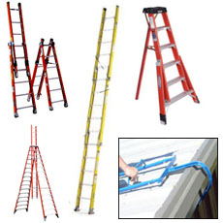
Folding Rolling Ladders | 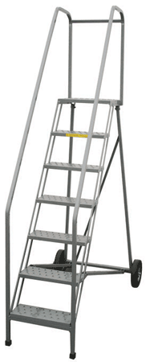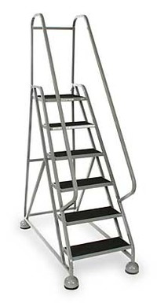
Free Fall | The act of falling, before the personal fall arrest system begins to arrest the fall.
Free Fall Distance | The vertical distance a person falls before the fall arresting system begins to arrest the fall. Must be no greater than 6 feet in a properly designed system.
Guardrail system | A barrier erected to prevent employees from falling to lower levels.
Hardware | Buckles, D-rings, snap hooks and associated hardware, which are used to attach the components of a Personal Fall Arrest System together.
Horizontal Lifeline System | A system composed of a synthetic or wire rope installed horizontally between two anchors, to which a worker attaches a personal fall arrest system.
IRATA | Industrial Rope Access Trade Association
JSA | Job Safety Analysis
Ladder Safety Device | A device, other than a cage or well, designed to prevent accidental falls from ladders, or to limit the length of such falls.
Lanyard | A flexible line used to secure a body belt or full body harness to a lifeline or point of anchorage.
Leading Edge | The edge of a deck, platform, or other walking/working surface, which is “unprotected” by barricades or barriers (e.g. edge of a platform adjacent to the capsule davit that has no barrier when the capsule is launched).
Lifeline | A line provided for direct or indirect attachment to a body harness, lanyard, or deceleration device. Such lifelines may be horizontal or vertical in application.  Retractable Lifeline – an automatic tensioning line that pays out and retracts a line at a certain speed, and locks or breaks when the speed is exceeded.
Load Indicator | A device which when strained under a load will deform indicating that the equipment has seen an impact from a fall.
LWI | Local Work Instruction
Midspan Load | A situation where the anchor load is subjected on a structural member, such as a beam or pipe, midway between two supports.
MMS | Minerals Management Service
MODU | Mobile Offshore Drilling Unit
NRTL | Nationally-Recognized Testing Laboratory
OEM | Original Equipment Manufacturer
OSHA | Occupational Safety and Health Administration
Pawl | A pivoted lever shaped to engage with a sperrad or ratchet wheel to prevent motion in a particular direction. This is a component of the locking mechanism of a self-retracting device.
Personal Fall Arrest System (PFAS) | A system used to arrest an employee in a fall from a working level. It consists of an anchorage, connectors, a body belt or body harness and may include a lanyard, deceleration device, lifeline, or suitable combinations of these. As of January 1, 1998, the use of a body belt for fall arrest is prohibited.
PFD | Personal Flotation Device
PM | Preventive Maintenance
Portable Ladder | A ladder that can be readily moved or carried.
Positioning Device System | A system rigged to an employee to be supported on an elevated vertical surface, such as a ladder, tower, etc. and work with both hands free.
Primary System | Any factors both human and fabricated which keep the worker at or on their current work level. (Includes such things as the floor, stairs, ladder rungs, work platform, balance, etc.)
Qualified Person | Someone “…who by possession or a recognized degree, certificate, or professional standing, or who by extensive knowledge, training, and experience, has demonstrated his ability to solve or resolve problems relating to the subject matter, work or the project.”
Rope Grab | A device that attaches to a lifeline as an anchoring point that provides a means of arresting a fall.
Saddle Belt | The moving component with licking mechanism of a ladder safety device that travels on the carrier and connects the carrier to the body harness or belt.
Safety Platforms | 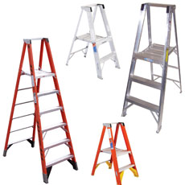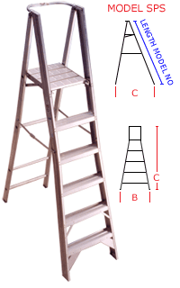
Safety Sleeve | A system rigged to an employee to be supported on an elevated vertical surface, such as a ladder, tower, etc. and work with both hands free.
Scaffold: Aluminum | 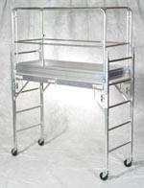
Scaffolding: Rolling Baker’s Type (with guardrails set; with toe boards) | 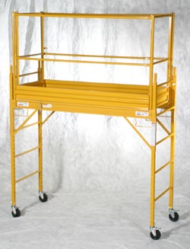
Self-retracting Device (SRD) | A device that contains a drum wound line that automatically locks at the onset of a fall to arrest the user, but that pays out from and automatically retracts onto the drum during normal movement of the person to whom the line is attached. After onset of a fall, the device automatically locks the drum and arrests the fall. SRD’s include self-retracting lanyards (SRLs), self-retracting lanyards with integral rescue capability (SRL-Rs), and self-retracting lanyards, personal (SRL-Ps).
Self-retracting Lifeline (SRL) | A self-retracting device in the form of a mechanical fall arrester, featuring a locking mechanism and energy management system to arrest the fall of and limit the forces imparted to the user.
Self-retracting Lanyard, Personal (SRL-P) | A self-retracting device designed such that it is compact enough and approved by the manufacturer to be worn by the user on a full-body harness to be used as a fall arrest connector, or alternatively mounted to an anchorage. These devices may, in some cases, be available in a dual configuration for the purpose of 100% tie off.
Self-retracting Lanyard with Integral Rescue Capability (SRL-R) | An SRL that includes an integral means for assisted rescue via raising or lowering the rescue subject. Some SRL-Rs may alternatively feature a mechanism which facilitates the controlled descent of the fallen user.
Shock Absorbers/  Deceleration Device | A component of a personal fall arrest system that allows dissipation of energy by extending the deceleration distance reducing fall arrest forces.
Shock-absorbing Lanyard | Specially designed shock absorbing lanyard elongates during a fall to significantly reduce fall arresting forces.
Snap Hook | A self-closing device with a keeper, latch or other similar arrangement that will remain closed until manually opened.
Sperrad | A ratchet wheel or locking wheel which engages with an articulating pawl or pawls, as a component of the locking mechanism within a self-retracting device.
SPRAT | Society of Professional Rope Access Technicians
Stepladders: Industrial | 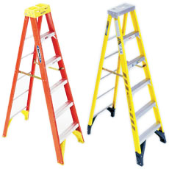
Step-Up Scaffolding | 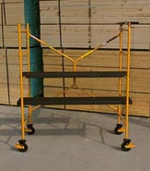  5' Unit
Suspension Belts | Simple or compound straps that may be secured about the body is an independent work support. Example – saddle belt.
Swing Fall | A pendulum like motion that can result from moving horizontally away from a fixed anchor point and falling.
Tension Load | A situation where the anchor is attached to a structural member where pulling forces are applied along the length of the support and tend to stretch or strain the member in a manner that would result in an elongation or deformation of that span.
TLP | Tension-Leg Platform
Total Fall Distance | The maximum vertical distance between the full-body harness attachment point and the lowest extremity of the body before and after the fall is arrested including lanyard extension and/or deceleration device.
DW-GOM | Deep Water - Gulf of Mexico
USCG | United States Coast Guard.

Tool HSE0044-PR01-TO.02

Fall Protection Planning Guide and Hazard Analysis

Site Requirements

Checklist | Use this checklist in conducting your Fall Protection hazard analysis.

No. | Question | Yes | No
1 | Can the job procedures be modified to eliminate a fall hazard while work is performed? | ¨ | ¨
2 | Is it possible to engineer out the problem to eliminate the hazard altogether? | ¨ | ¨
3 | Does each worker need to travel the entire length of the system? | ¨ | ¨
4 | Must the workers pass each other while connected? | ¨ | ¨
5 | Do the workers require protection from the deck or ground up to the work area?  ____ Lanyards  ____ SRD  ____ Ladder system  ____ Man-Ride system  ____ First Man Up system  ____ Other:
6 | What type of fall protection is required?  ____ Barricades  ____ Barriers/Warning Lines  ____ Vertical Lifelines  ____ Horizontal Lifelines  ____ Scaffolding  ____ Other:
7 | What is the maximum number of personnel expected to work at height?
8 | What is the maximum number of workers expected to be on the system at one time?
9 | What is the length of the area requiring protection (expected length of system)?
10 | How is the work area to be accessed? (Portable ladder, stairs, permanent ladder, etc.)  ______________________________________________________________________________________________________________________________________________
11 | What types of anchors are available/needed? Please Describe (existing structure, beams, piping, columns, etc.)  ______________________________________________________________________________________________________________________________________________
12 | Is the existing structure or anchor point  ____ beside  ____ below  ____ above  the worker?
13 | How far from the work area is the anchorage?  Distance ____________  ____ Above  ____ Below
14 | Are there any obstructions or unique hazards to consider? (vessels, piping, corrosion, water, H₂S, etc.)  ____________________________________________________________________________________________________________________________________________________________________________________________________________________________________________________________________________________________
15 | Are there other important issues that should be considered?  _____________________________________________________________________________________________________________________________________________________________________________________________________________________________________________________________________________________________________________________________________________________________________________________________________________________________________________________________________________________________________________________________________________________________________________________________________________________________________________________________________________________________________________________________________________________________________________________________________________

Hazard Analysis

Hazard Analysis Questionnaire | Follow the steps and answer the questions in the table below to identify potential fall hazards.

Step | Action/Question/Answer:
1 | Locate areas where workers may be at height. Provide the area name and any specific names or locations that may directly relate to the at height platform or work area.
 | Answer:
2 | What is the distance from the platform/work area to the next level below?
 | Answer:
3 | Are there any obstructions (beams, railings, vessels, equipment, toolboxes) or unusual risks (moving equipment, water, chemicals, sharp objects) below the work platform/area that could hurt the worker in the event of a fall?
 | Answer:
4 | Is it higher than the 6-ft requirement or do other fall hazards exist?  - If yes, proceed to question 5.  - If no, proceed to question 4(a).  4(a) Are there any obstructions (beams, piping, vessels, toolboxes) or unusual risks (moving equipment, water, chemicals, sharp objects) below the work platform/area that could hurt the worker in the event of a fall?  - If yes, proceed to question 5.  - If no, then not required to address the hazard.  4(b) Is there a slip or trip hazard?  - If yes, this hazard should be dealt with according to relevant regulations and Company policies.
5 | Is there a potential for the worker to fall during access to the platform/work area?  - If yes, proceed to question 5(a) and deal with the access as a separate hazard.  - If no, proceed to question 6.  5 (a) How does the worker access the work platform?  - Ladder. See 5(b).  - Catwalk. See 5(c).  - Hatch (doorway). See 5(d).  - Other. Describe access method and see 5(e).
5 | Answer:
5 | 5 (b) Is the height of the ladder over 20'?  - If yes, does it have some form of fall protection already installed?  - If yes, does it conform to relevant standards and requirements for ladder safety?  - If no, access is identified as a fall protection hazard. Proceed to question 6.  - If no, the use of fall protection at these heights should be assessed that if access is frequent, it would be prudent to provide some form of protection (Ladder system, SRD, etc.). Proceed to question 6 and deal with main hazard.  5 (c) Does the catwalk have guardrails or some form of traditional fall protection to eliminate/reduce the hazard?  - If yes, no further fall protection is required, proceed to question 6 and deal with the main hazard.  - If no, access is identified as a fall protection hazard. Proceed to question 6.  5 (d) Please explain how the work area is accessed. Is fall protection available at the access area?  - If yes, no further fall protection is required, proceed to question 6 and deal with the main hazard.  - If no, access is identified as a fall protection hazard. Proceed to question 6.  5 (e) How does the access hatch/door open to the work area? From the floor or deck level, ceiling/upper level, directly to work area? Is fall protection at the access area?  - If yes, no further fall protection is required, proceed to question 6 and deal with the main hazard.  - If no, access is identified as a fall protection hazard. Proceed to question 6.
You have identified that there is a fall hazard. Conduct a Job Safety Analysis (JSA).
6 | What do the workers do when at height?
 | Answer:
7 | How many workers will be at this work area?
 | Answer:
8 | How often must the workers be at height? (Daily, Weekly, Monthly, Quarterly, twice per Year, Yearly, only every few Years)
 | Answer:
9 | How long are the workers at height?
 | Answer:
10 | Are the workers working from a permanent or temporary structure?
 | Answer:

Rating the Risk | - Risk Calculations: Time at Height + Activity at height + Obstruction + Frequency (See the table below to calculate risk assessment values.)  - Risk Assessment: Low Risk 4-8; Medium Risk 9-14; High Risk 15-20  - Exposure: Risk x Number of Workers  NOTE: The higher the exposure, the higher the potential for an accident.

Risk Calculation Table | This Risk Calculation Table may be used in calculating values for risk assessment.

Issue |  | Value | Score
Height | 0' to 10' | 1
Height | 11' to 20' | 2
Height | 21' + | 3
Time | 0 to 5 minutes | 1
Time | 6 to 30 minutes | 2
Time | 31 + minutes | 3
Activity at Height | Light Duty (Inspections, light maintenance, checking levels, etc.) | 1
Activity at Height | Heavy Duty (minor repairs, cleaning sight glasses, changing lights) | 2
Activity at Height | Heavy Duty (construction, maintenance, valve replacement) | 3
Obstructions | Clear landing, no obstructions | 1
Obstructions | Minor obstructions (guardrails, tool boxes, piping) | 2
Obstructions | Unusual risks (sharp objects, moving equipment, water, etc.) | 3
Frequency | Never | 0
Frequency | Every few years | 1
Frequency | Yearly | 2
Frequency | Twice a year | 3
Frequency | Quarterly | 4
Frequency | Monthly | 5
Frequency | Weekly | 6
Frequency | Daily | 7
Frequency | Continual Work Area (for specific job; construction, operator, etc.) | 8
Total

Risk Assessment Worksheet | Use the Analysis Questions and the Risk Calculation Table to fill in the worksheet on the following pages.

Date: |  |  |  | Location: |  | Supervisor:
1
2
3
4
(a)
(b)
5
(a)
(b)
(c)
(d)
(e)
6
7
8
9
10
Risk Assessment Issue |  |  | Rating Value
Height
Time at Height
Activity at Height
Obstructions
Frequency
Risk Assessment Total:
Exposure = Risk Assessment Total x Number of Workers:

Tool HSE0044-PR01-TO.03

WaH Start-Work Check and Rescue Plan

Working at Height
WHEN TO COMPLETE – Before the start of any WORKING AT HEIGHT activities
All exposed person(s) performing work are to confirm each safeguard below. |  | How to examples: |  |  | Person(s) Performing Work (initial) | Start-Work Verifier
I HAVE CONFIRMED:
The hazards are identified, controlled and it is safe to start.  1 |  | - A task risk assessment has been completed specific to the scope of work.  - Discuss hazards with the work team prior to the start of work.  - Check for simultaneous operations that may introduce additional hazards.
My fall protection equipment is:  2  - certified  - inspected  - rated  - fit for the task |  | - Fall protection equipment includes fall arrest and/or fall restraint.  - Full body harness is load rated to support the weight of the worker.  - Check every strap, buckle, fitting and/or grommet for signs of wear on fall protection harness.  - Be removed from service 5 years after manufacture date if constructed of a synthetic web material (this Includes harnesses, lanyards, beam straps, SRD lines, etc.).  - Fall arrest system contains a self-retracting lifeline or shock absorbing lanyard.  - Fall restraint contains a fixed lifeline configured to prevent the worker from reaching the edge and falling.  - Fall arrest is shorter than the potential fall distance.  NOTE: Stop and notify supervisor if the fall protection equipment has excessive wear/damage/ mechanical malfunction or is not fit for the task.
The fall protection harness is adjusted to fit.  3 |  | - Only full body harnesses are used.  - Harness straps are not twisted.  - Harness body straps are adjusted for close body fit (i.e., no slack)  NOTE: Use of body belts is not allowed.
The fall protection harness is adjusted to fit.  4  The approved anchor point(s) are in place for 100% tie off. |  | - 100% tie off can occur outside of protected areas (such as an elevated work area not enclosed by handrails).  - The anchor point meets regulatory/company requirements.  - The position(s) of anchor points allow for 100% tie off.  - The number of anchor points available allow for 100% tie off.  - Pull on the connecting device to test if attachment is secure.  NOTE: Confirm anyone working at height is 100% tied off at all times (e.g., at least one hook must be anchored at all times).
If a fall occurs, the fall path is clear.  5 |  | - Fall protection is fit for purpose to protect the worker if they fall.  - Fall arrest distance is shorter than fall distance to first obstruction.  - If likely to swing, the path is free of obstruction.  - Mobile obstructions have been removed from fall path.
The tools/materials being used at height are secured.  6 |  | - Tools used at heights have securing wire/lanyards/tethers.  - Materials used at height are secured in storage boxes, pouches, bags etc.  - Cover openings to lower levels (e.g., grating, gaps etc.) or use debris nets.  NOTE: Follow the site/company dropped object prevention program (e.g., Work at Height tool register).
Barriers and drop/ exclusion zones are in place.  7 |  | - Identify drop/exclusion zones.  - Control access to drop/exclusion zones during work at height (e.g., attendant or physical barriers).
The rescue plan is in place and is ready to be used.  8 |  | - The work crew has discussed the rescue plan, including:  - How to start the rescue response.  - Location of rescue equipment and responders.  - The rescue crew:  - is available,  - is aware of specific hazards related to this task, and  - can execute the rescue plan.
Confirm these controls/safeguards are in place and verified prior to starting work. Stop and seek help if anything changes.
 | Printed Name & Role |  | Signature | Date
Start-Work Verifier

Start-Work Check

The following information is intended to provide an individual with more detailed inspection criteria that may be useful during the inspection process:
- Inspect all hardware, buckles, D-rings, back pad, and keepers for damage, cracks, and distortion.
- Check for any sharp edges, burrs, worn parts, and corrosion.
- Inspect all webbing for frays, cuts, tears, abrasions, stretching, mold, burns, holes, and discoloration.
- Checked stitching for pulls or cuts and any broken strands. Any signs of broken stitches may indicate the harness has been impact loaded during a fall.
- Inspect grommets for deformities and looseness.
- Ensure that metal keepers are not bent, arched, or deformed.
- Ensure that labels are present and fully legible.
- Ensure that snap hooks work freely and are not deformed in any way. Check springs and locks operation.
- Check all connectors, anchors, carabiners, etc. for deformities, discoloration, and corrosion.
- Ensure that D-rings are in good condition and not deformed or bent.
- Ensure that all spring-loaded latches and gates operate smoothly and easily.

NOTE: This detailed information is provided to assist in completing the required Start Work Check for Working at Height and any questionable items should be checked more closely and removed from service.

Working at Height
Rescue Plan

Rescue Plan
An individual who has suffered a fall and is suspended in his harness is a medical emergency. Do not allow a false sense of security to develop because the individual’s fall has been arrested. Rescue must be performed quickly and effectively, or the victim may very well die.
Uninjured individuals who have been suspended for greater than 10 minutes should be evaluated by a medical professional.
Rescue plan content and considerations
- The means of identifying that someone has fallen and needs rescuing
- The choice of rescue technique
- Specification of rescue equipment
- Possible obstructions to accessing the fallen person
- The possible need for additional resources (e.g., fire & rescue service, ambulance, hospital)
- The plan should assume the fallen person is injured and unconscious
- The rescue must be initiated immediately and should be completed within 10 minutes0
- The means of communication between observer, the rescue team, and the suspended person (if conscious) including possible language barrier
- Method of attaching and if necessary, immobilizing the injured person
- The environmental conditions (e.g., weather, lighting, adjacent work activities)
- Rescuers and first aiders must be familiar in the treatment of suspension trauma victims. (See TOOL HSE0044-PR01-TO.10 for Suspension Trauma)

The Rescue Plan should be kept simple, using Job Aids such as pictures and diagrams. The form below is intended to assist in considering the obstacles associated with a rescue.

If rope access is identified as the rescue plan, then competent rope access technicians are to be on standby with all the equipment required at the work location. Rope access rescue technicians need to be included in the work planning stage and have ample time to develop their response plan for the specific job.

Working at Height Rescue Plan

Date: |  |  | Shell Sup/Sponsor:
Location: |  |  | Contractor Sup:
Overview of WaH Activity:
Work Crew:
Names of workers who are involved in the work at height:
1) |  |  | 2)
3) |  |  | 4)
5) |  |  | 6)

The Rescuer is to check all rescue equipment to verify that they are in good working condition prior to proceeding with the work at height task and sign below. WAH Rescuer to always remain with workers while WaH activities are ongoing.

7) | Name of Designated Rescuer: |  |  | Signature

RESCUE
The rescue plan should ensure that the potential for suspension trauma is minimized by beginning a rescue within 5 minutes.

Communication
What communication systems will be used between the workers and the rescue team? (Direct voice, Radio, etc)

Rescue Considerations:
- as appropriate
 |  | Yes |  | No
Are WaH team trained/competent in use of rescue equipment?
Are Rescuers trained/competent in the use of rescue equipment?
Are there sufficient numbers of rescuers available?
Is rescue equipment selected appropriate for nature of work?
Is rescue equipment in good condition, certified and inspected as required?
Have assessments been made of any anchor points needed for the rescue?
Are the rescuers familiar with suspension trauma?
(See TOOL HSE0044-PR01-TO.10 for Suspension Trauma)

What equipment is needed to perform a rescue for this Job Task?
- as appropriate
Fall retrieval equipment/pole |  |  |  | Rescue Ladder
Remote rescue kit |  |  |  | Single Point Suspension Scaffold (Spider)
Suspension trauma straps |  |  |  | Rope Access
SRL-R (SRL w/ Integral rescue Capability) |  |  |  | Crane personnel basket
First aid-kit or trauma kit |  |  |  | Immobilization device (stretcher, sled, etc.)
 |  |  |  | Other: (Add below)
What obstructions are in the way of reaching the suspended worker? What additional controls or
mitigations are to be employed. (Detail):

How will rescuers get to the suspended worker? (Detail):

How will rescuers perform the rescue using the above listed equipment? (Detail):

What method will be used for attaching and if necessary, immobilizing injured person? (Detail):

Other considerations:

Working environment- lighting, weather, etc. (Details):

SIMOPs precautions. (Details):

Language barriers. (Details):
Insert picture(s) or drawing(s) of attachment point(s), rescue equipment, and immobilization process here (Optional)

Tool HSE0044-PR01-TO.04

Equipment Inspection Form – Annual

Harness |  |  | Lanyard |  |  |  |  | Connectors |  |  |  |  | Tie-offs |  |  | SRD
Model |  |  |  | Serial # |  |  |  |  | Lot #: |  |  |  |  | Date of Purchase:
Hardware |  |  |  | Materials and Fibers |  |  |  |  | Locks/Latches/Gates/  Swivels |  |  |  |  | Arrest Components
Accept | Reject |  |  | Accept | Reject |  |  |  | Accept | Reject |  |  |  | Accept | Reject
 |  | Buckle |  |  |  | Webbing |  |  |  |  | Snap hooks |  |  |  |  |  | Shock Absorber
 |  | D-ring |  |  |  | Rope |  |  |  |  | Carabiners |  |  |  |  |  | SRD
 |  | Back Pad |  |  |  | Stitches |  |  |  |  | Swivels
 |  | Grommets |  |  |  | Labels |  |  |  |  |  |  |  | Yes | No
 |  | Keepers |  |  |  |  |  |  |  |  |  |  |  |  |  |  | Torn web
Yes | No |  |  | Yes | No |  |  |  | Yes | No |  |  |  |  |  |  | Elongated web
 |  | Bent/Damaged |  |  |  | Frayed web |  |  |  |  | Broken/ Damaged |  |  |  |  |  | Indicator tag torn
 |  | Distorted |  |  |  | Cuts 1/8" or larger |  |  |  |  | Bent |  |  |  |  |  | Torn cover
 |  | Worn Edges |  |  |  | Brittle |  |  |  |  | Operate freely |  |  |  |  |  | Torn threads
 |  | Cracks |  |  |  | Broken fibers/strand |  |  |  |  | Close fully |  |  |  |  |  | Loop ruptured
 |  | Sharp Edges |  |  |  | Tears |  |  |  |  | Cracks |  |  |  |  |  | Band exposed
 |  | Burrs |  |  |  | Abrasions |  |  |  |  | Burrs |  |  |  |  |  | Reserve line used
 |  | Corrosion |  |  |  | Knots |  |  |  |  | Deformed |  |  |  |  |  | Labels present
 |  | Discoloration |  |  |  | Mold |  |  |  |  | Excessive Corrosion |  |  |  |  |  | Cable damaged
 |  | Loose in strap |  |  |  | Stains |  |  |  |  | Markings legible |  |  |  |  |  | Swivels rotate
 |  | Deformed thimble |  |  |  | Dis-colored |  |  |  |  | Springs present |  |  |  |  |  | Lock works
 |  | Pitting |  |  |  | Heavy Paint |  |  |  |  | Swivel rotates |  |  |  |  |  | Anchor bent
 |  | PVC damaged |  |  |  | Holes 1/16" or larger |  |  |  |  | Gates turn easily |  |  |  |  |  | Anchor cracked
 |  |  |  |  |  | Pulled stitches |  |  |  |  |  |  |  |  |  |  | Screws tight
 |  |  |  |  |  | Broken stitches |  |  |  |  |  |  |  |  |  |  | Housing cracked
 |  |  |  |  |  | Labels attached
 |  |  |  |  |  | Labels legible
Comments:
Name: |  |  |  |  |  |  | Date Inspected: |  |  |  |  | Signature:

Tool HSE0044-PR01-TO.05

Equipment Inspection Form – Monthly SRD

Fall Protection Equipment Inspection Form – Monthly SRD
Model No. |  |  |  |  |  |  | Manufacture Date:
Serial No. |  |  |  | Lot No. |  |  | Purchase/Service Date:
Location: |  |  |  | Manufacturer Paperwork on file: Y ¨ N ¨
General Factors |  |  |  | Accepted / Rejected |  | Support Details or Comments
Impact Indicator: Inspect indicator for activation (rupture of red stitching, elongated indicator, etc.) |  |  |  | - Accepted  Rejected ¨
Screws/Fasteners: Inspect for damage and ensure all screws and fasteners are tight. |  |  |  | - Accepted  Rejected ¨
Housing: Inspect for distortion, cracks, and other damage. Inspect anchoring loop for distortion and damage. |  |  |  | - Accepted  Rejected ¨
Lifeline: Inspect for cuts; burns; tears; abrasion; frays; paint; excessive soiling and discoloration; bent, deformed, or broken wires, etc. |  |  |  | - Accepted  Rejected ¨
Locking Action: Inspect for proper lock-up of brake mechanism. |  |  |  | - Accepted  Rejected ¨
Retraction/Extension: Inspect spring tension by pulling lifeline out fully and allowing to retract fully (lifeline must be taut, no slack, do not store extended, recommend attaching a tag line). |  |  |  | - Accepted  Rejected ¨
Hooks/Carabiners: Inspect for physical damage, blueing, corrosion, proper operation, and markings (see separate checklist for carabiners, hooks, etc.). |  |  |  | - Accepted  Rejected ¨
Reserve Lifeline: Inspect reserve lifeline retention system for deployment. |  |  |  | - Accepted  Rejected ¨
Labels: Inspect; ensure all labels are securely held in place and are legible. |  |  |  | - Accepted  Rejected ¨
Additional Comments:

Overall Disposition: Accepted ¨ Rejected ¨
Date Inspected: |  |  | Competent Person Signature:

Inspection Criteria

Inspection Schedule | Pre-use:  Before each use the SRD unit must be visually inspected.  Monthly:  A competent person, other than the user must perform an inspection, record the results, and file the inspection form in the unit files.  Every 2 Years:  - All SRDs must be inspected by a factory authorized service center or the manufacturer.  - For SRDs exposed to severe conditions the inspection shall be annual.  - The 2-year inspection shall include a thorough inspection and cleaning of all internal and external components.  - Repair and/or replacement of defective components as required.  - Failure to provide proper service to the unit may shorten the useful life of the unit and compromise performance.

Impact Indicator Inspection | Before each use, inspect the stitched loop on the web lifeline near the hook (red stitching).  - If the loop is stitched and in place, it has experienced no impact.  - If the stitching is ruptured and the loop is torn or ripped apart an impact loading has occurred.  Do not re-stitch the loop or return the unit to service. Ship to an authorized service center for resetting.

Fall Indicator Inspection | The following indicate that the line has experienced impact loading due to a fall and must be inspected before each use. If the unit displays these indications, it must be serviced before use:  - Tell Tale indicator – exposed color band showing red/orange, lap broken.  - Hook slightly extended at swivel connection and will not turn freely.  - Reserve line – Deployed (label showing, ferrule visible).

SRD Unit Inspection | Before each use, ensure that the following are true:  - There are no loose screws and bent or damaged parts.  - There are no cracks, distortion, or other damage to the housing.  - There is no damage or distortion to the anchorage point.  - Anchor point swivels freely and smoothly.  - Life line fully extends and retracts.  - Breaks operate as designed and lock up when the line is jerked sharply. Lock up should be positive with no slipping.  - All labels are present and fully legible.  - There is no corrosion.  - Webbing has no cuts, burns (brown, hard areas), or chemical contact or severely abraded areas.  - Carabiner connecting hooks show no signs of damage or corrosion and are in proper working condition.  - There is no excessive buildup of dirt, paint, etc. in the reel opening. Excessive buildup of materials can prevent the lifeline from fully retracting into the housing causing a potential free fall hazard.  - Inspection results are recorded and placed in the unit filing system.

Tool HSE0044-PR01-TO.06

Air/Hydraulic Hoist Operations

Overview | During man-ride operations a secondary fall arrest system (consisting of a full body harness, lanyard, vertical lifeline or SRD, etc.) and appropriate anchorage (other than the man-ride winch line) is required.

Lifting Procedures | When personnel are to be lifted with a hoist the following procedures shall be applied.  - All personnel shall be instructed in the proper use and maintenance of air/hydraulic hoists on the rig.  - All hoists shall be equipped with a drum guard and line guide.  - All hoisting lines shall be inspected periodically and prior to each lift.  - Load capacity of the hoist and wire rope shall not exceed the manufacturer’s recommendation.  - Rig personnel should stand clear of any suspended load.  - The hoist operator shall set the drum break anytime a load is in suspension and shall not leave the hoist unattended at any time.  - The hoist operating lever shall be designed to return to neutral, locked position when released by the operator.  - The air or hydraulic hoist shall not be used to lift personnel until all required conditions are met.

Pre-Lift Conditions | The following conditions must be met before operations using an air or hydraulic lift may begin:  - A written JSA shall be completed and discussed in a tailgate safety meeting with all personnel.  - Personnel shall not be raised during adverse weather conditions.  - The hoist operator shall check the air hoist mechanism, wire rope, brake, drum guard, and line guard for condition and proper operation.  - A flagman shall be utilized when the hoist operator cannot see or hear the person being raised or lowered. Radios shall not be the sole source of communications when the operator cannot see the person in the lift.  - The rotary and blocks shall not be in operation.  - An approved fall restraint system shall be worn by personnel on the hoist line.  - The hoist operator shall raise and lower the hoist in a slow steady manner and must be alert to the situation and flagman at all times.  - A tag line shall be attached at all times. In instances where long runs are made a tag line may create an additional hazard and its use should be evaluated.  - The hoist drum must have “controlled load lowering” mechanism. A break does not satisfy the requirement; free fall is prohibited.  - A quick opening/closing valve will be installed on the hoist supply line in very close proximity to the hoist, such that the hoist operator will have “ready” access to the valve.  - In addition to approved safety harness with inward latching double locking snap hook, secondary fall protection shall be used for personnel on the air hoist (Sala block, Retractalok, Ropelok, Controlled Descent Device, or equivalents).  - The cable should be marked to indicate to the operator the hoisted employee has reached a point 45' over the rig floor and closer attention to his activities is warranted to avoid running him into the sheave.

Tool HSE0044-PR01-TO.07

Rope Access Criteria (IRATA/SPRAT)

Introduction

Scope | Rope access uses specific techniques to access areas of a structure using ropes suspended from the structure.  Specific guidelines apply to all access work where ropes are used:  - as the primary means of support,  - as the primary means of fall prevention and protection,  - where personnel ascend or descend on a rope, or  - where personnel traverse along a horizontal rope.

Associations | Standardization, safe practices, and personnel certification for rope access work are facilitated by the following organizations:  - USA – Society of Professional Rope Access Technicians (SPRAT)  - Europe – Industrial Rope Access Trade Association (IRATA)  Due to the gaps that exist between associations, the following ISO documents provide a minimum standard that must be met when working for Shell:  - ISO 22846-1 Fundamental principles for a system of work  - ISO 22846-2 Code of practice

Training and Certification

Training | For maximum safety, personnel are trained and certified in techniques, equipment, and regulatory considerations.  IRATA and SPRAT have established three levels of certification that require demonstration of the following in varying degrees:  - Skills  - Experience  - Knowledge of:  - Rope access techniques  - Equipment  - Hazards for technicians

Level 1 Certification | A level 1 technician is able to perform a limited range of rope access tasks under the supervision of a level 3 technician.  To be certified as level 1, technicians must successfully undertake an approved IRATA/SPRAT training course and assessment.

Level 2 Certification | A level 2 (lead) technician is able to rig working ropes, undertake rescues, and perform other rope access tasks under the supervision of a level 3 technician.  To be certified as level 2, technicians must:  - Obtain level 1 certification  - Log 500 working hours using rope access techniques  - Complete further IRATA/SPRAT training and assessment

Level 3 Certification | A level 3 (supervisor) technician meets the following criteria:  - Able to take complete responsibility for work projects  - Demonstrates the skills and knowledge required of levels 1 and 2  - Is conversant with relevant work techniques and legislation  - Has a comprehensive knowledge of advanced rescue techniques  - Holds a current first aid certificate  - Has knowledge of the IRATA or SPRAT certification requirements  To be certified as level 3, technicians must:  - obtain level 2 certification,  - log an additional 500 working hours using rope access techniques, and  - complete further IRATA/SPRAT training and assessment.

Refresher Training | Refresher training is required at shorter intervals for individuals who have not continuously engaged in rope access work.

Equipment

Requirements | Equipment used for rope access must meet the requirements of the European PPE directive and the resulting UK regulations and must be CE marked to designate compliance.  Most equipment will be Category III according to the regulations and must be independently tested to a standard such as BS EN ISO 9000.  If lifting equipment is used, the Lifting Operations and Lifting Equipment Regulations 1998 (LOLER) or the Provision and Use of Work Equipment Regulations 1998 (PUWER) apply.

Further Information

References | For more detailed review of Rope Access Regulations and Requirements, please reference:  - IRATA Guidelines on the use of Rope Access for Industrial Purposes  - IRATA International Guidelines in the use of Rope Access for Industrial Purposes  - SPRAT Safe Practices For Rope Access Work  - Lifting Operations and Lifting Equipment Regulations 1998 (LOLER)  - Provision and Use of Work Equipment Regulations 1998 (PUWER)  - ISO 22846-1 Personal Equipment for Protection Against Falls – Rope Access Systems – Part 1: Fundamental Principles for a System of Work  - ISO 22846-2 Personal Equipment for Protection Against Falls – Rope Access Systems – Part 2: Code of Practice

Tool HSE0044-PR01-TO.08

Anchorages Matrix

Member Loading Guidance Table | The table below provides guidance for anchor points of fall protection.  The members selected were the lightest members in their group. For example, The W12 selected is a W12x14, the lightest W12. The heaviest W12 is a W12x190. A W12x190 can hold a considerable amount more than what is listed here.  If a question arises on a specific case, please consult the unit Civil Engineer.
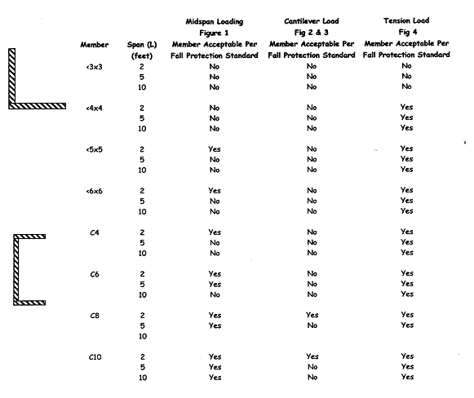
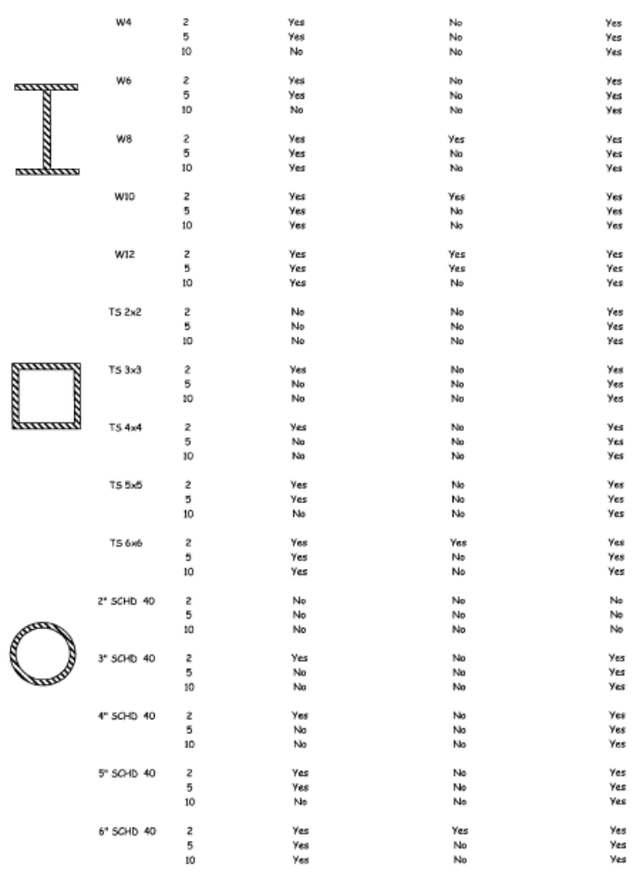
Horizontal Intercostal Loading | The following figure illustrates loading on a horizontal intercostals member.  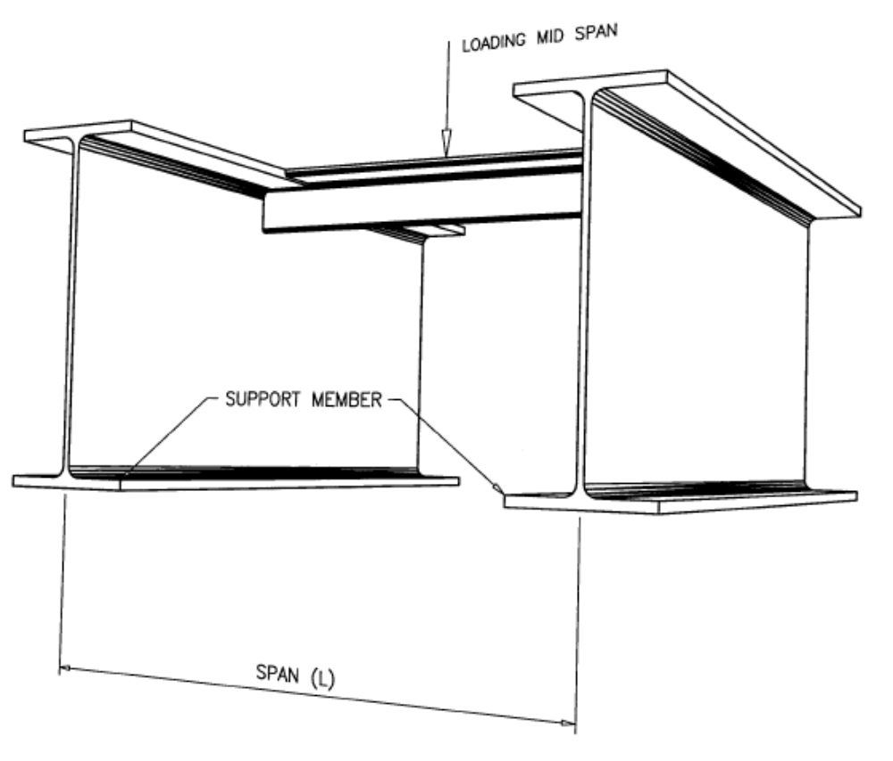

Horizontal Cantilever Loading | The following figure illustrates loading on a horizontal cantilever member.  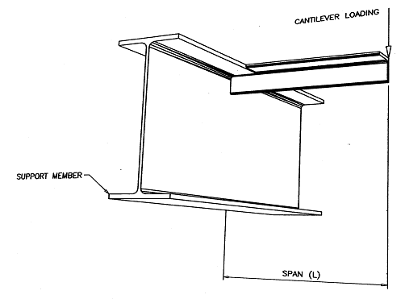

Vertical Cantilever Loading | The following figure illustrates loading on a vertical cantilever member.  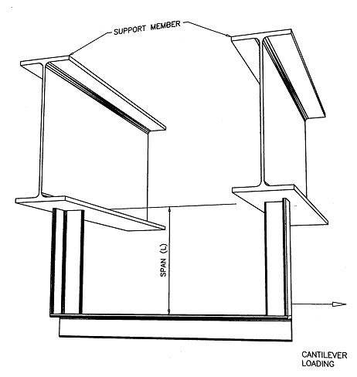

Vertical Tension Loading | The following figure illustrates loading on a vertical tension member.  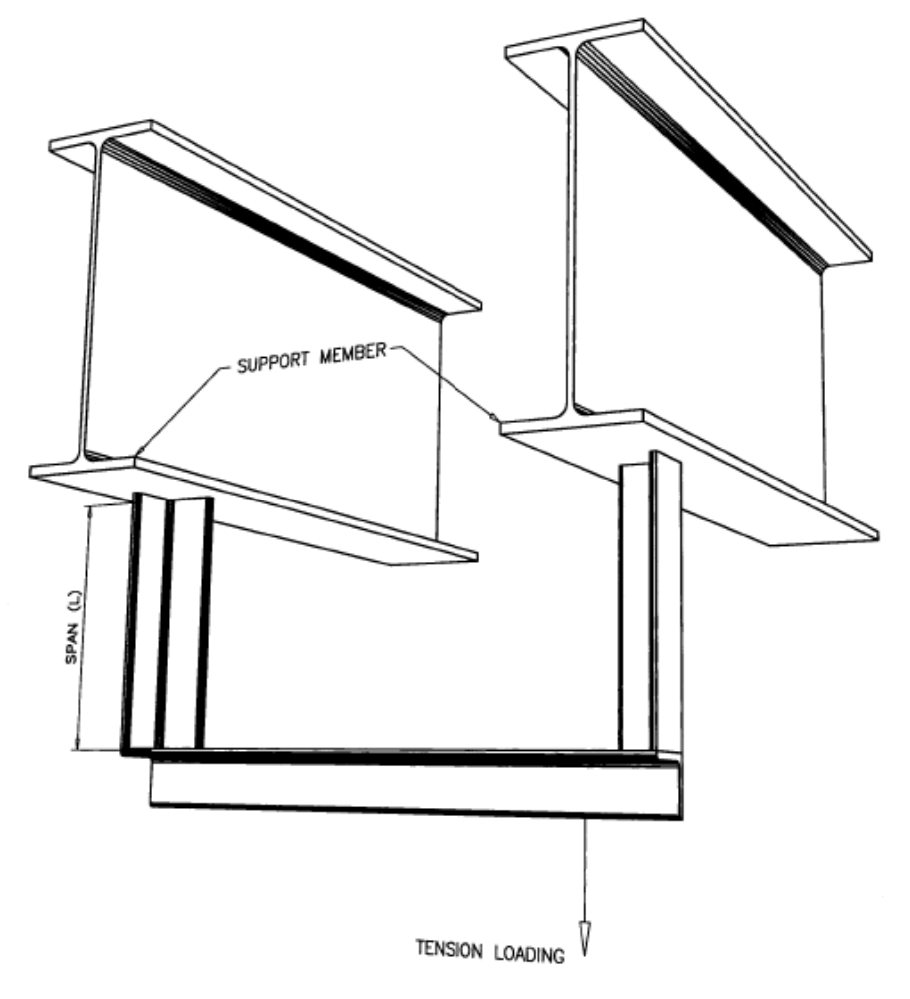

Tool HSE0044-PR01-TO.09

Fall Distance and Clearance Calculation

Lanyard Safe Fall Zone

General | To reduce fall arresting forces, lanyards should be kept as short as possible, shock absorbing lanyards are to be used, and free fall distance should be minimized by proper anchorage positioning and minimizing lanyard length.  The figure below illustrates the Lanyard Safe Fall Zone.
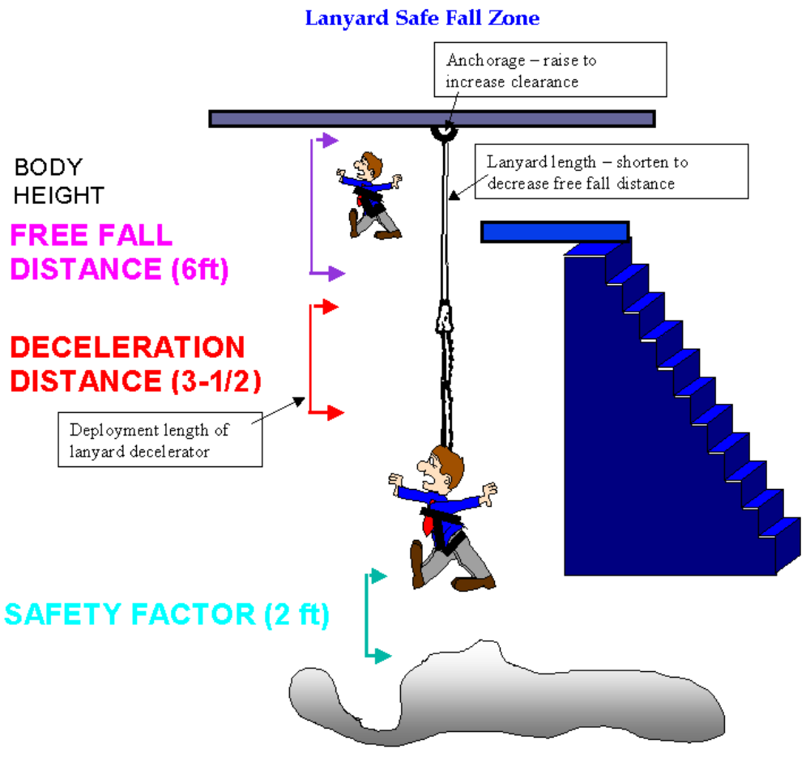

Example Calculations Using Lanyard

Example 1 | - 6' – Average height of worker  - 6' – Lanyard length  - 3 ½' – Maximum shock absorber extension  - 15 ½' – Maximum fall from anchor point.  - 2' – Safety Factor  - 17 ½' – Total Distance

Example 2 | - 6' – Average height of worker  - 4' – Lanyard length - shortened by use of D-ring  - 3 ½' – Maximum shock absorber extension  - 13 ½' – Fall from anchor point  - 2' – Safety Factor  - 15 ½' – Total Distance

Calculating fall Distance with an SRD

The factors affecting total fall distance:

- Free Fall Distance. How far the worker will have to fall before the line begins to be extracted from the device. For a Class 1 SRD used in the overhead configuration, this distance is zero as the activation begins immediately.
- Arrest Distance. The arrest distance is the activation distance, or the distance travelled prior to the locking engagement, plus the deceleration distance. This distance can be found within the manufacturer’s instructions/charts provided. A normal arrest distance of a Class 1 SRD in the overhead configuration is 3 feet.
- Stretch Out. This is the stretching of the torso straps and the removal of any slack in the harness. Maximum allowable in ANSI/ASSP Z359.11 is 18 inches.
- Safety margin. A clearance factor of safety which should be calculated as 2 feet.

Example Calculations Using an Overhead SRD (Class 1)

Example 1 | - Free fall distance – 0 feet  - Arrest Distance – 3 feet  - Stretch Out (Harness) – 1.5 feet  - Safety Margin – 2 feet  - Total Distance Required Below Walking/Working Surface – 6.5 feet  Note: Because calculating fall clearances from the walking/working surface is often clearer for SRDs, that is the method used here.  There are other factors that must be considered when working near a leading edge requiring a Class 2 SRD, as well as attaching below the dorsal D-ring.

Tool HSE0044-PR01-TO.10

Suspension Trauma (Orthostatic Intolerance)

Overview | Suspension trauma is a condition that may occur when there is no movement of the legs and calves, especially when in a suspended position, where venous pooling occurs and venous return to the heart suffers. It is also known as:  - Orthostatic intolerance  - Orthostatic syndrome  - Orthostatic shock  - Harness hang syndrome

Possible Results | Suspension trauma can result in a loss of consciousness or death.

Exposure to Suspension Trauma | Exposure to suspension trauma can occur:  - When a climber or a utility or construction worker is suspended in a harness for an extended period of time and is unable to move his or her extremities.  - During the process of rescue, where a victim who is restrained and unable to move in a stretcher during a vertical haul.  - In a confined space situation where the person is trapped in a vertical position without resting on his or her feet.

Physiological Explanation | Consider what happens in suspension trauma:  - Up to 20% of the body's blood supply is in the legs at any given time.  - To move that blood around, the heart must pump effectively but there must also be muscular action in the legs to help a series of one-way valves move blood back toward the heart.  - Without movement of the legs and calves, especially in a suspended position, venous pooling occurs and venous return to the heart suffers.  - The patient will become cerebrally hypoxic after about 10 minutes of being suspended and immobile.

Conditions that may Exacerbate Suspension Trauma | The following conditions may exacerbate the problem of decreased venous return to the heart and the pooling of blood in the legs:  - Harness becomes a tourniquet and reduces venous return even more  - Patient becomes hypothermic  - Patient is unconscious  - Reduced blood volume because of dehydration  - Injury from a fall

Warning Signs | Warning signs of impending suspension trauma include:  - Faintness  - Nausea  - Dizziness  - Paleness  - Diaphoresis  - Increasing pulse rate and blood pressure, progressing to a pulse rate and blood pressure drop  - Unconsciousness

Treatment | Treatment of the patient should begin as soon as safely possible.
  If… | Then…
  The suspended patient is conscious: | The patient should be made to keep his or her legs moving while being rescued:  This movement will reduce the chances of blood accumulating in the legs and allow the heart to maintain adequate venous return.  If possible, the patient should also be repositioned into a sitting position with the thighs horizontal or elevated with respect to the pelvis.  The patient should then be rescued as soon as possible.
  Once Rescued… | Then…
  The patient shall not be laid down.  NOTE: This is key to treatment. | All restrictive clothing, belts, and equipment should be removed immediately and the patient should be placed in a seated, squatting, or crouched position with the head well elevated.  The patient should be maintained in this position during transport and for 20 to 40 minutes thereafter.
  Other treatment | The patient shall be monitored, and as always, airway, breathing, and circulation should be assessed and maintained.  The patient should receive 100% oxygen.  If an IV line of normal saline is established, it should be maintained at a KVO rate so the patient is not overhydrated.  A patient who is hypothermic should be gradually rewarmed. EKG should be monitored and arrhythmias treated per local protocols.
  URGENT Transport | - Urgent transport to a trauma center is necessary if the patient has lost consciousness.
  Follow-up | - Any patient suspended in a harness and immobile for any period of time must be rescued and transported to the hospital for further evaluation because it is impossible to assess delayed damage such as kidney function at the scene.

References | Dawes R. “Suspension trauma – A medical perspective.” (2000); Technical Rescue, Issue 27 September 2000 (p 20).

Tool HSE0044-PR01-TO.11

Single Point Suspension Scaffold Start Work Checklist


Start Work Check: Man-Riding in Single Point Powered Scaffold
When to Complete – Before the start of any MAN-RIDING IN SINGLE POINT POWERED SCAFFOLD (e.g. SPIDER) activities
All exposed person(s) performing work are to confirm each safeguard below. | Work Performer(s) complete information below. | Work Performer(s) | Start-Work Verifier
I HAVE CONFIRMED: |  | Initial | Initial
Personnel involved  1  with the man-riding  operations are qualified  to perform their task | - Rider and Spotter have all been trained and can describe their responsibilities
The man-riding  2  equipment is certified, inspected, and rated for the task | - A documented inspection of all parts of the man-rider has been conducted.  - Working at Height SWC has been completed
Hazards close to  3  man-riding activities  are identified and secured to prevent incident | - Process piping (i.e., pipes, needle valves, gauges, high pressure hoses, etc.) and line pressures are identified, and loss of primary containment are safeguarded  - Line of fire hazards have been identified, and mitigations are in place.  - Verify adequate access / egress for accessing man-rider
Communication  4  methods are in place | - Rider and Spotter have functioning radios
The tools/materials  5  being used at height  are secured | - Follow the site/company dropped object prevention program  - Tools and materials are secured with lanyards, tethers, bags, etc.; Hoses are secured with ropes
Barriers and DROP/  6  exclusion zones are in  place | - Control access to DROP/exclusion zones  - Use flagging tape, barricades, and/or monitor
The rescue plan is in place  7  and is ready to be used | - The work crew has discussed the rescue plan, including:  - How to start the rescue response  - Rescue equipment and responders are in immediate work area  - The Rescue Team is available, aware of specific hazards related to this task and can execute the rescue plan
Approved anchor point(s) are in place | - Approved anchor point(s) for the single point powered scaffold (man-rider) have been identified and are in place
Critical Equipment is protected  8 | - Critical equipment (i.e., firefighting, gas detection, ESD, etc.) in the work area identified and protected.
Confirm these controls/safeguards are in place and verified prior to starting work. Stop and seek help if anything changes.
9
Signatures
Start-Work Verifier  Name: | Start-Work Verifier  Signature: | Date:

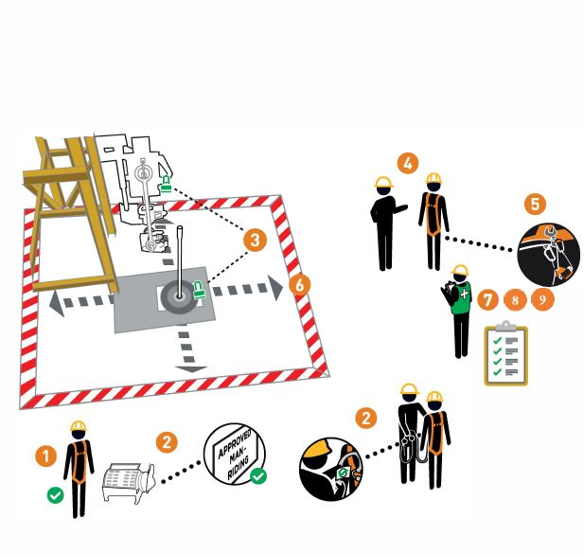

Tool HSE0044-PR01-TO.12

Equipment Annual Inspection Log

Unit/Location: __________________________________ Competent Person: ____________________________________ Date: _____________

Type | Serial # | Description | Model # | Company | Lot # | DOM | Date Rec’d | Inspection Date | Pass/ Fail | Comments/  Equipment Status

Inspection Criteria

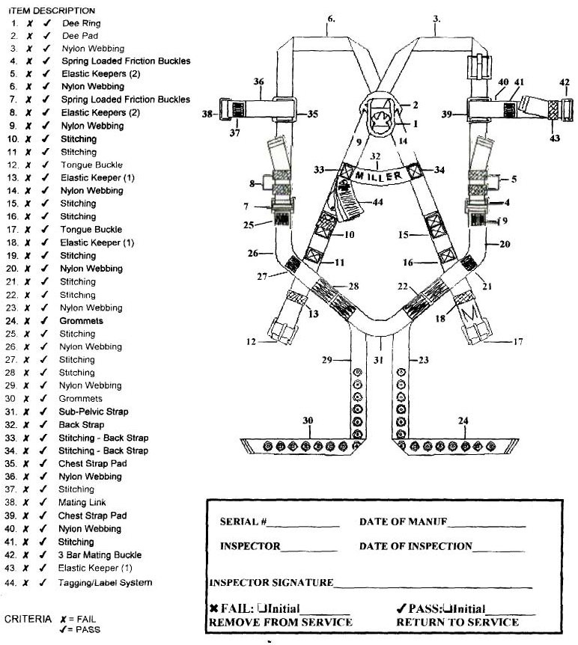
- Inspect all hardware, buckles, D-rings, back pad, and keepers for damage, cracks, and distortion.
- Check for any sharp edges, burrs, worn parts, and corrosion.
- Inspect all webbing for frays, cuts, tears, abrasions, stretching, mold, burns, holes, and discoloration.
- Stitching should be checked for pulls or cuts and any broken strands. Any signs of broken stitches may indicate the harness has been impact loaded during a fall.
- Inspect Grommets for deformities and looseness.
- Metal keepers should not be bent, arched, or deformed.
- Labels should be present and fully legible.
- Snap hooks should work freely and not be deformed in any way; springs and locks should be checked for operation.
- All connectors, anchors, carabiners, etc. should be inspected for deformities, discoloration, and corrosion.
- D-rings should be in good condition and not deformed or bent.
- All spring-loaded latches and gates should operate smoothly and easily.
- Any questionable items should be checked more closely and removed from service if necessary.
- When inspecting an SRD, check for proper function of the snap hook, and check brake function by pulling sharply on line. Pull the line out completely to check for damage. Ensure the line retracts completely. Locate and check the impact indicator. Look for any damage to the housing or block.

Tool HSE0044-PR01-TO.13

Horizontal Lifeline Inspection Form

Lifeline Location/ID: ______________________________________ Date: _____________

 | Pass | Fail | Comments
Synthetic rope horizontal lifeline
Inspect rope for cuts, tears, burns, holes, etc.
Inspect metal hardware for rust, corrosion, deformation, etc.
Inspect tensioner for proper operation.
Inspect anchor points/anchor connectors
Cable horizontal lifeline
Inspect cable for broken wire strands, damage, acute bends, etc.
Inspect metal hardware for rust, corrosion, deformation, etc.
Inspect tensioner and intermediates if present.
Inspect shock absorber.
Inspect anchor points/anchor connectors.

These lists should not be considered all-inclusive as there are many other factors that come into play when inspecting a horizontal lifeline. There are many different types of horizontal lifelines used in the oil and gas industry today.

Consider a third party to provide the inspection and certification. This is a service that Safety Connection can provide. Call (800) 480-3521 toll free.

__________________________________________
Inspector (Competent Person) Signature

Tool HSE0044-PR01-TO.14

Personnel Work Basket Inspection Form – Annual

Location: Competent Person:
Manufacturer: Current Inspection Date:
Model #: Serial #: Last Inspected Date:

 | Description | Y | N | NA | Pass/Fail | Comments/Equipment Status
1 | Are Certification Papers for the work basket available? Is the work basket designed to support its own weight and at least 5X the maximum intended load?
2 | Is the personnel platform conspicuously posted with a manufacturer's plate or other permanent marking which indicates the weight of the platform, and its rated load capacity or maximum intended load?
3 | Is the work basket equipped with a test weight? Is the weight 125% of the platform's rated capacity?
4 | Are test weight pins available and in acceptable condition?
5 | Are suspension/lift cables attached to the basket?
6 | Does the suspension system design minimize tipping of the platform due to movement of employees?
7 | Are tags attached to cables?
8 | Are the cables within the 1yr certification date allowed?
9 | Are wire rope certification papers available?
10 | Are guard rails and fall arrest system anchors available?
11 | Are the guard rails and fall arrest system anchors in good condition, free of damage, corrosion, etc.?
12 | Is the basket enclosed from the toeboard to mid-rail with solid construction or expanded metal with opens no greater than 1/2 inch?
13 | Is a grab rail installed inside the entire perimeter of the basket?
14 | Are access gates designed to prevent an outward swing during hoisting?
15 | Is the access gate in acceptable condition?
16 | Is the gate provided with a restraining device/latch to prevent opening?
17 | Does the device/latch function as designed?
18 | Does the basket design and suspension system allow employees to stand upright in the platform?
19 | Are all rough edges surfaced or smoothed to prevent injury to workers?
20 | Is the overall condition of the lift basket acceptable? Are there signs of damage, deformation, corrosion, cracks to the frame or welds, heat damage, etc.?
21 | Are pre-use inspections and trial lift weight test documents available?
22 | Are there any field repairs or welds on the basket or system?
23 | Are repairs/modifications, if any, conducted per manufacturer requirements and by manufacturer authorized service providers? Are all replacement parts OEM parts?
24 | Are procedures for work basket use available and posted?
25 | Are tag lines available or attached to the basket?
26 | Is the work basket used only for personnel and the necessary tools/equipment for the task and not used to hoist only materials or tools without personnel?

Tool HSE0044-PR01-TO.15

Ladder System Annual Inspection Checklist

Platform/Facility:__________________ Ladder System ID.______________________
GENERAL
Formal Inspection: A formal inspection of the ladder safety sleeve, the ladder system installation, and the ladder structure must be performed at least annually by a competent person other than the user. See manufacturer documents for more detail. If the inspection reveals an unsafe or defective safety system, remove from service, and contact an authorized service vendor for repair.

Top Brackets: |  | Pass | Fail | N/A | Comments
 | Inspect for proper installation.
 | Check for visible damage or corrosion. Look for cracks, bends, or wear that could affect the strength and operation of the system. Inspect welds. Look for cracked or broken welds that could affect strength of bracket. Replace parts if defects are found.
 | Check for loose or missing fasteners that secure the top bracket to the structure (bolts, clamp plates, U bolts). If fasteners are loose, re-tighten to the torque levels listed. Torque on 3/8" fasteners should be 20-25 ft-lbs. (27-34 N-m). Torque on 1/2" fasteners should be 40-45 ft-lbs. (54-61 N-m). Retighten as necessary.
Inspect carrier clamps (some models will contain a swaged on carrier lug in place of the carrier clamp). The cable should extend above the carrier clamp 1.0" (2.5 cm) to 2.0" (5.0 cm). Adjust the cable if amount of cable extension is outside of described range.

A steel washer should be present between the carrier clamp and the shock absorber.
 | Look down the inside of the pipe and inspect the shock absorber for damage such as cracks or splits. The bottom of the shock absorber should project out the bottom hole in the top bracket pipe. Replace the shock absorber if defects are found.
Bottom Bracket: |  | Pass | Fail | N/A | Comments
 | Check for proper installation.
 | Check for damage or corrosion. Look for cracks, bends, or wear that could affect the strength and operation of the system. Replace parts if defects are found.
 | Check for loose or missing fasteners that secure the bottom bracket to the structure. If fasteners are loose, re-tighten to listed torque levels. Torque on 3/8" fasteners should be 20-25 ft-lbs. (27-34 N-m). Torque on 1/2" fasteners should be 40-45 ft-lbs. (54-61 N-m). Retighten as necessary.
 | Inspect the tension rod assembly. Make certain saddle clips securely retain the cable. Check torque on saddle clamps – 35 ft-lbs. (47 N-m). Replace or retighten if defects are found.
 | Check cable guides for damage. Look for wear or damage to black urethane. Cable guides should restrain the cable and prevent cable contact with the ladder/structure. Cable guides should be placed approximately every 25' (8 m) or closer if required. Replace parts if defects are found.
 | Check cable guide fasteners. The fasteners should the secure cable guide in position. Tighten as necessary.
Cable and Cable Tension: |  | Pass | Fail | N/A | Comments
 | Inspect the cable for corrosion, kinks, or damage that will affect strength and impede the cable sleeve from traveling on the cable. Look for worn or broken strands of wire. Inspect for signs of abrasion against the ladder or structure. Replace the cable if defects are found.
 | Inspect the cable tension. 1. For systems that utilize a compression spring, the spring in the bottom bracket should be compressed to 5-1/2" (13.8 cm) length.
 | Inspect the cable tension. 2. For systems that utilize a tension rod and tension indicator washer, the washer should be indicated (center ridge sheared off) and the washer imbedded fully into hole of bottom bracket. You should not be able to the pull tension rod down by hand.
 | The cable should be tight enough to prevent contact with the ladder/structure. Re-tension the cable if necessary. For bottom brackets that contain an indicating washer, a new washer should be installed if the cable is re-tensioned. Tighten the system until indicating washer ring is sheared off. Do not over-tension the system.
Installation and Service Label:
 | Inspect the installation and service label. The label should be securely attached and fully legible. The installation date and number of users allowed on the system should be clearly marked on the label. Record the inspection date on the label after inspection is completed.
Ladder/Climbing Structure:
 | Inspect the ladder/climbing structure to which the system is attached. Make sure the structure is in good condition, secure, and safe to climb. If the condition of the structure is questionable, consult instructions and/or personnel familiar with the structure prior to use.
Detachable Cable Sleeve:
 | If inspection reveals an unsafe or defective condition, remove the safety sleeve from service and destroy it or contact an authorized service center for repair.

NOTE: For multiple Ladder Systems, use inspection criteria in conjunction with the Ladder Climb System Log below to record findings data. Document system deficiencies/failures on individual forms with comments.

Inspector/Competent Person Name
Inspector/Competent Person Signature |  | Date

Ladder System Log

Ladder Identification/Location |  | Length | Manufacturer | Date | Pass | Fail
1
2
3
4
5
6
7
8
9
10
11
12
13
14
15
16
17
18
19
20
21
22
23
24
25
26
27
28
29
30
31
32
33
34
35
36
37
38
39
40
41
42
43
44
45

Tool HSE0044-PR01-TO.16

Aerial Lift Rules

Aerial Lift Rules Table | The following table outlines actions that must be followed during aerial lifts.

# | Rule
1 | Do not exceed the load-capacity limits. Take the combined weight of the worker(s), tools, and materials into account when calculating the load.
2 | Do not use the aerial lift as a crane.
3 | Do not carry objects larger than the platform.
4 | Do not drive with the lift platform raised (unless the manufacturer’s instructions allow this).
5 | Do not operate lower level controls unless permission is obtained from the worker(s) in the lift (except in emergencies).
6 | Do not exceed vertical or horizontal reach limits.
7 | Do not operate an aerial lift in high winds above those recommended by the manufacturer.
8 | Do not override hydraulic, mechanical, or electrical safety devices.
9 | Ensure that access gates or openings are closed.
10 | Stand firmly on the floor of the bucket or lift platform.
11 | Do not climb on or lean over guardrails or handrails.
12 | Do not use planks, ladders, or other devices as a working position.
13 | Use a body harness or a restraining belt with a lanyard attached to the boom or bucket.
14 | Do not anchor to adjacent structures or poles while in the bucket.

TOOL HSE0044-PR01-TO.17

Man-Riding Single Point Powered Scaffold Transfer (Spider)

Overview | Performing the Single Point Powered Scaffold Transfer Procedure with a Single Point Powered Scaffold Transfer Cable with Adjustable I-Beam Clamp.

Safety Notes | - Do not use equipment if you do not understand operating and handling procedures.  - Always inspect equipment before each use.  - Do not use equipment if you question that it is in safe working condition.  - Report unsafe equipment immediately to proper personnel.  - Follow all safety rules and regulations. Failure to do so can result in injury or death.  - Wear a safety harness, tied off to independent anchor points.  - Properly secure and store equipment when not in use.  - Each connection point on the beam can add additional loads to the beam and needs to be considered by a qualified person before the system is used.  - For the connection point of the main suspension line, the connection must be rated for 4x (the hoist capacity rating).  - For the connection point of the transfer rigging, the load rating is 4x (the dead weight of the equipment and the live load).  - The connection point for the independent safety line must be rated for either 5000 lbs., or for an engineered designed/controlled system 2x (the potential impact energy).

Introduction | - Transfer cable and anchor is intended to support the weight of a Single Point Powered Scaffold equipped with guards on the fairlead. It allows for “walking” the rigging point by transferring weight back and forth from the transfer cable to rigging point to move along a horizontal structural beam and around vertical obstacles. Typical maximum distance is approximately 18". The transfer system makes it possible to transfer from the rigging point to transfer cable, to allow repositioning of the rigging point and reloading the main suspension wire rope. Eliminates need to lower stage to ground to move rigging point.  - Minimum I-beam flange width 7-1/2"  - Adjustable I-Beam Clamp is intended to be used on the bottom flange of a horizontal I-Beam or Structural T. The beam clamp selected for use shall be appropriately sized to properly fit the beam flange to which it will be connected. The beam shall be capable of sustaining four times the maximum rated working load of the basket. I-beam clamps are adjustable to width of I-beam flange, with Rigging Bar parallel to I-beam flange slide I-beam hook inward to within 1/32 to 1/8 of I-beam flange. Lock the clamp in place by rotating Rigging Bar to perpendicular position in relation to I-beam flange. Use with the appropriately sized anchor bolt shackle

Step 1 | Before beginning the process of rigging the transfer cable, the worker shall be secured with an independent personal fall arrest system (harness and connecting device) to the I-beam with a separate I-Beam Clamp or I-Beam Roller, as shown in Figure 1.  Ensure transfer cable is secured to basket, so that it’s not accidentally dropped.  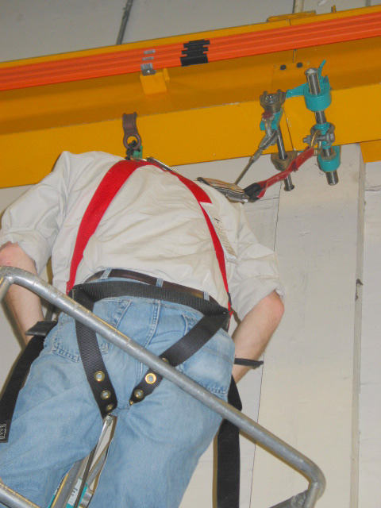  Separate fall arrest connection point.  Figure 1  NOTE: Use the following information when transferring a Single Point Powered Scaffold using a cable.  - Use a cable that you cannot slide one end thru the other allowing it to chock down on the tripod.  - This will cause an unwanted crushing action on the Tripod. The Cable Guard on the Tripod is designed to hold the load of the unit while being transferred. It is preferred that you wrap the cable thru the cable guard and shackle the two ends together.  - The cable used needs to be rated at 6 times the load capacity of the basket. Cable should be rated to support at least 6000lbs.  - Use a softener where the cable comes into contact with the cable guard on the tripod. Do not allow the cable to have a sawing motion on the tripod without the softener in place.

Step 2 | Position sling and rigging kooks onto lower I-beam flange as shown in Figure 2. Pull the cable downward to wrap around the fairlead and secure with shackle.  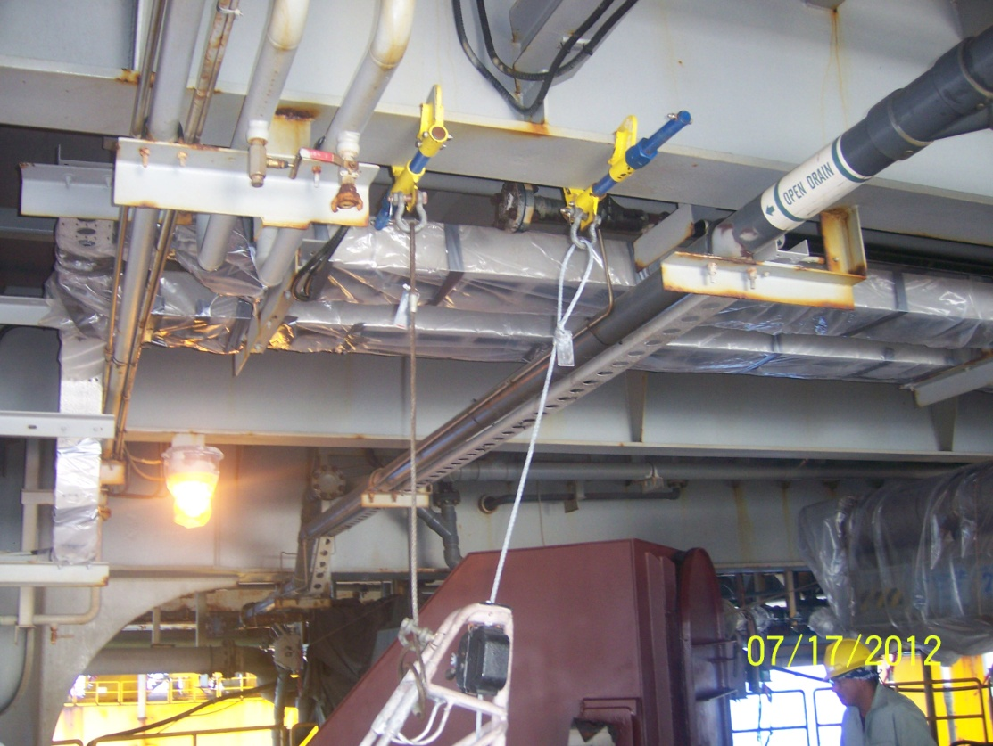  Figure 2

Step 3 | Check installation to ensure clamp and cable are secure. If not, repeat step 2 above until components are secure.

Step 4 | Step 4 - Thread cable through both sides of guards (both fairlead legs) as shown in figures 3a and 3b.  Thread cable through both fairlead legs.  Double wrap through guards and secure with shackle.  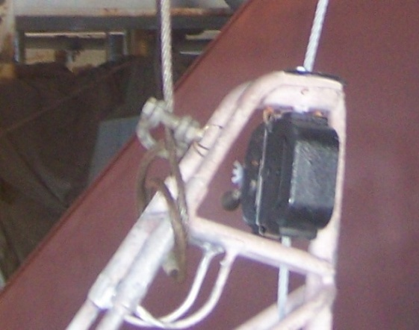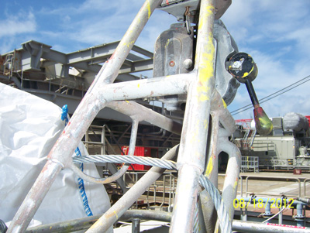  Figure 3b  Figure 3a

Step 5 | Next position cable eye to attach shackle around working length of cable as shown in Figure 4.  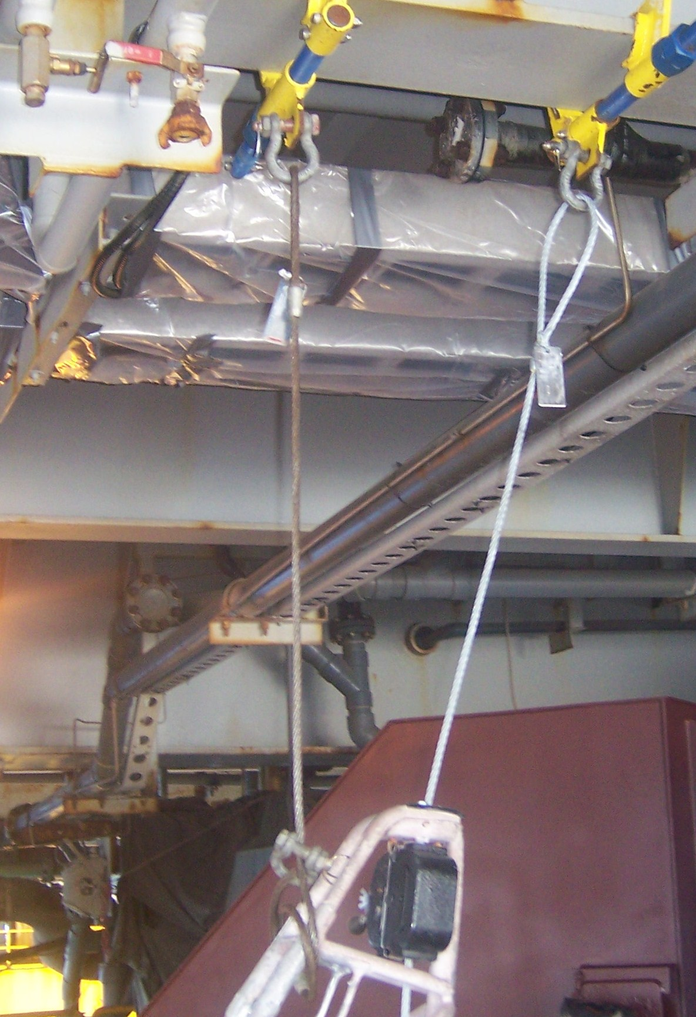  Figure 4

Step 6 | Perform a final check on all positioned and secured components.

Step 7 | Press the DOWN Control lever to begin descent until the work basket is fully suspended from the transfer rigging cable and there is appropriate slack in the primary wire rope to disconnect as shown in Figure 5. Be sure to use the tension holder to keep the wire rope from going slack on the drum (maintaining tight wrap).  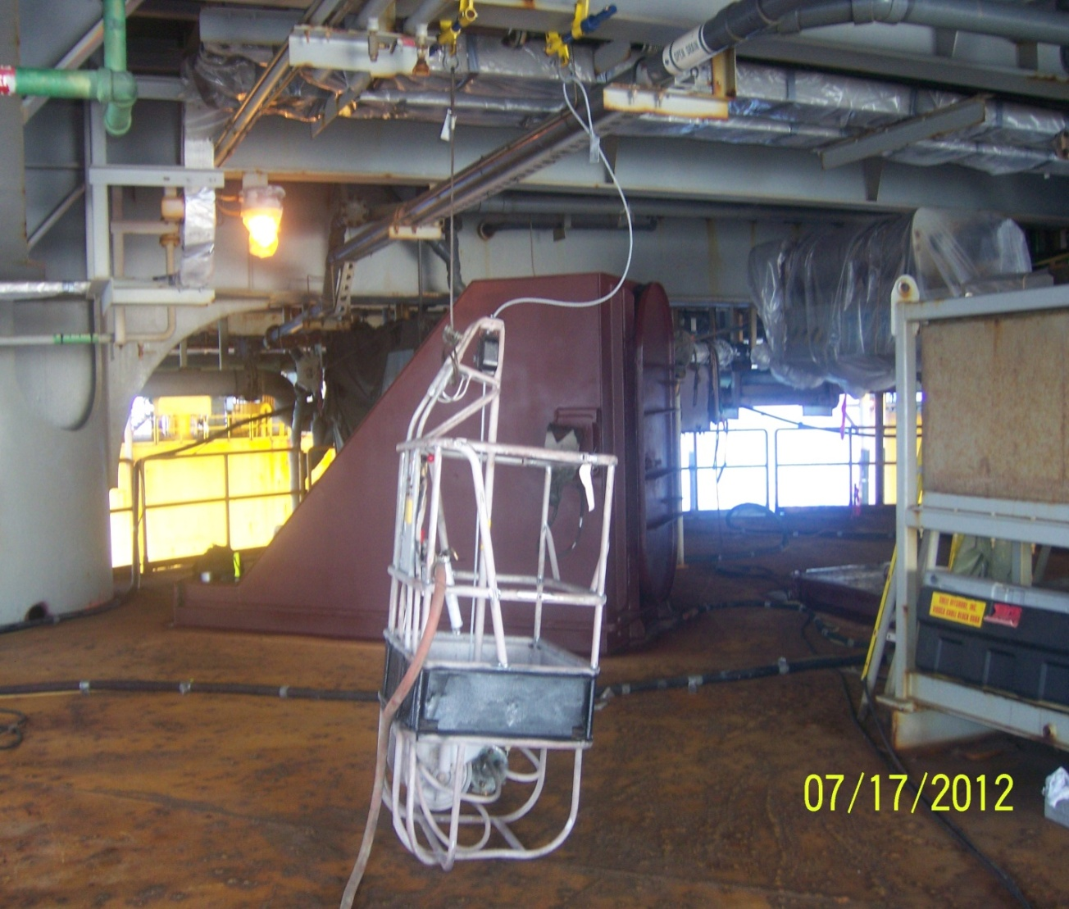  Lower basket until fully suspended from transfer connection.  Move primary connection to desired location.  Figure 5

Step 8 | Plan your moves and keep your rigging device attached to the beams. Slide as needed rather than removing whenever possible. Recheck all connections prior to loading.

Step 9 | Press the UP Control lever to begin ascent until work cage is fully suspended from your primary connection and that there is appropriate slack on the transfer rigging to disconnect as shown in Figures 6a and 6b.  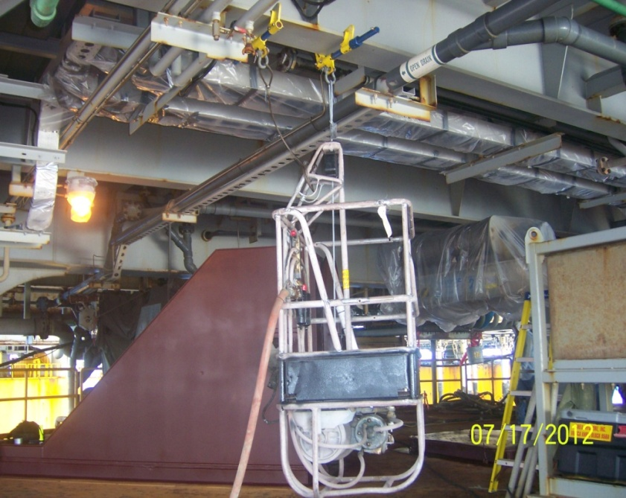  Lift basket to fully suspend from primary connection.  Figure 6a  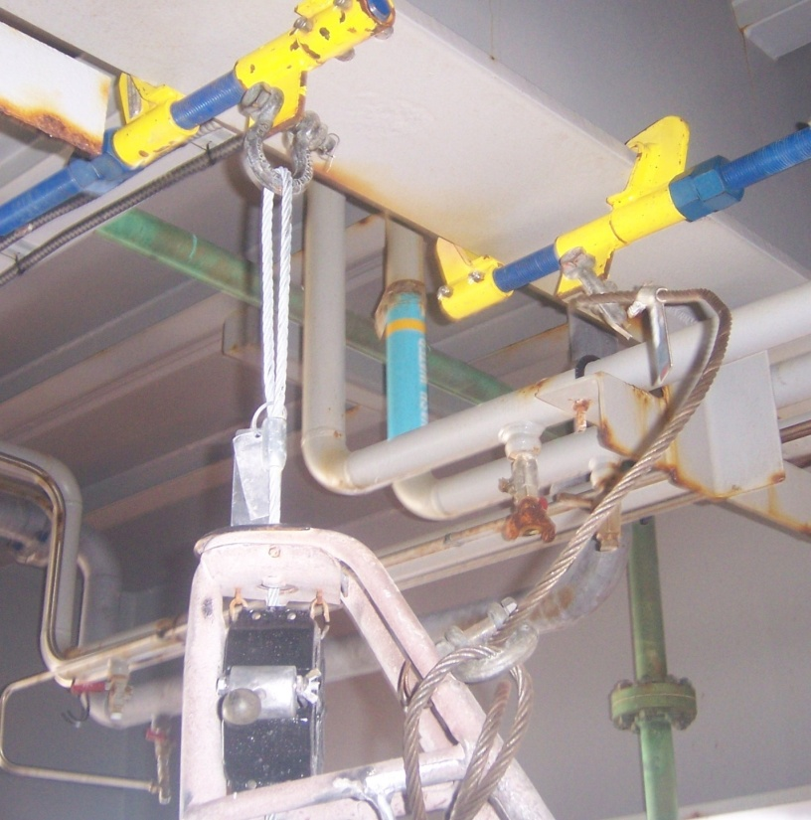  Figure 6b

Step 10 | After completion of transfer, proceed to next desired work location.

Step 11 | Reverse rigging procedures to return to your original location (if necessary).

Step 12 | Properly secure and store equipment when not in use.

