Use the Four Step Process in Table 1 below to capture your responses  1: Identify and document the scope or scopes of work.  2: Use the Risk Assessment Matrix for evaluating the unmitigated risk.  3: Document the common barriers and mitigations.  4: Identify the residual risk severity after the common barriers and  mitigations are in place. If multiple scopes are identified under a contract,  default your HSE Risk to the highest risk value for the overall risk  identification of the contract. Examples are provided on Page 2. | 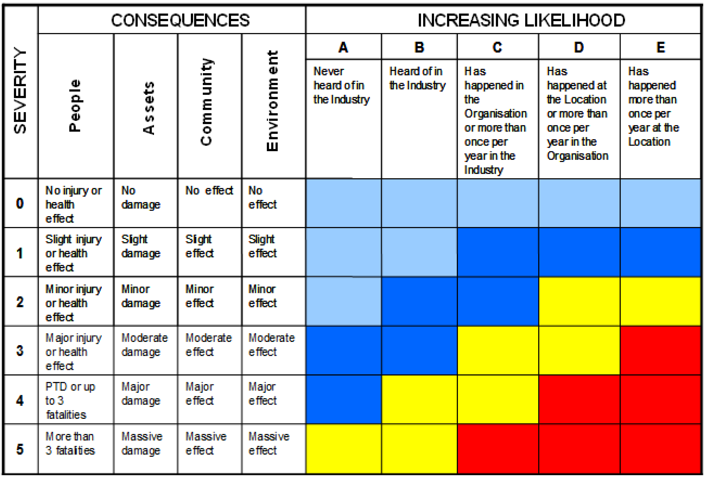
  Company: Alimak
  Contract Owner: Andre Barrios
  Contract Holder: Jama Ayers
  Contract HSE Focal: *Donell Williams (Facilitator)
  Contract Ops Focal: Zac Lawlor
  Contract Reference Numbers: CW444295
  Resultant HSE Risk:
  High | RAM Red plus Yellow 5A/5B
  Medium | RAM Yellow excluding 5A/5B
  Low | RAM Blue
Step 1  Identify Scope or Scopes of Work | Step 2  Identify the Unmitigated Risk  (identified as an Alpha/numeric value) | Step 3  Identify Barriers & Mitigations  (Common Standard Work Barriers/Mitigations) | Step 4  Identify Residual Risk  (What is the Alpha/numeric value risk ranking after common barriers and mitigations are in place)
Scope includes the inspection, certification, maintenance, repair, tracking, reporting and account management of company’s industrial elevators, dumbwaiters and various vertical lift equipment. Engineering services shall include the provision of personnel to undertake mechanical, hydraulic, pneumatic, structural and electrical engineering services as requested in writing by company.
 | Working at Height  People 4D | Fall Protection Devices, Training, Permitted Work Program | People 2B
 | Rotating Equipment  People 4C | Guards, Gloves, JSA’s, Training, LOTO De-energizing Procedures | People 1C
 | Energized Equipment  People 4B | LOTO De-energizing Procedures, Low Voltage, Insulated Equipment | People 1B
 | Pinch Points  People 3C | Gloves, PPE, JSA | People 1C
 | Open Hole  People 4B | Barricading work areas, permitted activity, Covered Openings | People 1B
 | Uneven Walking Surfaces  People 1B | Lighting, Environmental Awareness, signage, spill prevention(housekeeping) | People 1B
 | Fire  People 1A | Training, chemical storage, gas detectors, fire extinguishers | People 0A
 | Equipment Malfunction  People 4D | Inspection, PM, Testing | People 5D
 | Manual Labor (lifting, handling heavy loads) People 2D | PPE, proper lifting techniques, body positioning, use of proper tools | People 2D

Contractual Changes Required:
Recommend: Elevator work and Inspections in Hull Columns). Residual Risk:
- Working at height.
- Rotating equipment
- Energized equipment
Based on the scope of work, hazard exposure, soft barriers and risk, I recommend the Contract’s HSE be assigned as HIGH.

